Unit 4 Lesson 2: Ratios and Rates With Fractions

1 Number Talk: Division (Warm up)

Student Task Statement
Find each quotient mentally.
$5÷\frac{1}{3}$
$2÷\frac{1}{3}$
$\frac{1}{2}÷\frac{1}{3}$
$2\frac{1}{2}÷\frac{1}{3}$

2 A Train is Traveling at . . .

Student Task Statement
A train is traveling at a constant speed and goes 7.5 kilometers in 6 minutes. At that rate:
- How far does the train go in 1 minute?
- How far does the train go in 100 minutes?
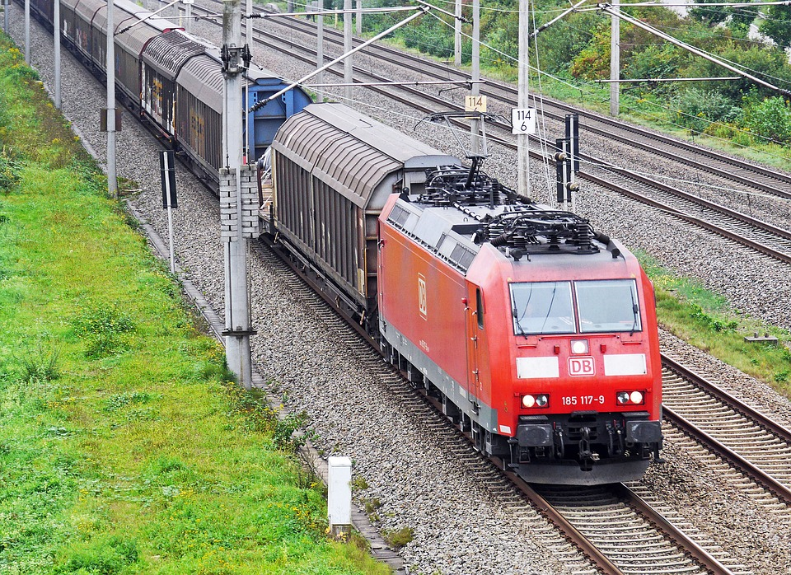

3 Comparing Running Speeds

Student Task Statement
Lin ran $2\frac{3}{4}$ miles in $\frac{2}{5}$ of an hour. Noah ran $8\frac{2}{3}$ miles in $\frac{4}{3}$ of an hour.
- Pick one of the questions that was displayed, but don’t tell anyone which question you picked. Find the answer to the question.
- When you and your partner are both done, share the answer you got (do not share the question) and ask your partner to guess which question you answered. If your partner can’t guess, explain the process you used to answer the question.
- Switch with your partner and take a turn guessing the question that your partner answered.

4 Scaling the Mona Lisa (Optional)

Student Task Statement
In real life, the Mona Lisa measures $2\frac{1}{2}$ feet by $1\frac{3}{4}$ feet. A company that makes office supplies wants to print a scaled copy of the Mona Lisa on the cover of a notebook that measures 11 inches by 9 inches.
- What size should they use for the scaled copy of the Mona Lisa on the notebook cover?
- What is the scale factor from the real painting to its copy on the notebook cover?
- Discuss your thinking with your partner. Did you use the same scale factor? If not, is one more reasonable than the other?
© CC BY Open Up Resources. Adaptations CC BY IM.

