Lesson 9 Practice Problems
- This package of sliced cheese costs $2.97.
- How much would a package with 18 slices cost at the same price per slice? Explain or show your reasoning.
- 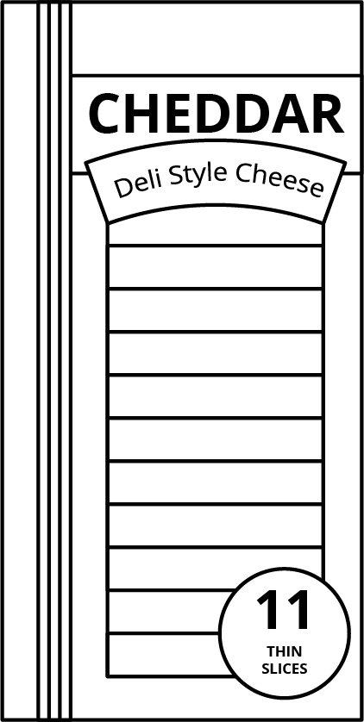
- A copy machine can print 480 copies every 4 minutes. For each question, explain or show your reasoning.
  - How many copies can it print in 10 minutes?
  - A teacher printed 720 copies. How long did it take to print?
- Order these objects from heaviest to lightest.
- (Note: 1 pound = 16 ounces, 1 kilogram $≈$ 2.2 pounds, and 1 ton = 2,000 pounds)
- item | - weight
- school bus | - 9 tons
- horse | - 1,100 pounds
- elephant | - 5,500 kilograms
- grand piano | - 15,840 ounces

- Andre sometimes mows lawns on the weekend to make extra money. Two weeks ago, he mowed a neighbor’s lawn for $\frac{1}{2}$ hour and earned $10. Last week, he mowed his uncle’s lawn for $\frac{3}{2}$ hours and earned $30. This week, he mowed the lawn of a community center for 2 hours and earned $30.
- Which jobs paid better than others? Explain your reasoning.
- (From Unit 3, Lesson 5.)
- Calculate and express your answer in decimal form.
  - $\frac{1}{2}⋅17$
  - $\frac{3}{4}⋅200$
  - $\left(0.2\right)⋅40$
  - $\left(0.25\right)⋅60$
- (From Unit 3, Lesson 1.)
- Here is a polygon.
- 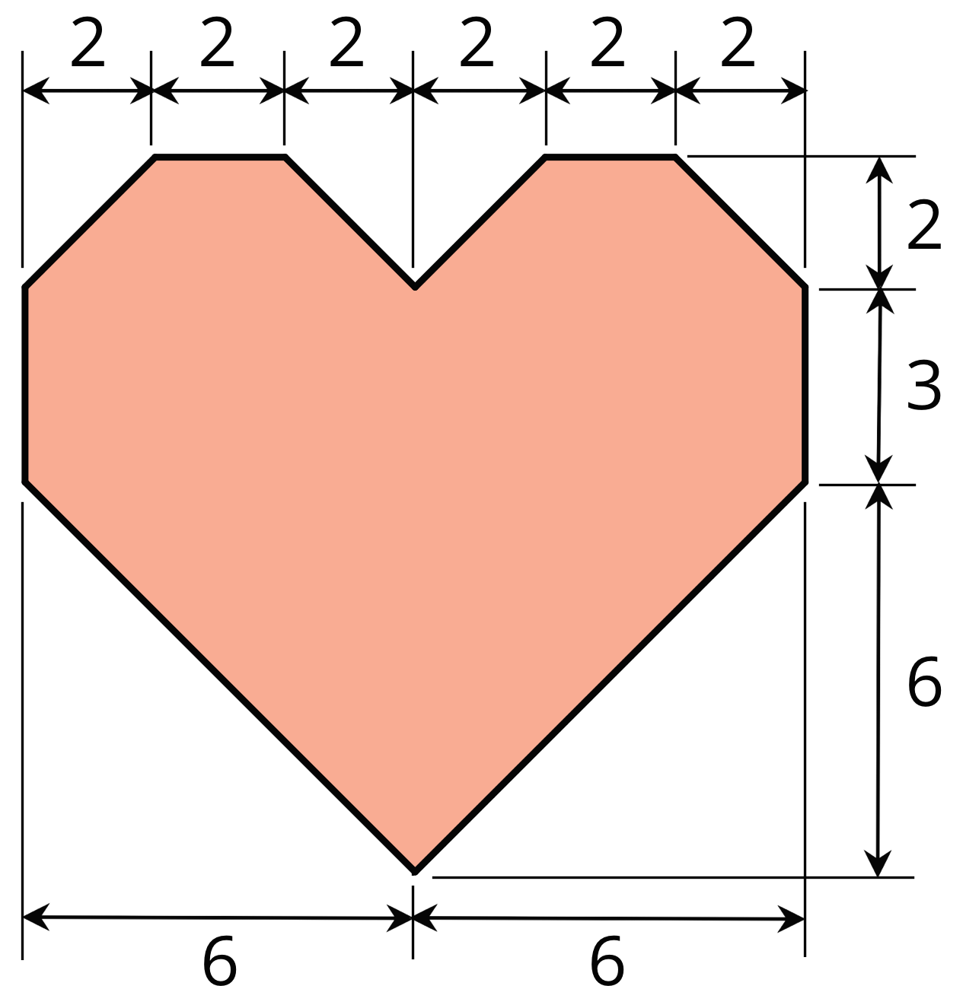
  - Decompose this polygon so that its area can be calculated. All measurements are in centimeters.
  - Calculate its area. Organize your work so that it can be followed by others.
- (From Unit 1, Lesson 11.)
© CC BY Open Up Resources. Adaptations CC BY IM.

