Lesson 9 Practice Problems
- Select all the expressions that represent the area of the large, outer rectangle.
- 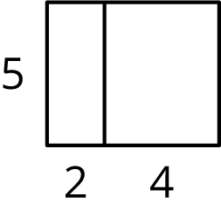
  - $5\left(2+4\right)$
  - $5⋅2+4$
  - $5⋅2+5⋅4$
  - $5⋅2⋅4$
  - $5+2+4$
  - $5⋅6$
- Draw and label diagrams that show these two methods for calculating $19⋅50$.
  - First find $10⋅50$ and then add $9⋅50$.
  - First find $20⋅50$ and then take away 50.
- Complete each calculation using the distributive property.
- $98⋅24$ $\left(100−2\right)⋅24$ $…$
- $21⋅15$ $\left(20+1\right)⋅15$ $…$
- $0.51⋅40$ $\left(0.5+0.01\right)⋅40$ $…$
- A group of 8 friends go to the movies. A bag of popcorn costs $2.99. How much will it cost to get one bag of popcorn for each friend? Explain how you can calculate this amount mentally.

  - On graph paper, draw diagrams of $a+a+a+a$ and $4a$ when $a$ is 1, 2, and 3. What do you notice?
  - Do $a+a+a+a$ and $4a$ have the same value for any value of $a$? Explain how you know.
- (From Unit 6, Lesson 8.)
- 120% of $x$ is equal to 78.
  - Write an equation that shows the relationship of 120%, $x$, and 78.
  - Use your equation to find $x$. Show your reasoning.
- (From Unit 6, Lesson 7.)
- Kiran’s aunt is 17 years older than Kiran.
  - How old will Kiran’s aunt be when Kiran is:
  - 15 years old?
  - 30 years old?
  - $x$ years old?
  - How old will Kiran be when his aunt is 60 years old?
- (From Unit 6, Lesson 6.)
© CC BY Open Up Resources. Adaptations CC BY IM.

