Lesson 10 Practice Problems
- Here is a rectangle.
- 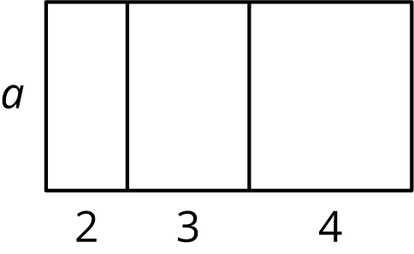
  - Explain why the area of the large rectangle is $2a+3a+4a$.
  - Explain why the area of the large rectangle is $\left(2+3+4\right)a$.
- Is the area of the shaded rectangle $6\left(2−m\right)$ or $6\left(m−2\right)$?
- Explain how you know.
- 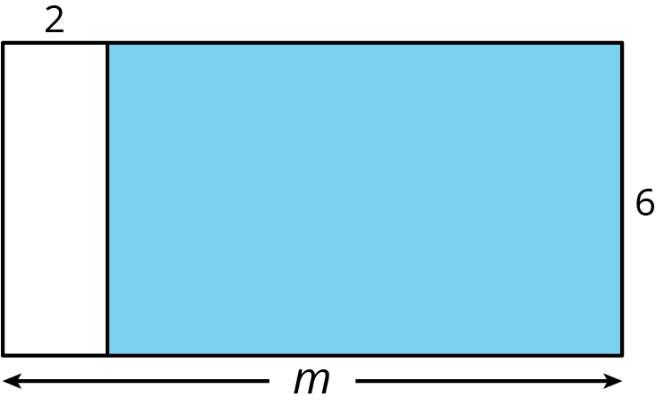
- Choose the expressions that do not represent the total area of the rectangle. Select all that apply.
- 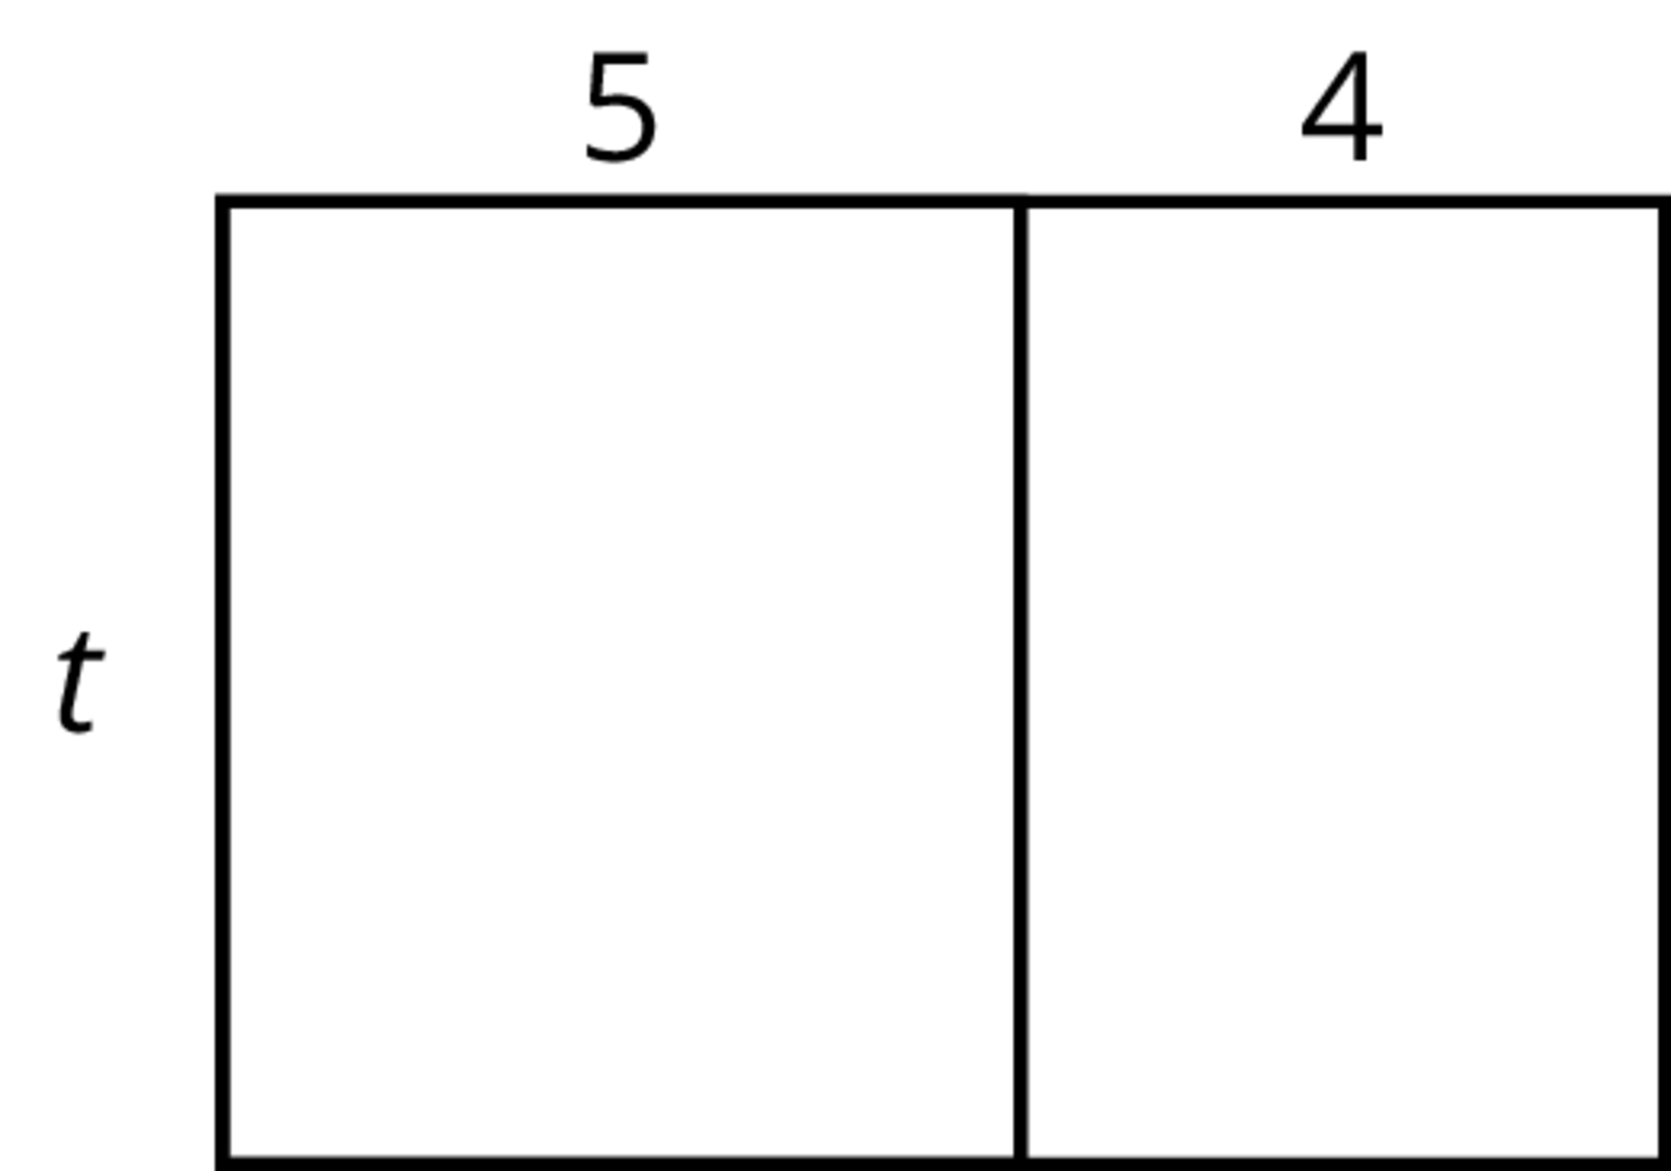
  - $5t+4t$
  - $t+5+4$
  - $9t$
  - $4⋅5⋅t$
  - $t\left(5+4\right)$
- Evaluate each expression mentally.
  - $35⋅91−35⋅89$
  - $22⋅87+22⋅13$
  - $\frac{9}{11}⋅\frac{7}{10}−\frac{9}{11}⋅\frac{3}{10}$
- (From Unit 6, Lesson 9.)
- Select all the expressions that are equivalent to $4b$.
  - $b+b+b+b$
  - $b+4$
  - $2b+2b$
  - $b⋅b⋅b⋅b$
  - $b÷\frac{1}{4}$
- (From Unit 6, Lesson 8.)
- Solve each equation. Show your reasoning.
- $111=14a$

- $13.65=b+4.88$
- $c+\frac{1}{3}=5\frac{1}{8}$
- $\frac{2}{5}d=\frac{17}{4}$

- $5.16=4e$
- (From Unit 6, Lesson 4.)
- Andre ran $5\frac{1}{2}$ laps of a track in 8 minutes at a constant speed. It took Andre $x$ minutes to run each lap. Select all the equations that represent this situation.
  - $\left(5\frac{1}{2}\right)x=8$
  - $5\frac{1}{2}+x=8$
  - $5\frac{1}{2}−x=8$
  - $5\frac{1}{2}÷x=8$
  - $x=8÷\left(5\frac{1}{2}\right)$
  - $x=\left(5\frac{1}{2}\right)÷8$
- (From Unit 6, Lesson 2.)
© CC BY Open Up Resources. Adaptations CC BY IM.

