Lesson 3: More about Constant of Proportionality
Let’s solve more problems involving proportional relationships using tables.

3.1: Equal Measures
Use the numbers and units from the list to find as many equivalent measurements as you can. For example, you might write “30 minutes is $\frac{1}{2}$ hour.”
You can use the numbers and units more than once.
1
12
0.4
60
50
$\frac{1}{2}$
40
0.01
$3\frac{1}{3}$
30
0.3
24
$\frac{1}{10}$
6
2
$\frac{2}{5}$
centimeter
meter
hour
feet
minute
inch

3.2: Centimeters and Millimeters
There is a proportional relationship between any length measured in centimeters and the same length measured in millimeters.
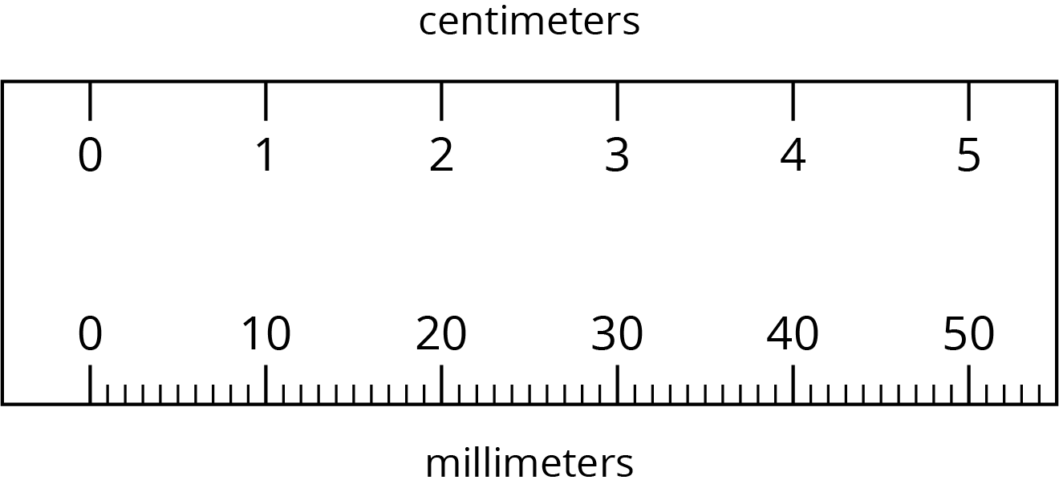
There are two ways of thinking about this proportional relationship.
- If you know the length of something in centimeters, you can calculate its length in millimeters.
  - Complete the table.
  - What is the constant of proportionality?
- length (cm) | - length (mm)
- 9
- 12.5
- 50
- 88.49
- If you know the length of something in millimeters, you can calculate its length in centimeters.
  - Complete the table.
  - What is the constant of proportionality?
- length (mm) | - length (cm)
- 70
- 245
- 4
- 699.1
- How are these two constants of proportionality related to each other?
- Complete each sentence:
  - To convert from centimeters to millimeters, you can multiply by ________.
  - To convert from millimeters to centimeters, you can divide by ________ or multiply by ________.

Are you ready for more?
- How many square millimeters are there in a square centimeter?
- How do you convert square centimeters to square millimeters? How do you convert the other way?

3.3: Pittsburgh to Phoenix
On its way from New York to San Diego, a plane flew over Pittsburgh, Saint Louis, Albuquerque, and Phoenix traveling at a constant speed.
Complete the table as you answer the questions. Be prepared to explain your reasoning.
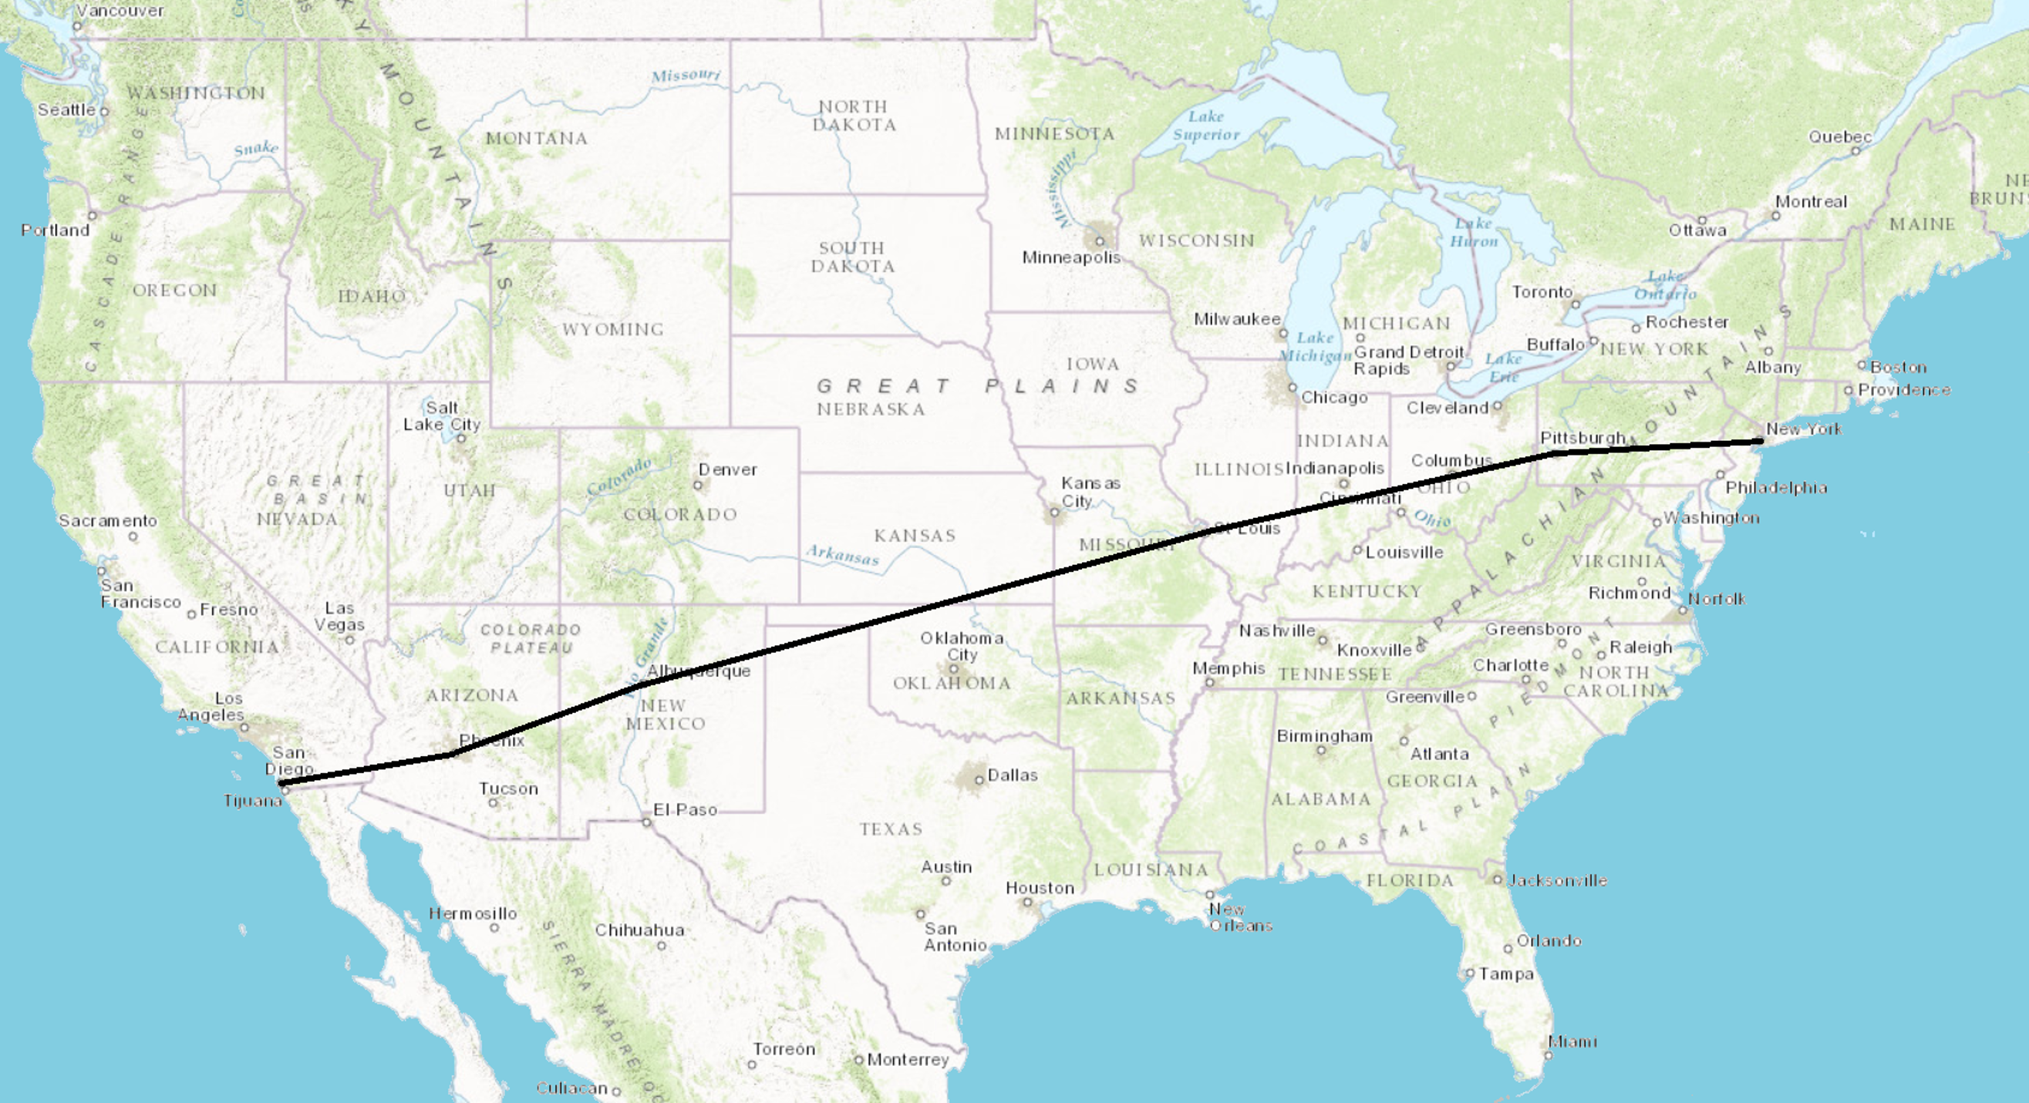
segment | time | distance | speed
Pittsburgh to Saint Louis | 1 hour | 550 miles
Saint Louis to Albuquerque | 1 hour 42 minutes
Albuquerque to Phoenix |  | 330 miles
- What is the distance between Saint Louis and Albuquerque?
- How many minutes did it take to fly between Albuquerque and Phoenix?
- What is the proportional relationship represented by this table?
- Diego says the constant of proportionality is 550. Andre says the constant of proportionality is $9\frac{1}{6}$. Do you agree with either of them? Explain your reasoning.

Lesson 3 Summary
When something is traveling at a constant speed, there is a proportional relationship between the time it takes and the distance traveled. The table shows the distance traveled and elapsed time for a bug crawling on a sidewalk.
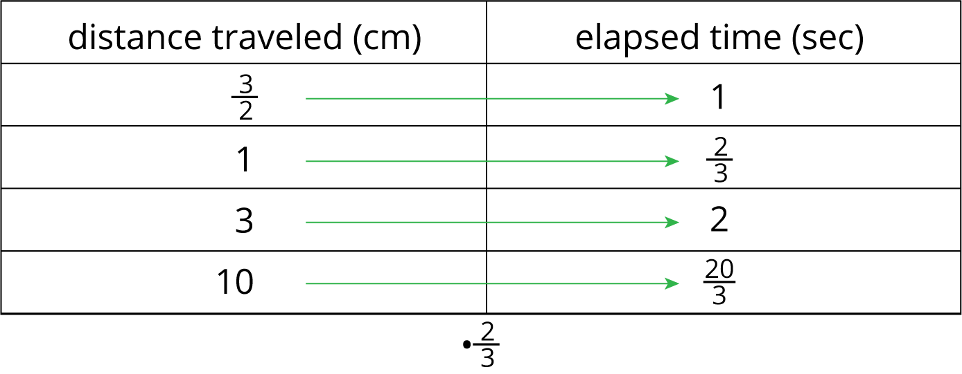
We can multiply any number in the first column by $\frac{2}{3}$ to get the corresponding number in the second column. We can say that the elapsed time is proportional to the distance traveled, and the constant of proportionality is $\frac{2}{3}$. This means that the bug’s pace is $\frac{2}{3}$ seconds per centimeter.
This table represents the same situation, except the columns are switched.
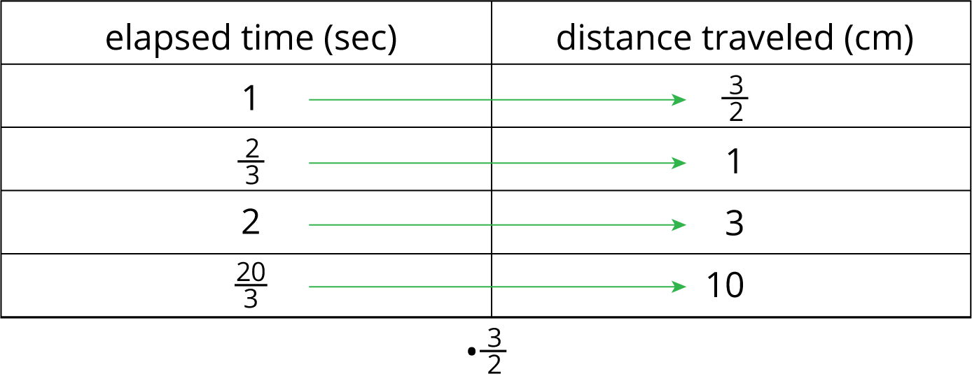
We can multiply any number in the first column by $\frac{3}{2}$ to get the corresponding number in the second column. We can say that the distance traveled is proportional to the elapsed time, and the constant of proportionality is $\frac{3}{2}$. This means that the bug’s speed is $\frac{3}{2}$ centimeters per second.
Notice that $\frac{3}{2}$ is the reciprocal of $\frac{2}{3}$. When two quantities are in a proportional relationship, there are two constants of proportionality, and they are always reciprocals of each other. When we represent a proportional relationship with a table, we say the quantity in the second column is proportional to the quantity in the first column, and the corresponding constant of proportionality is the number we multiply values in the first column to get the values in the second.
© CC BY Open Up Resources. Adaptations CC BY IM.

