Lesson 9 Practice Problems
- Han ran 10 meters in 2.7 seconds. Priya ran 10 meters in 2.4 seconds.
  - Who ran faster? Explain how you know.
  - At this rate, how long would it take each person to run 50 meters? Explain or show your reasoning.
- A scooter travels 30 feet in 2 seconds at a constant speed.
  - What is the speed of the scooter in feet per second?
  - Complete the double number line to show the distance the scooter travels after 1, 3, 4, and 5 seconds.
  - A skateboard travels 55 feet in 4 seconds. Is the skateboard going faster, slower, or the same speed as the scooter?
- A cargo ship traveled 150 nautical miles in 6 hours at a constant speed. How far did the cargo ship travel in one hour?
- 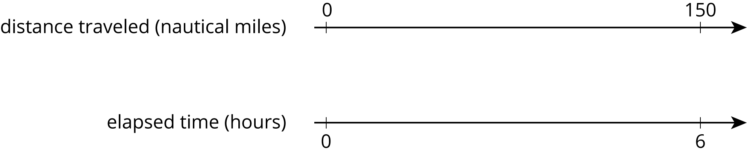
- A recipe for pasta dough says, “Use 150 grams of flour per large egg.”
  - How much flour is needed if 6 large eggs are used?
  - How many eggs are needed if 450 grams of flour are used?
- (From Unit 2, Lesson 3.)
- The grocery store is having a sale on frozen vegetables. 4 bags are being sold for $11.96. At this rate, what is the cost of:
  - 1 bag
  - 9 bags
- (From Unit 2, Lesson 8.)
- A pet owner has 5 cats. Each cat has 2 ears and 4 paws.
  - Complete the double number line to show the numbers of ears and paws for 1, 2, 3, 4, and 5 cats.
  - If there are 3 cats in the room, what is the ratio of ears to paws?
- 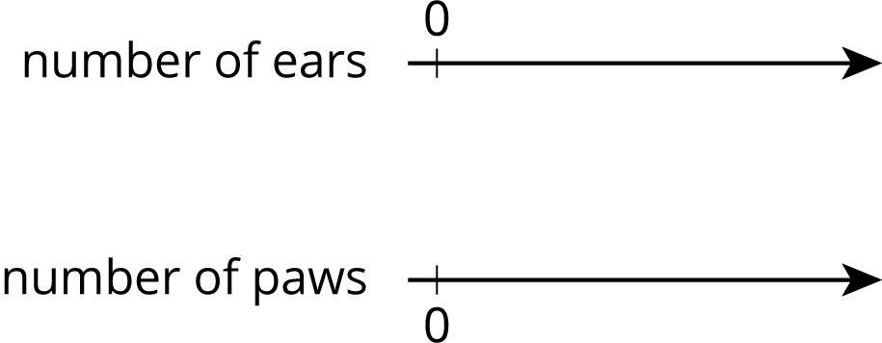
  - If there are 4 cats in the room, what is the ratio of paws to ears?
  - If all 5 cats are in the room, how many more paws are there than ears?
- (From Unit 2, Lesson 7.)
- Each of these is a pair of equivalent ratios. For each pair, explain why they are equivalent ratios or draw a representation that shows why they are equivalent ratios.
  - $5:1$ and $15:3$
  - $25:5$ and $10:2$
  - $198:1,​287$ and $2:13$
- (From Unit 2, Lesson 5.)
© CC BY Open Up Resources. Adaptations CC BY IM.

