Unit 3 Lesson 4: Applying Circumference

1 What Do We Know? What Can We Estimate? (Warm up)

Student Task Statement
Here are some pictures of circular objects, with measurement tools shown. The measurement tool on each picture reads as follows:
- Wagon wheel: 3 feet
- Plane propeller: 24 inches
- Sliced Orange: 20 centimeters
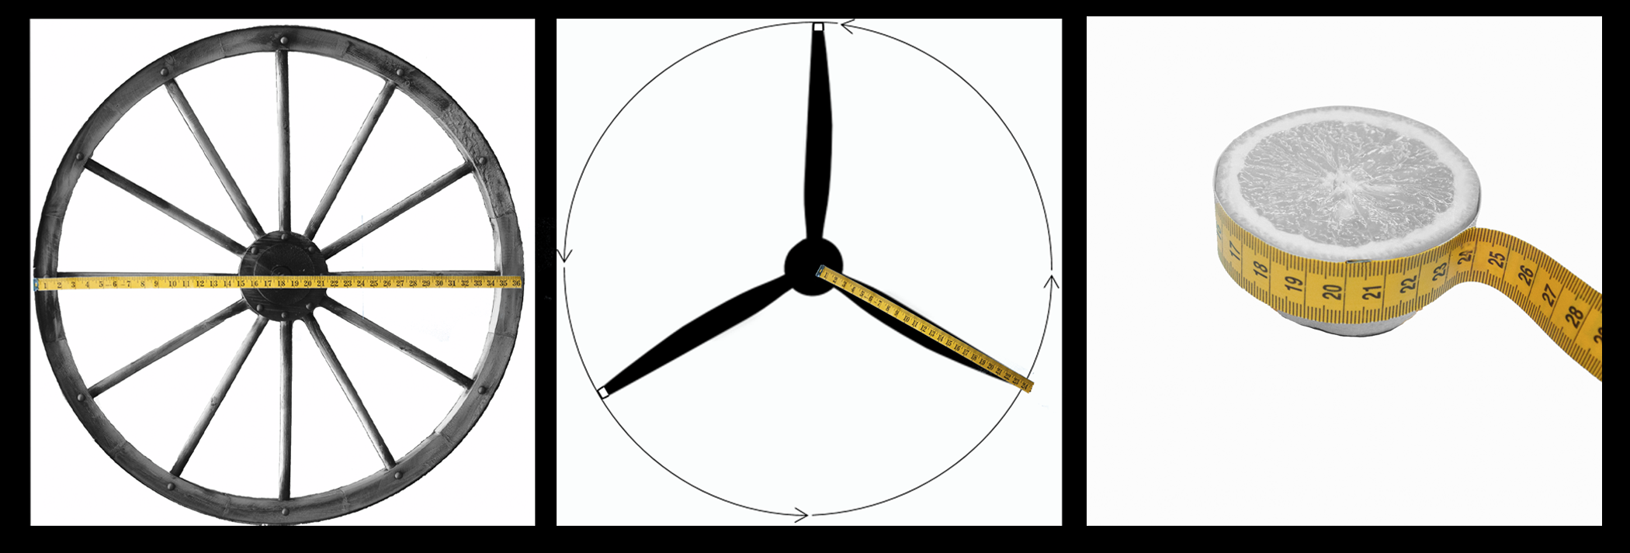
- For each picture, which measurement is shown?
- Based on this information, what measurement(s) could you estimate for each picture?

2 Using $π$

Student Task Statement
In the previous activity, we looked at pictures of circular objects. One measurement for each object is listed in the table.
Your teacher will assign you an approximation of $π$ to use for this activity.
- Complete the table.
- object | - radius | - diameter | - circumference
- wagon wheel |  | - 3 ft
- airplane propeller | - 24 in
- orange slice |  |  | - 20 cm
- A bug was sitting on the tip of the propeller blade when the propeller started to rotate. The bug held on for 5 rotations before flying away. How far did the bug travel before it flew off?

3 Around the Running Track (Optional)

Student Task Statement
The field inside a running track is made up of a rectangle that is 84.39 m long and 73 m wide, together with a half-circle at each end.
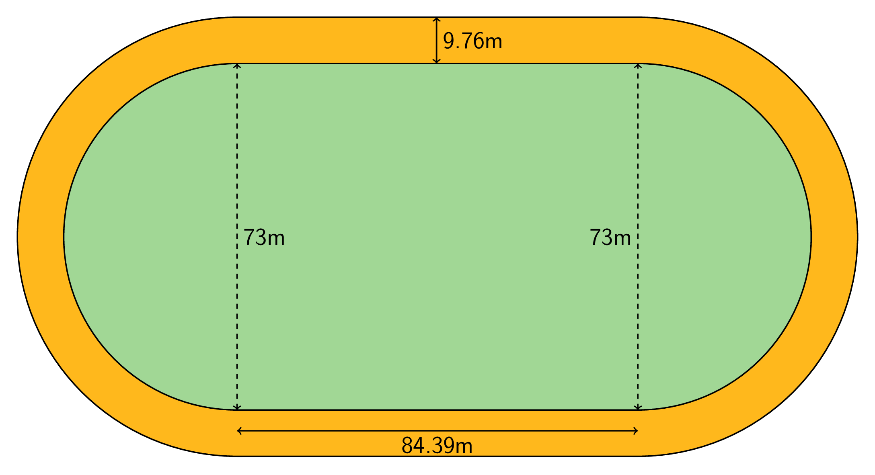
- What is the distance around the inside of the track? Explain or show your reasoning.
- The track is 9.76 m wide all the way around. What is the distance around the outside of the track? Explain or show your reasoning.

4 Measuring a Picture Frame

Student Task Statement
Kiran bent some wire around a rectangle to make a picture frame. The rectangle is 8 inches by 10 inches.
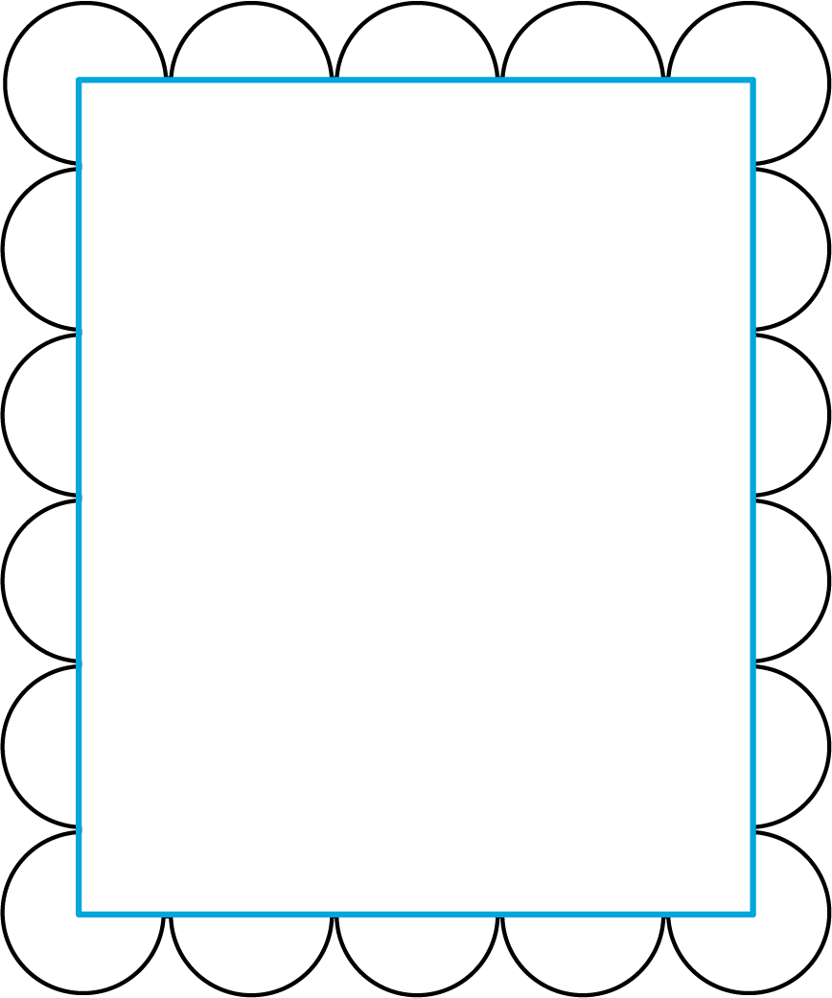
- Find the perimeter of the wire picture frame. Explain or show your reasoning.
- If the wire picture frame were stretched out to make one complete circle, what would its radius be?
© CC BY Open Up Resources. Adaptations CC BY IM.

