Lesson 7 Practice Problems
- Here is a rectangle that has been partitioned into four smaller rectangles.
- 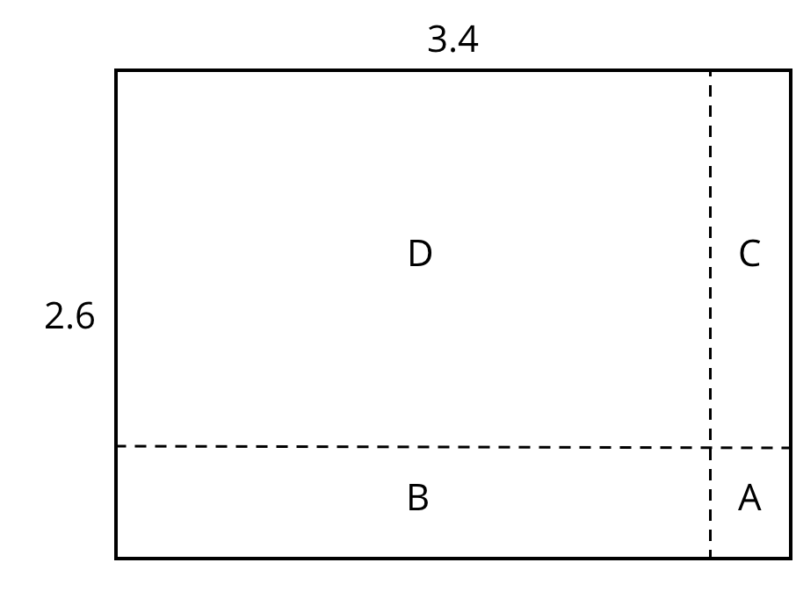
- For each expression, choose the sub-rectangle whose area, in square units, matches the expression.
  - $3⋅\left(0.6\right)$
  - $\left(0.4\right)⋅2$
  - $\left(0.4\right)⋅\left(0.6\right)$
  - $3⋅2$
- Here is an area diagram that represents $\left(3.1\right)⋅\left(1.4\right)$.
- 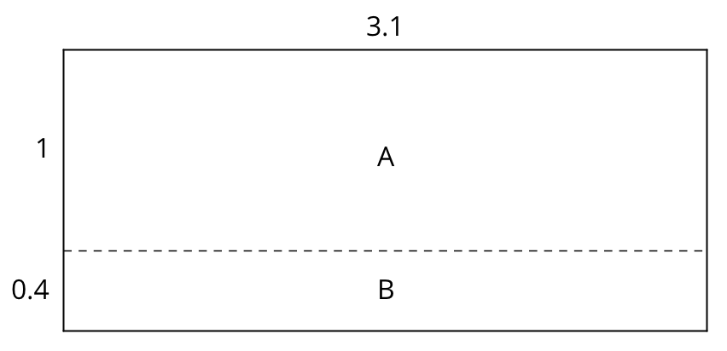
  - Find the areas of sub-rectangles A and B.
  - What is the area of the 3.1 by 1.4 rectangle?
- Draw an area diagram to find $\left(0.36\right)⋅\left(0.53\right)$. Label and organize your work so that it can be followed by others.
- Find each product. Show your reasoning.
  - $\left(2.5\right)⋅\left(1.4\right)$
  - $\left(0.64\right)⋅\left(0.81\right)$
- Complete the calculations so that each shows the correct sum.
- 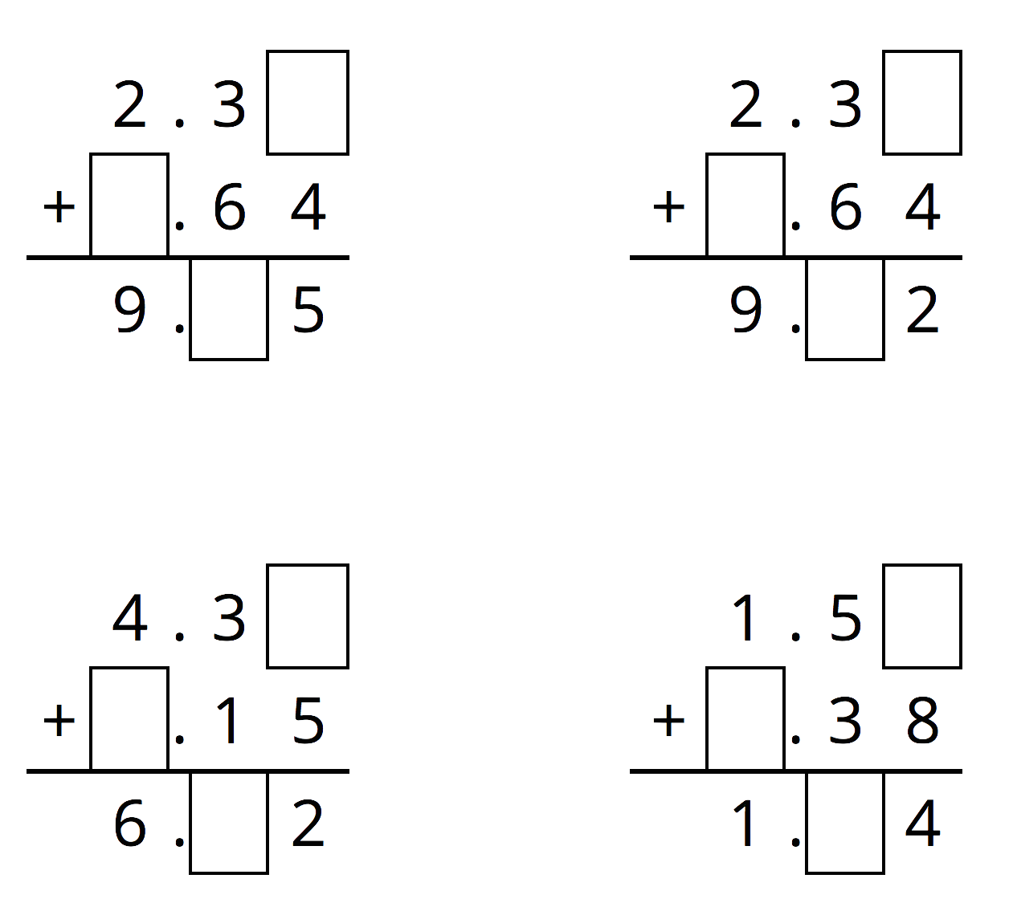
- (From Unit 5, Lesson 3.)
- Diego bought 12 mini muffins for $4.20.
  - At this rate, how much would Diego pay for 4 mini muffins?
  - How many mini muffins could Diego buy with $3.00? Explain or show your reasoning. If you get stuck, consider using the table.
- number of  mini muffins | - price in  dollars
- 12 | - 4.20
- (From Unit 2, Lesson 12.)
© CC BY Open Up Resources. Adaptations CC BY IM.

