Lesson 6 Practice Problems
- Find each product. Show your reasoning.
  - $\left(1.2\right)⋅\left(0.11\right)$
  - $\left(0.34\right)⋅\left(0.02\right)$
  - $120⋅\left(0.002\right)$
- You can use a rectangle to represent $\left(0.3\right)⋅\left(0.5\right)$.
  - What must the side length of each square represent for the rectangle to correctly represent $\left(0.3\right)⋅\left(0.5\right)$?
  - What area is represented by each square?
  - What is $\left(0.3\right)⋅\left(0.5\right)$? Show your reasoning.
- 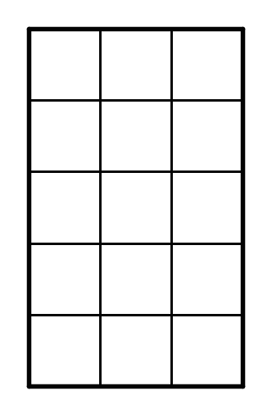
- One gallon of gasoline in Buffalo, New York costs $2.29. In Toronto, Canada, one liter of gasoline costs $0.91. There are 3.8 liters in one gallon.
  - How much does one gallon of gas cost in Toronto? Round your answer to the nearest cent.
  - Is the cost of gas greater in Buffalo or in Toronto? How much greater?
- Calculate each sum or difference.
- $10.3+3.7$
- $20.99−4.97$
- $15.99+23.51$
- $1.893−0.353$
- (From Unit 5, Lesson 2.)
- Find the value of $\frac{49}{50}÷\frac{7}{6}$ using any method.
- (From Unit 4, Lesson 11.)
- Find the area of the shaded region. All angles are right angles. Show your reasoning.
- 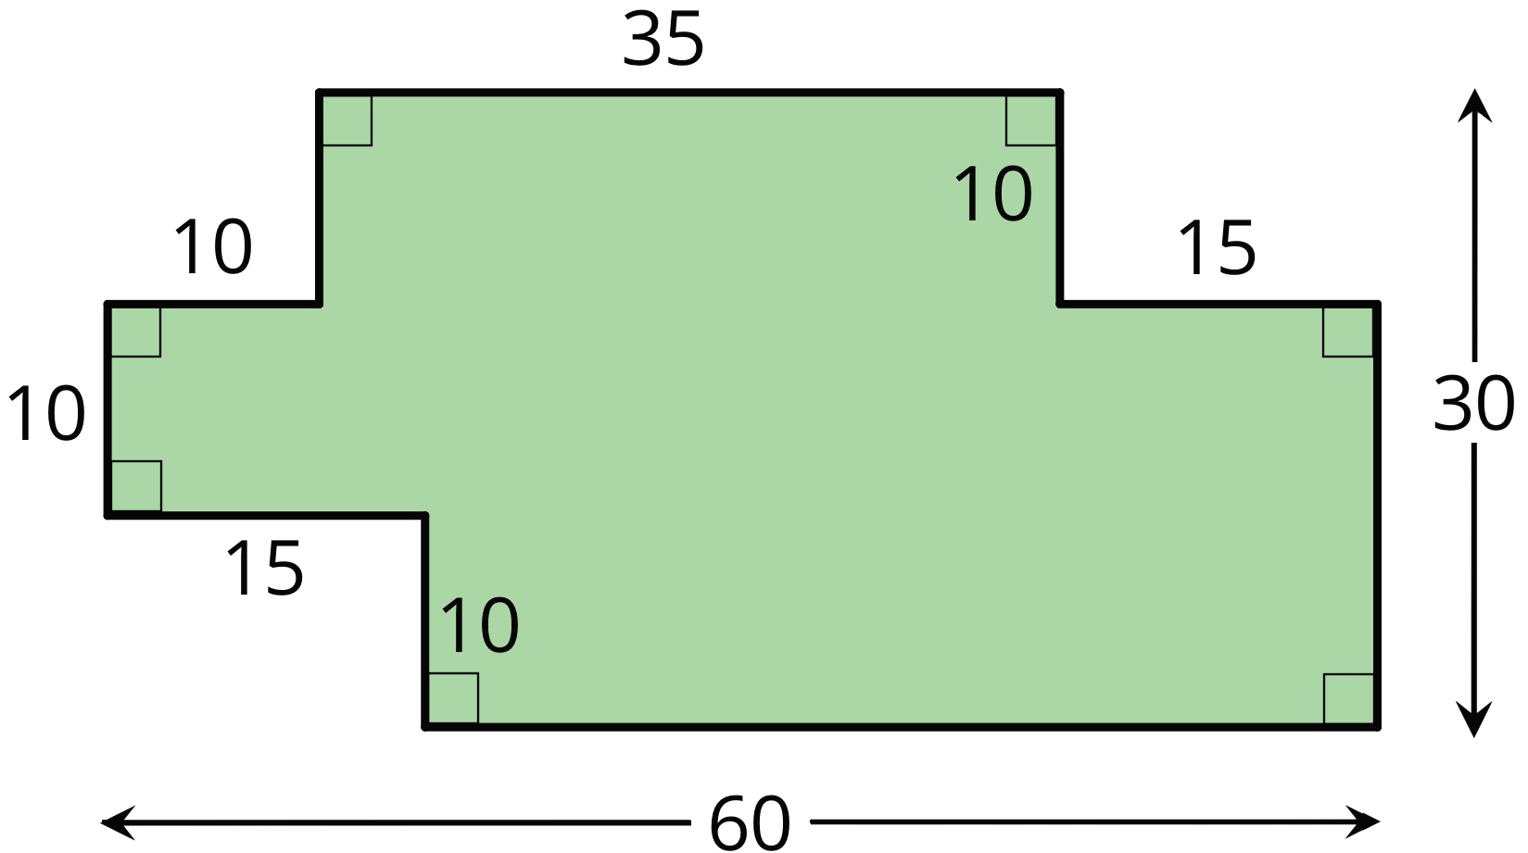

- (From Unit 1, Lesson 1.)

  - Priya finds $\left(1.05\right)⋅\left(2.8\right)$ by calculating $105⋅28$, then moving the decimal point three places to the left. Why does Priya’s method make sense?
  - Use Priya’s method to calculate $\left(1.05\right)⋅\left(2.8\right)$. You can use the fact that $105⋅28=2,​940$.
  - Use Priya’s method to calculate $\left(0.0015\right)⋅\left(0.024\right)$.
© CC BY Open Up Resources. Adaptations CC BY IM.

