Unit 7 Lesson 1: Relationships of Angles

1 Visualizing Angles (Warm up)

Student Task Statement
- Which angle is bigger?
- 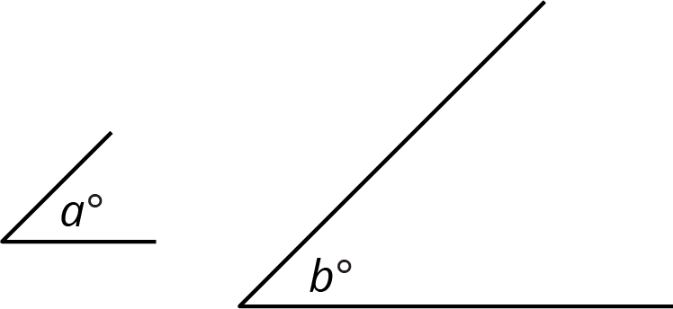
- Identify an obtuse angle in the diagram.
- 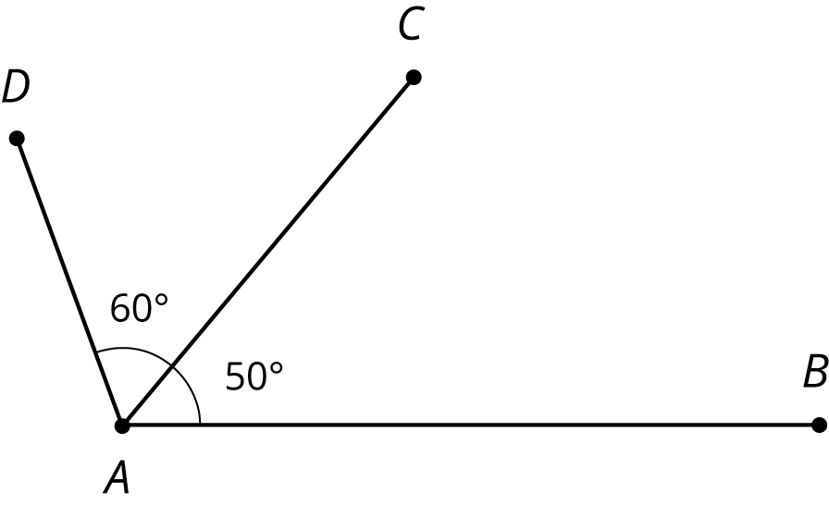

2 Pattern Block Angles

Images for Launch
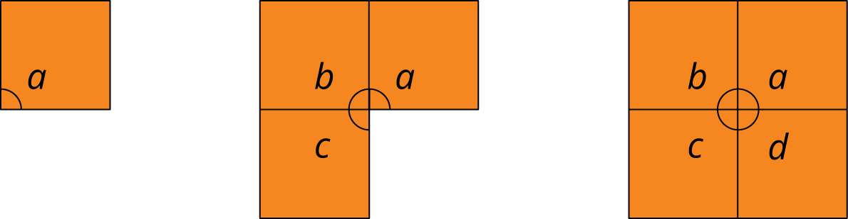

Student Task Statement
- Trace one copy of every different pattern block. Each block contains either 1 or 2 angles with different degree measures. Which blocks have only 1 unique angle? Which have 2?
- If you trace three copies of the hexagon so that one vertex from each hexagon touches the same point, as shown, they fit together without any gaps or overlaps. Use this to figure out the degree measure of the angle inside the hexagon pattern block.
- 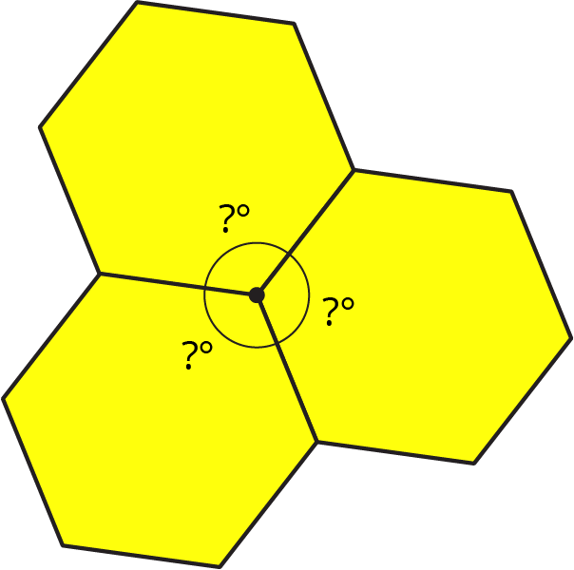
- Figure out the degree measure of all of the other angles inside the pattern blocks that you traced in the first question. Be prepared to explain your reasoning.

Activity Synthesis
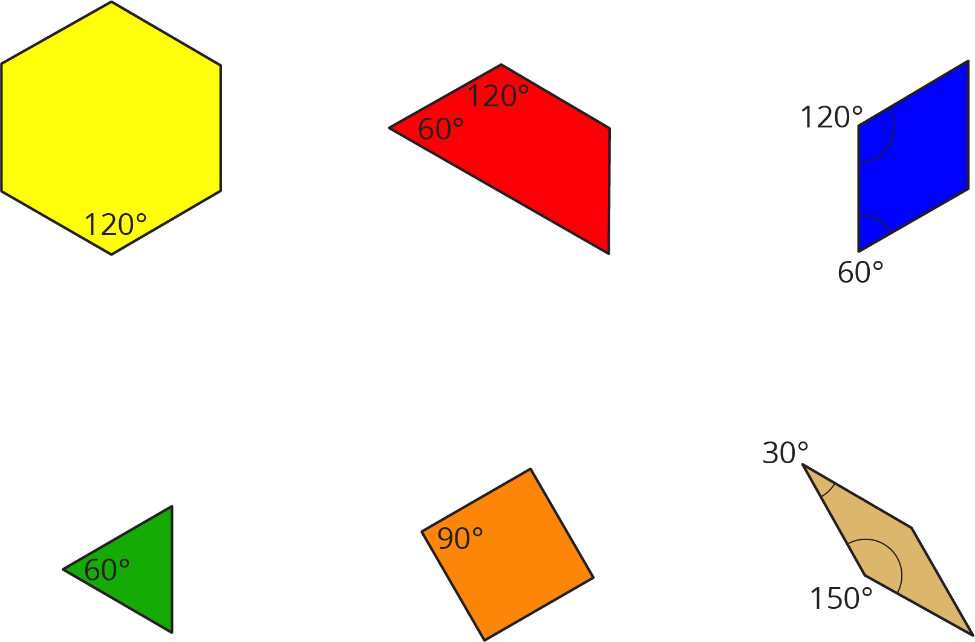

3 More Pattern Block Angles

Student Task Statement
- Use pattern blocks to determine the measure of each of these angles.
- 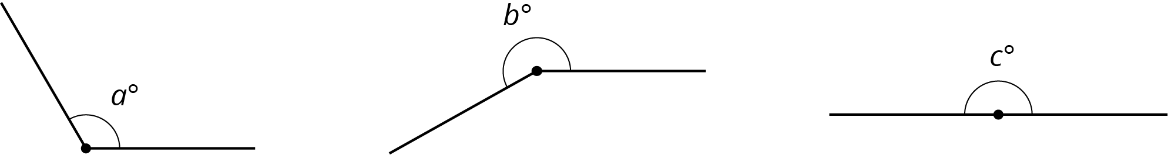
- If an angle has a measure of ${180}^{∘}$, then its sides form a straight line. An angle that forms a straight line is called a straight angle. Find as many different combinations of pattern blocks as you can that make a straight angle.

4 Measuring Like This or That (Optional)

Student Task Statement
Tyler and Priya were both measuring angle $TUS$.
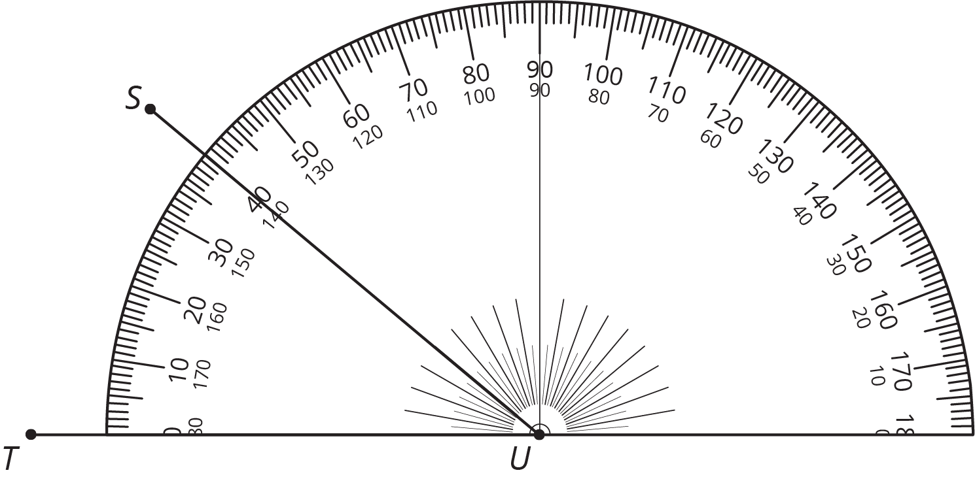
Priya thinks the angle measures 40 degrees. Tyler thinks the angle measures 140 degrees. Do you agree with either of them? Explain your reasoning.
© CC BY Open Up Resources. Adaptations CC BY IM.

