Unit 7 Lesson 9: Drawing Triangles (Part 1)

1 Which One Doesn’t Belong: Triangles (Warm up)

Student Task Statement
Which one doesn’t belong?
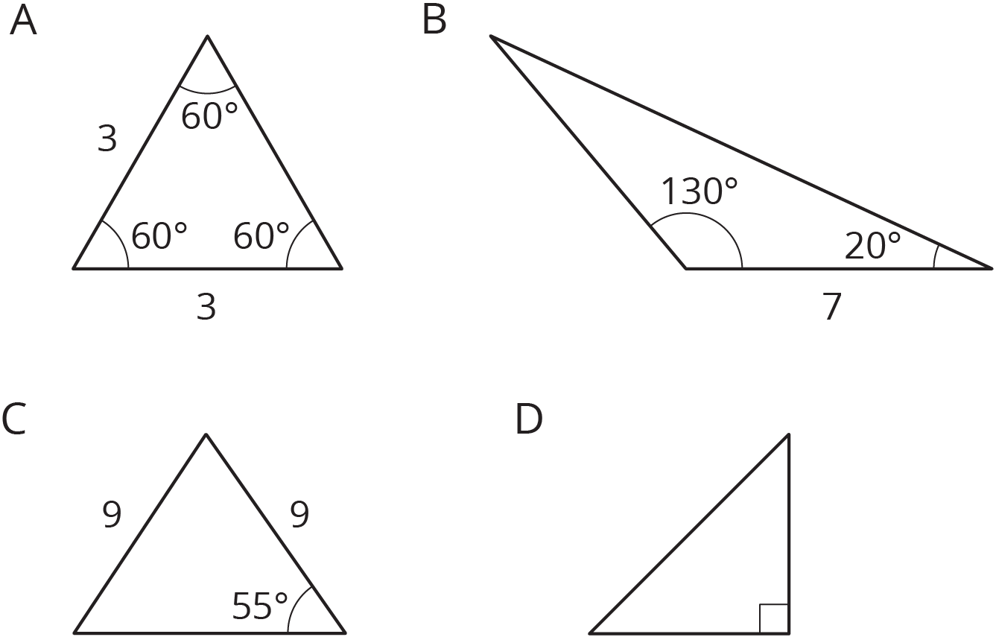

2 Does Your Triangle Match Theirs?

Student Task Statement
Three students have each drawn a triangle. For each description:
- Draw a triangle with the given measurements.
- Measure and label the other side lengths and angle measures in your triangle.
- Decide whether the triangle you drew must be an identical copy of the triangle that the student drew. Explain your reasoning.
- Jada’s triangle has one angle measuring ${75}^{∘}$.
- Andre’s triangle has one angle measuring ${75}^{∘}$ and one angle measuring ${45}^{∘}$.
- Lin’s triangle has one angle measuring ${75}^{∘}$, one angle measuring ${45}^{∘}$, and one side measuring 5 cm.

Activity Synthesis
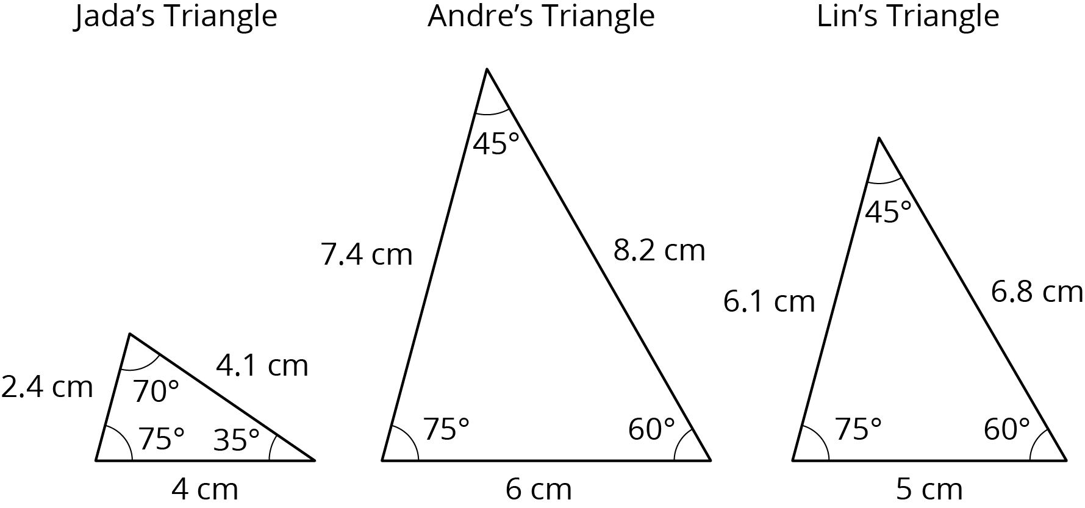
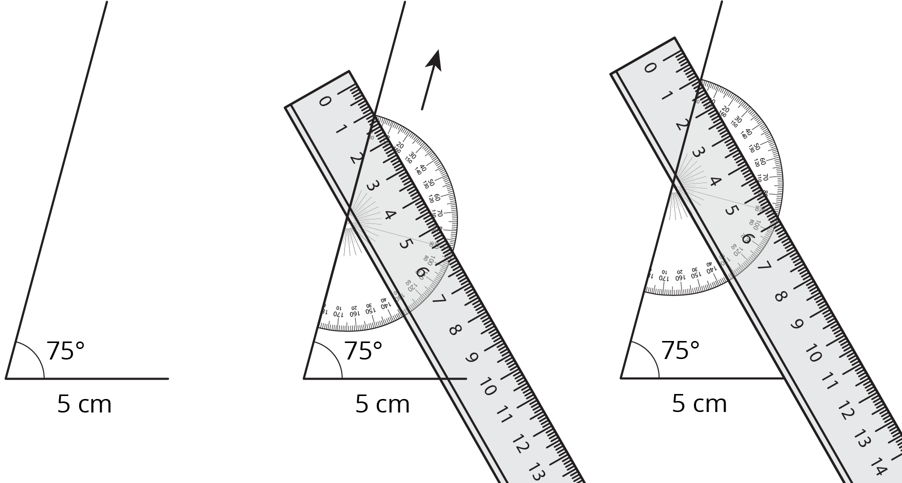

3 How Many Can You Draw?

Student Task Statement
- Draw as many different triangles as you can with each of these sets of measurements:
  - Two angles measure ${60}^{∘}$, and one side measures 4 cm.
  - Two angles measure ${90}^{∘}$, and one side measures 4 cm.
  - One angle measures ${60}^{∘}$, one angle measures ${90}^{∘}$, and one side measures 4 cm.
- Which of these sets of measurements determine one unique triangle? Explain or show your reasoning.
© CC BY Open Up Resources. Adaptations CC BY IM.

