Unit 7 Lesson 13: Decomposing Bases for Area

1 Are These Prisms? (Warm up)

Student Task Statement
- Which of these solids are prisms? Explain how you know.
- 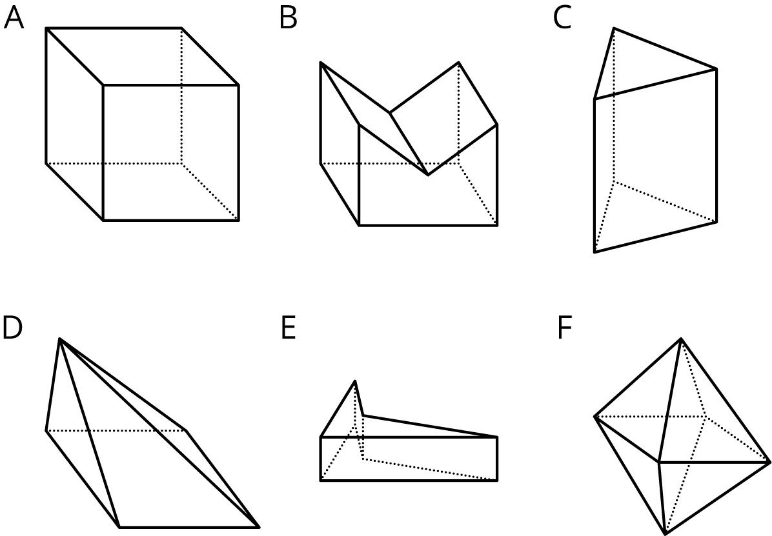
- For each of the prisms, what does the base look like?
  - Shade one base in the picture.
  - Draw a cross section of the prism parallel to the base.

2 A Box of Chocolates

Images for Launch
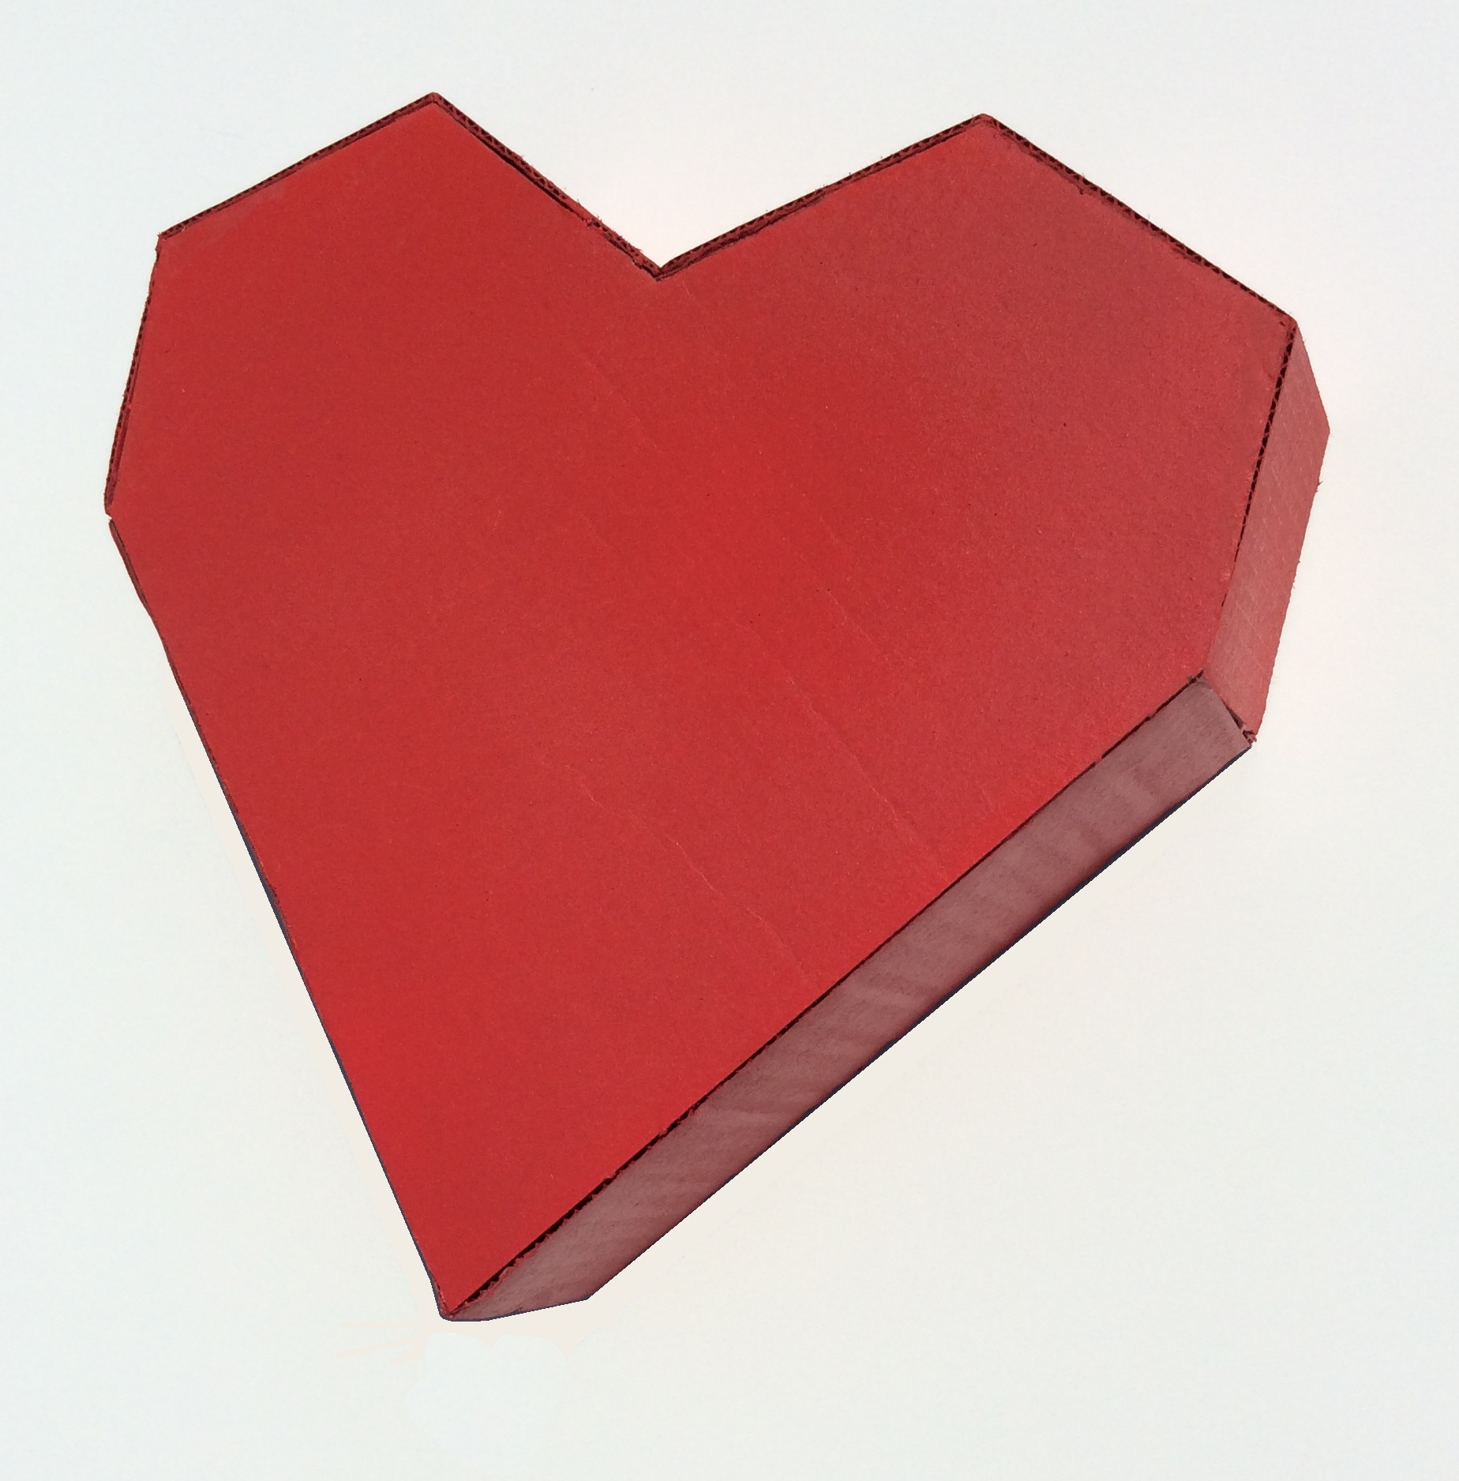

Student Task Statement
A box of chocolates is a prism with a base in the shape of a heart and a height of 2 inches. Here are the measurements of the base.
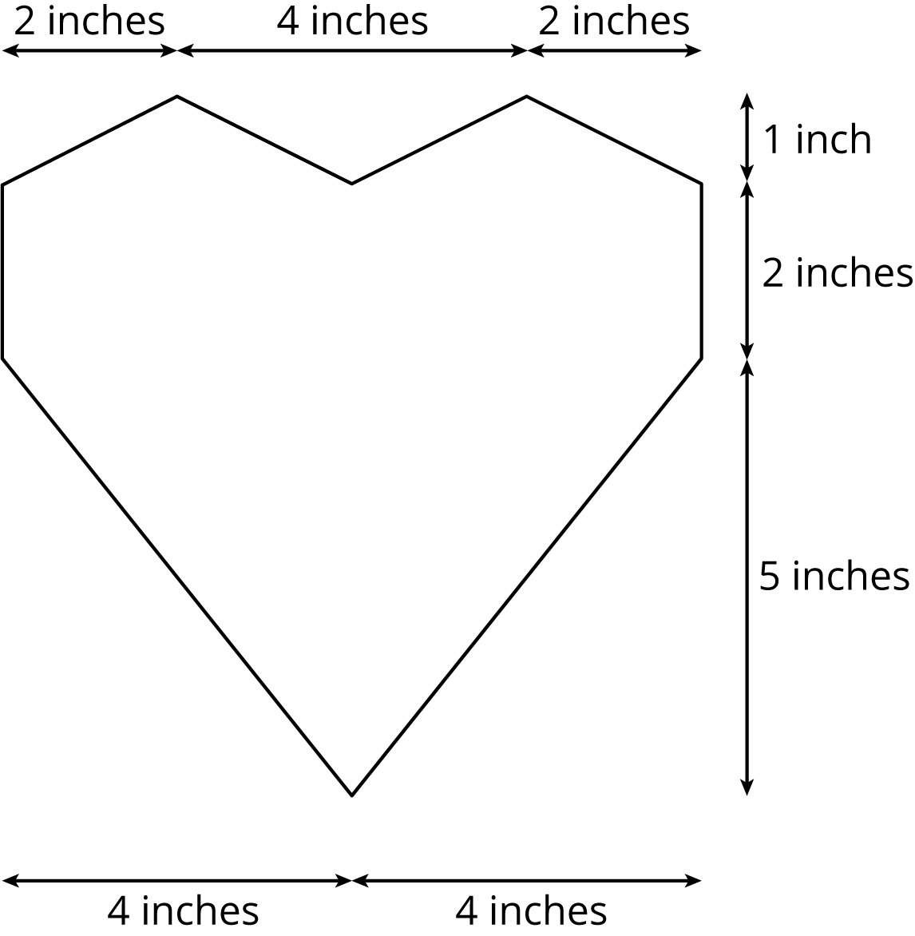
To calculate the volume of the box, three different students have each drawn line segments showing how they plan on finding the area of the heart-shaped base.
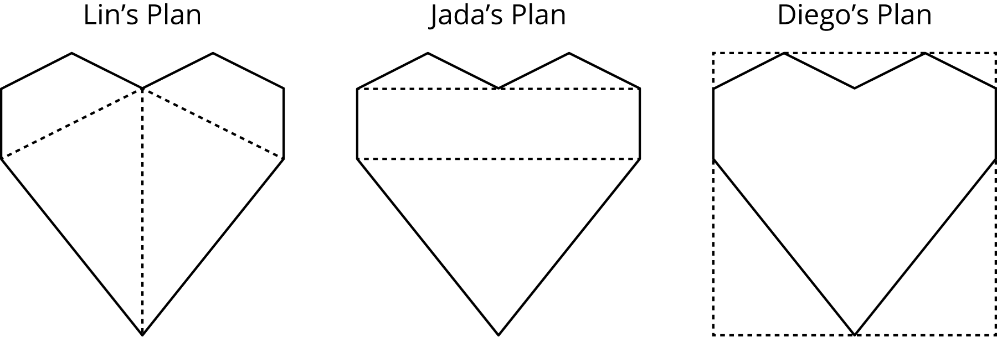
- For each student’s plan, describe the shapes the student must find the area of and the operations they must use to calculate the total area.
- Although all three methods could work, one of them requires measurements that are not provided. Which one is it?
- Between you and your partner, decide which of you will use which of the remaining two methods.
- Using the quadrilaterals and triangles drawn in your selected plan, find the area of the base.
- Trade with a partner and check each other’s work. If you disagree, work to reach an agreement.
- Return their work. Calculate the volume of the box of chocolates.

3 Another Prism

Student Task Statement
A house-shaped prism is created by attaching a triangular prism on top of a rectangular prism.
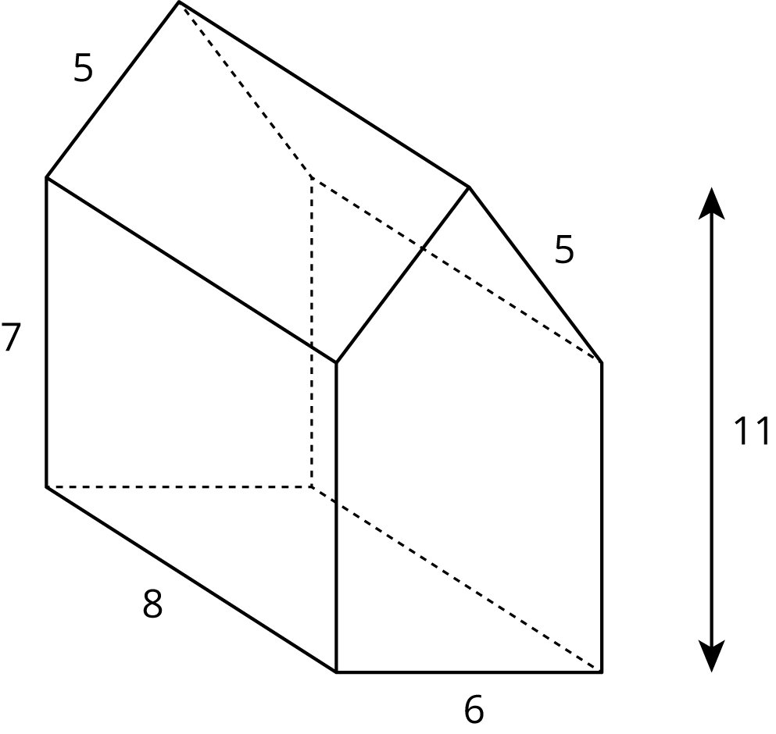
- Draw the base of this prism and label its dimensions.
- What is the area of the base? Explain or show your reasoning.
- What is the volume of the prism?
© CC BY Open Up Resources. Adaptations CC BY IM.

