Unit 7 Lesson 14: Surface Area of Right Prisms

1 Multifaceted (Warm up)

Student Task Statement
Your teacher will show you a prism.
- What are some things you could measure about the object?
- What units would you use for these measurements?

2 So Many Faces

Student Task Statement
Here is a picture of your teacher's prism:
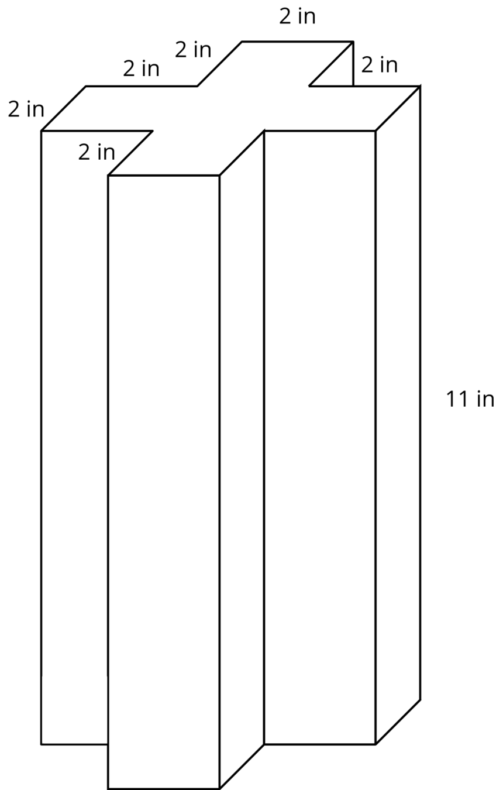
Three students are trying to calculate the surface area of this prism.
- Noah says, “This is going to be a lot of work. We have to find the areas of 14 different faces and add them up.”
- Elena says, “It’s not so bad. All 12 rectangles are identical copies, so we can find the area for one of them, multiply that by 12 and then add on the areas of the 2 bases.”
- Andre says, “Wait, I see another way! Imagine unfolding the prism into a net. We can use 1 large rectangle instead of 12 smaller ones.”
- Do you agree with any of them? Explain your reasoning.
- How big is the “1 large rectangle” Andre is talking about? Explain or show your reasoning. If you get stuck, consider drawing a net for the prism.
- Will Noah’s method always work for finding the surface area of any prism? Elena’s method? Andre’s method? Be prepared to explain your reasoning.
- Which method do you prefer? Why?

Activity Synthesis
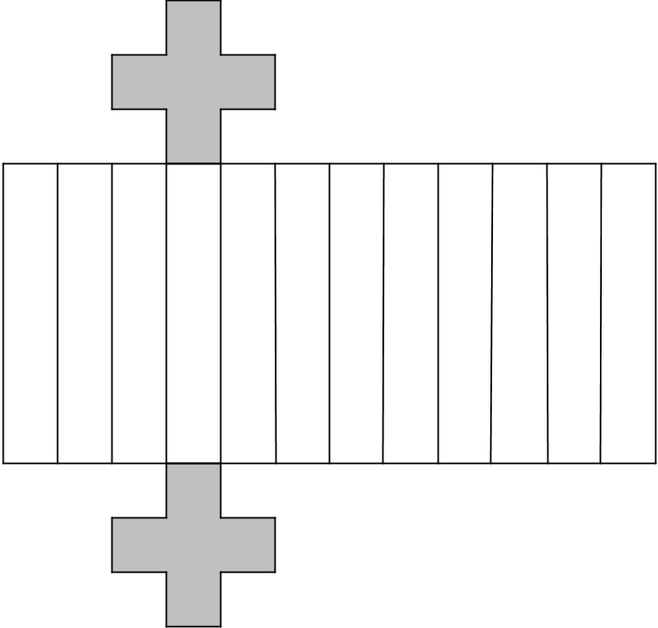

3 Revisiting a Pentagonal Prism

Student Task Statement
- Between you and your partner, choose who will use each of these two methods to find the surface area of the prism.
  - Adding the areas of all the faces
  - Using the perimeter of the base.
- Use your chosen method to calculate the surface area of the prism. Show your thinking. Organize it so it can be followed by others.
- 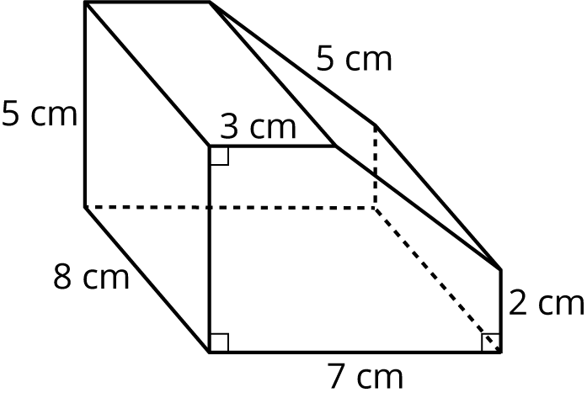

- Trade papers with your partner, and check their work. Discuss your thinking. If you disagree, work to reach an agreement.
© CC BY Open Up Resources. Adaptations CC BY IM.

