Lesson 1: Lots of Flags
Let’s explore the U.S. flag.

1.1: Scaled or Not?
- Which of the geometric objects are scaled versions of each other?
- 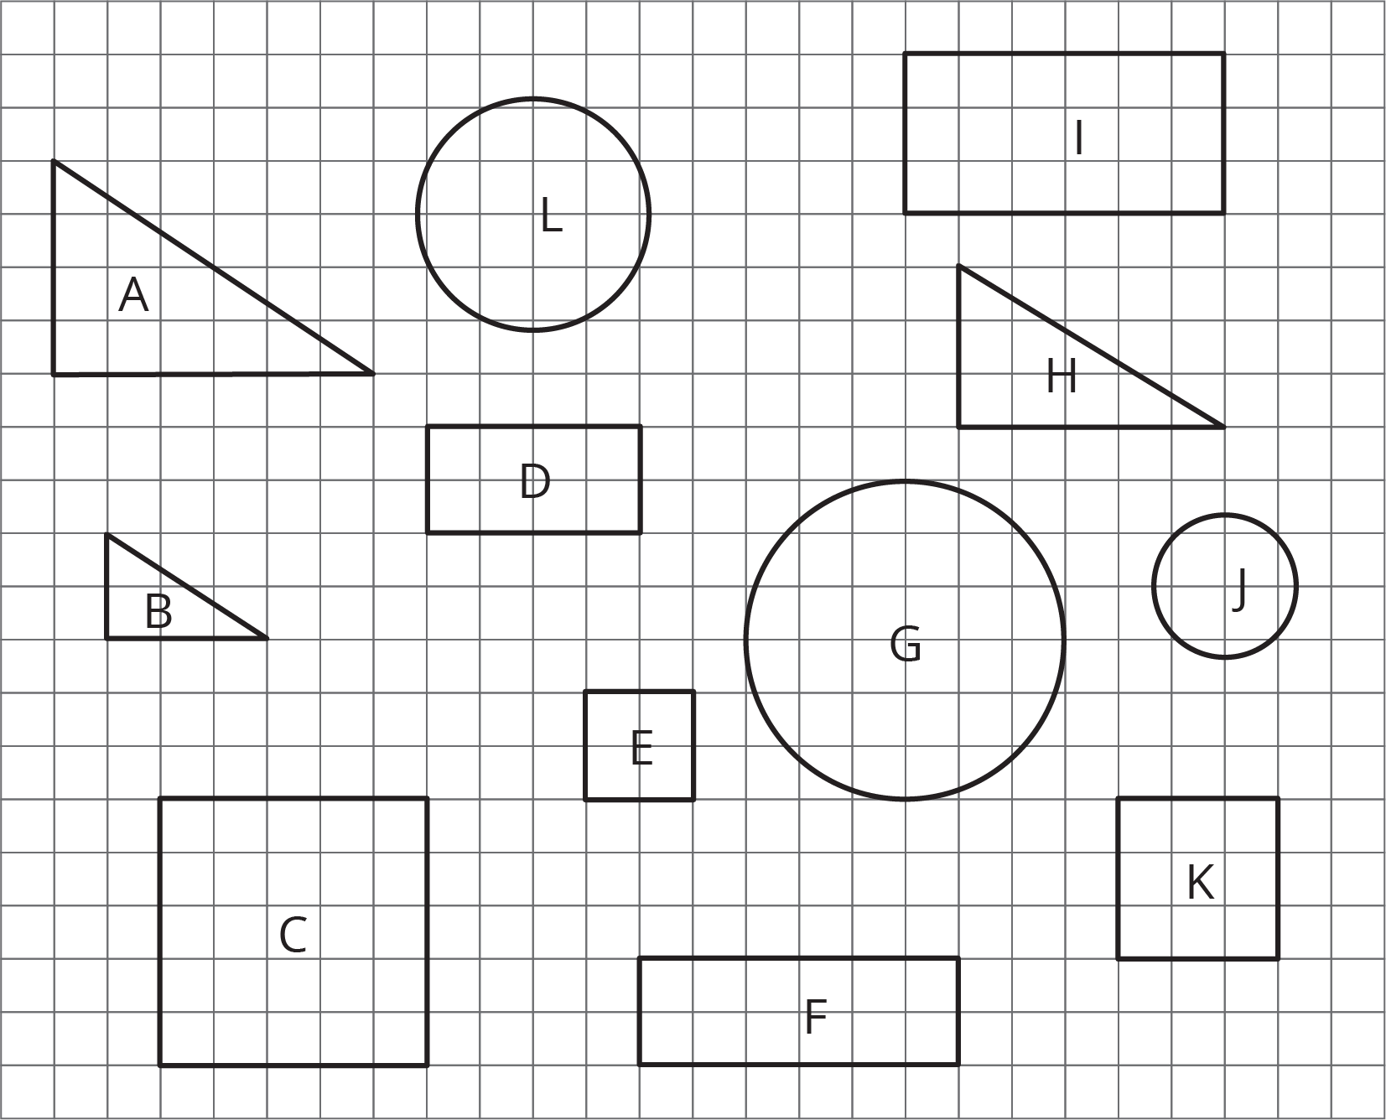
- Pick two of the objects that are scaled copies and find the scale factor.

1.2: Flags Are Many Sizes
One standard size for the United States flag is 19 feet by 10 feet. On a flag of this size, the union (the blue rectangle in the top-left corner) is $7\frac{5}{8}$ feet by $5\frac{3}{8}$ feet.
There are many places that display flags of different sizes.
- Many classrooms display a U.S. flag.
- Flags are often displayed on stamps.
- There was a flag on the space shuttle.
- Astronauts on the Apollo missions had a flag on a shoulder patch.
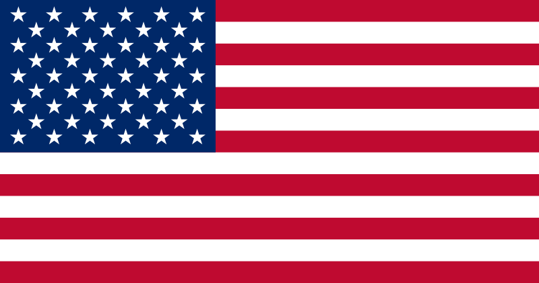
- Choose one of the four options and decide on a size that would be appropriate for this flag. Find the size of the union.
- Share your answer with another group that used a different option. What do your dimensions have in common?

1.3: What Percentage Is the Union?
On a U.S. flag that is 19 feet by 10 feet, the union is $7\frac{5}{8}$ feet by $5\frac{3}{8}$ feet. For each question, first estimate the answer and then compute the actual percentage.
- What percentage of the flag is taken up by the union?
- What percentage of the flag is red? Be prepared to share your reasoning.

Are you ready for more?
The largest U.S. flag in the world is 225 feet by 505 feet.
- Is the ratio of the length to the width equivalent to $1:1.9$, the ratio for official government flags?
- If a square yard of the flag weighs about 3.8 ounces, how much does the entire flag weigh in pounds?

Lesson 1 Summary
Imagine you have a painting that is 15 feet wide and 5 feet high. To sketch a scaled copy of the painting, the ratio of the width and height of a scaled copy must be equivalent to $15:5$. What is the height of a scaled copy that is 2 feet across?
width | height
15 | 5
2 | $h$
We know that the height is $\frac{1}{3}$ the width, so $h=\frac{1}{3}⋅2$ or $\frac{2}{3}$.
Sometimes ratios include fractions and decimals. We will be working with these kinds of ratios in the next few lessons.
© CC BY Open Up Resources. Adaptations CC BY IM.

