Lesson 4 Practice Problems
- Select all of the parallelograms. For each figure that is not selected, explain how you know it is not a parallelogram.
- 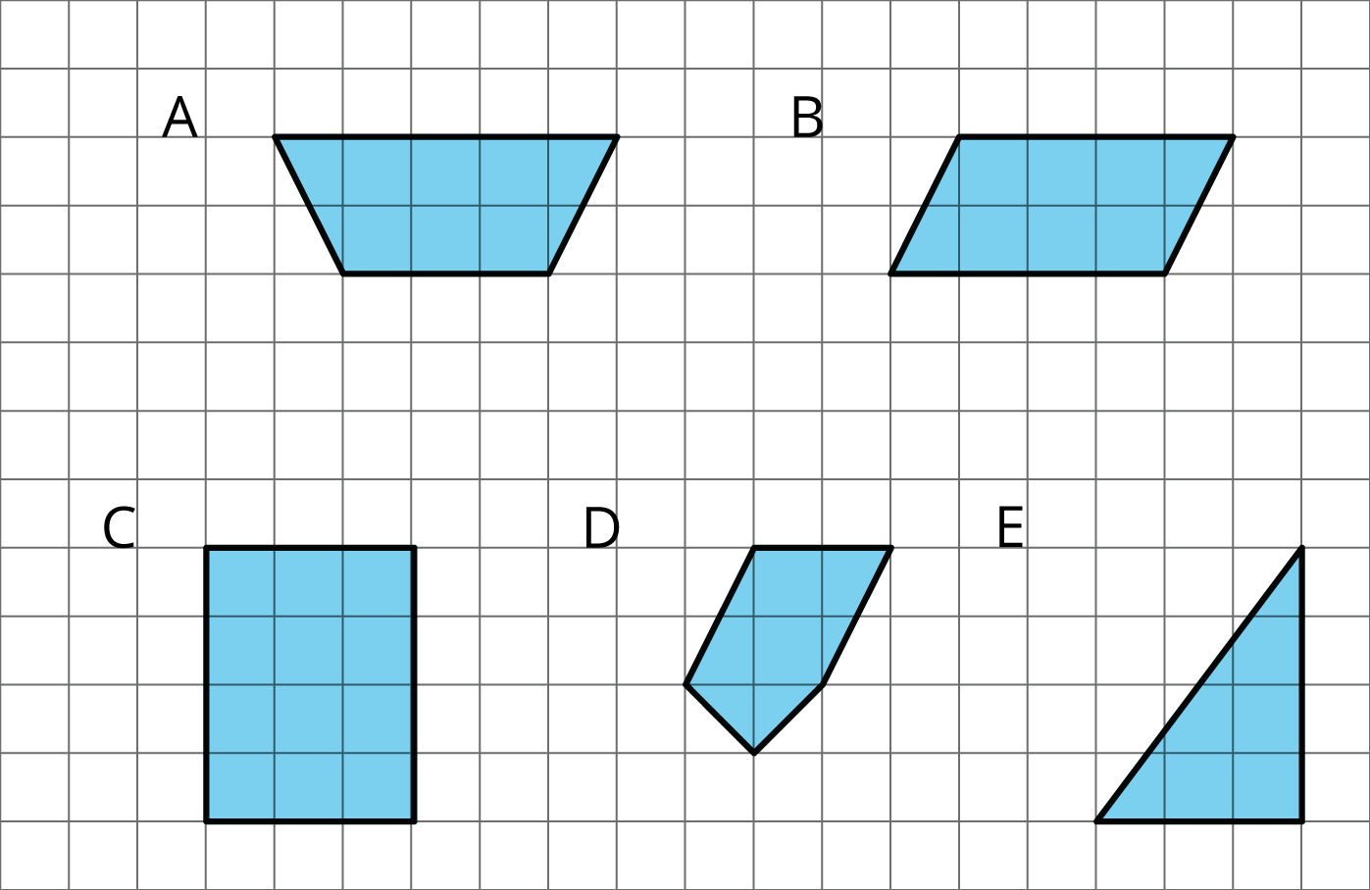

  - Decompose and rearrange this parallelogram to make a rectangle.
  - 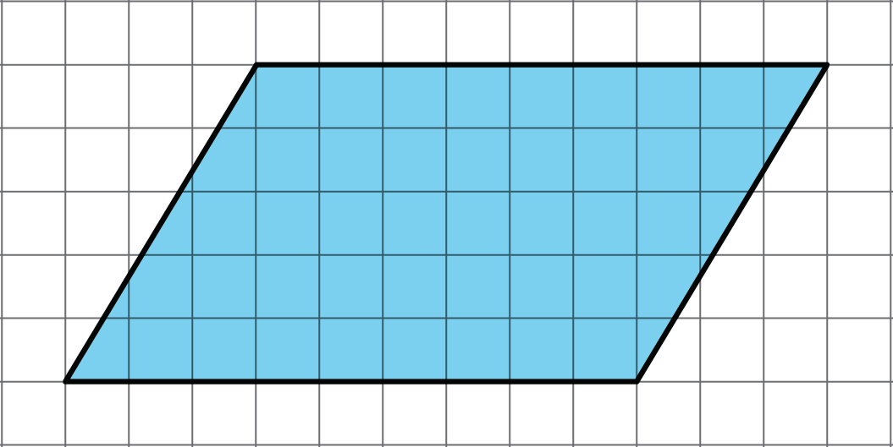
  - What is the area of the parallelogram? Explain your reasoning.
- Find the area of the parallelogram.
- 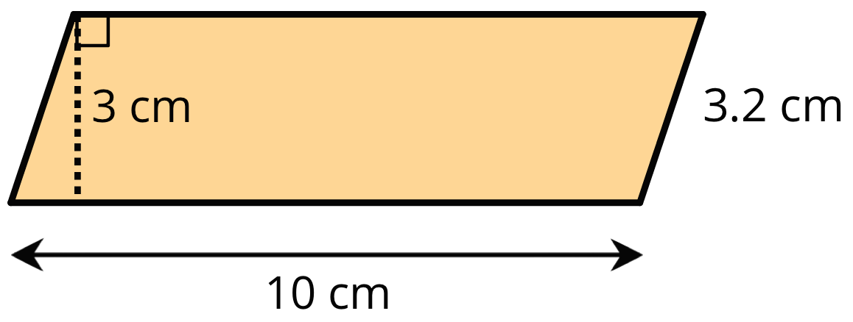

- Explain why this quadrilateral is not a parallelogram.
- 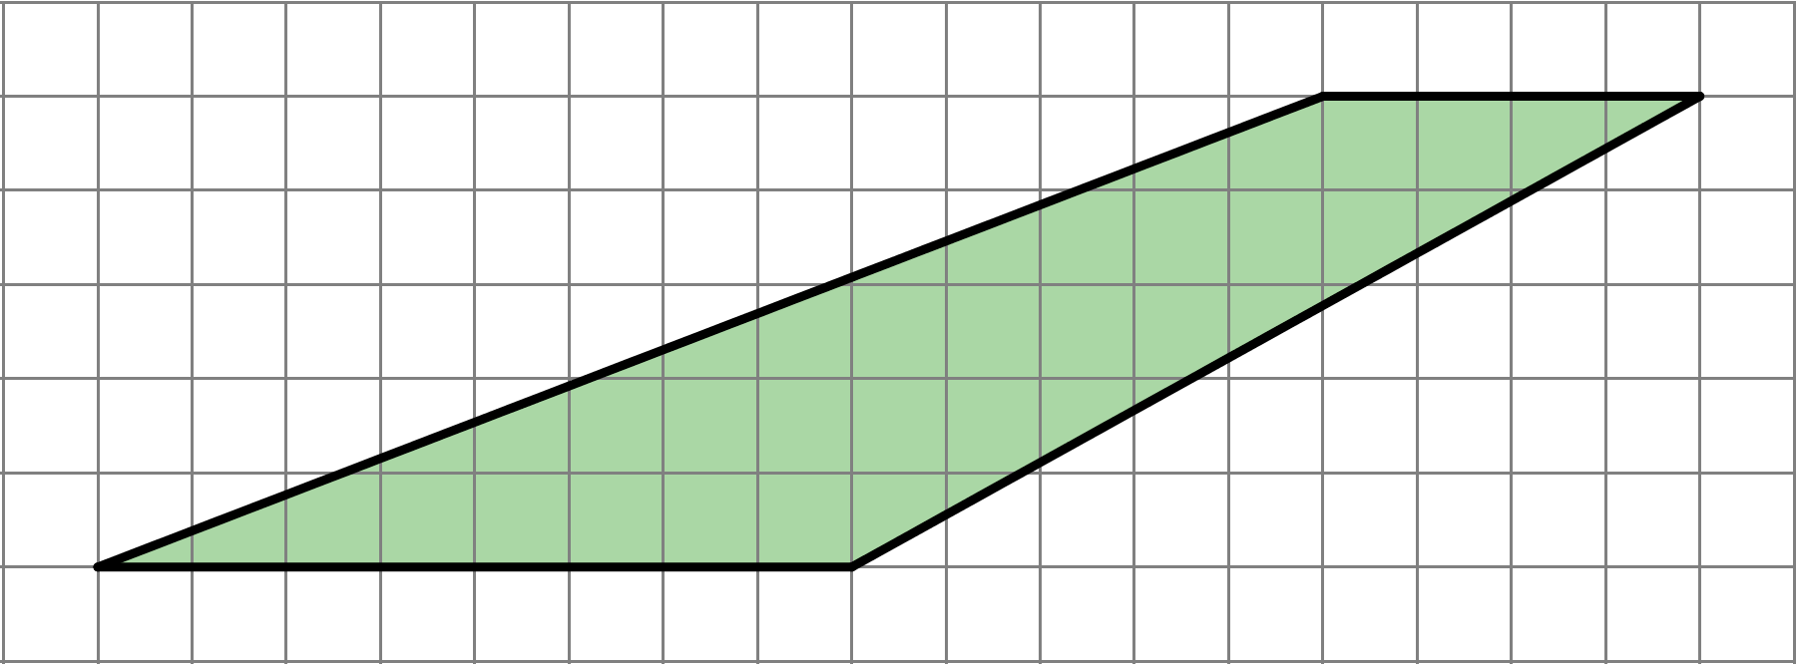

- Find the area of each shape. Show your reasoning.
- 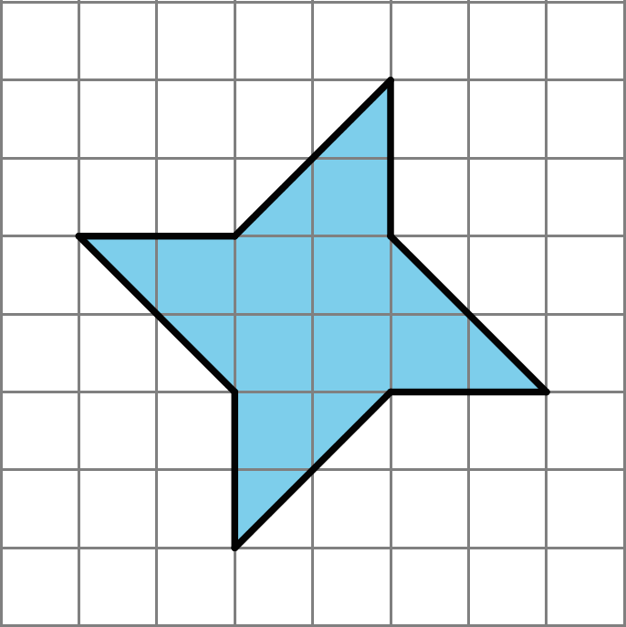
- 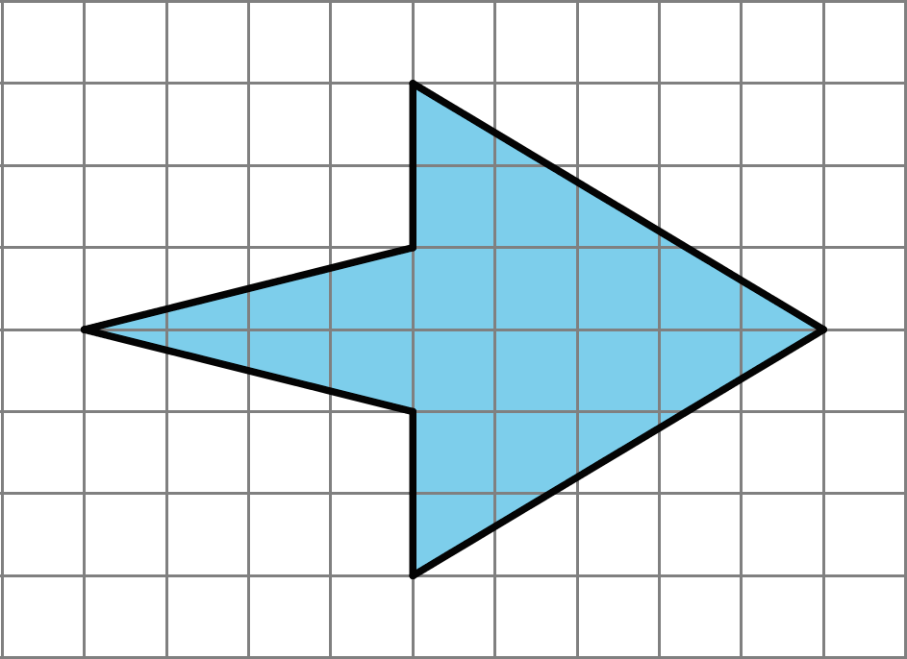

- (From Unit 1, Lesson 3.)
- Find the area of the rectangle with each set of side lengths.
  - 5 in and $\frac{1}{3}$ in
  - 5 in and $\frac{4}{3}$ in
  - $\frac{5}{2}$ in and $\frac{4}{3}$ in
  - $\frac{7}{6}$ in and $\frac{6}{7}$ in
- (From Unit 1, Lesson 1.)
© CC BY Open Up Resources. Adaptations CC BY IM.

