Lesson 4: How Many Groups? (Part 1)
Let’s play with blocks and diagrams to think about division with fractions.

4.1: Equal-sized Groups
Write a multiplication equation and a division equation for each sentence or diagram.
- Eight $5 bills are worth $40.
- There are 9 thirds in 3 ones.
- 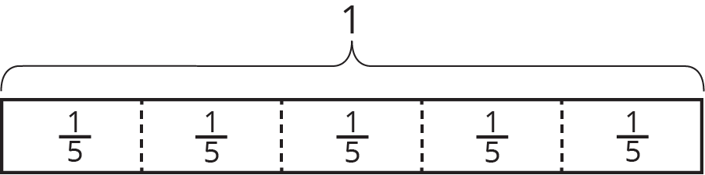

4.2: Reasoning with Pattern Blocks
Your teacher will give you pattern blocks as shown here. Use them to answer the questions.
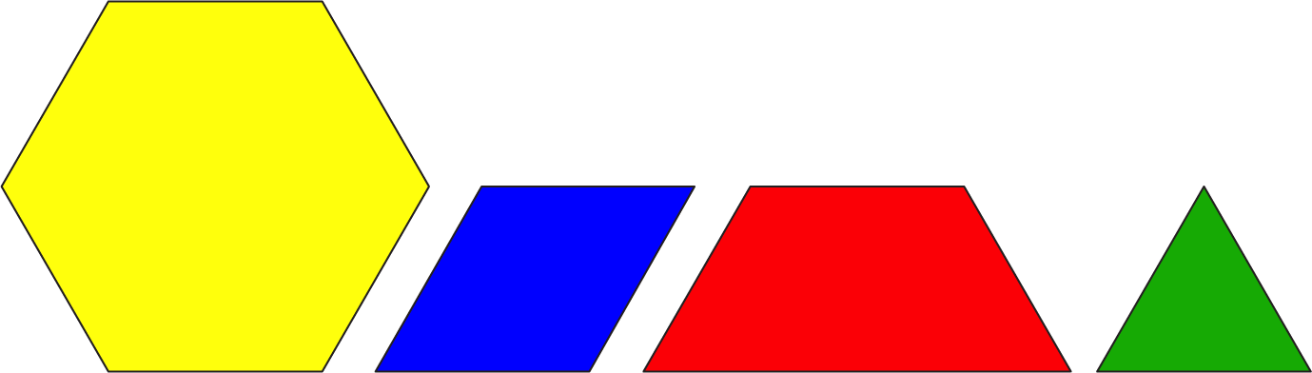
- If a hexagon represents 1 whole, what fraction does each of the following shapes represent? Be prepared to show or explain your reasoning.
  - 1 triangle
  - 1 rhombus
  - 1 trapezoid
  - 4 triangles
  - 3 rhombuses
  - 2 hexagons
  - 1 hexagon and 1 trapezoid
- Here are Elena’s diagrams for $2⋅\frac{1}{2}=1$ and $6⋅\frac{1}{3}=2$. Do you think these diagrams represent the equations? Explain or show your reasoning.
- 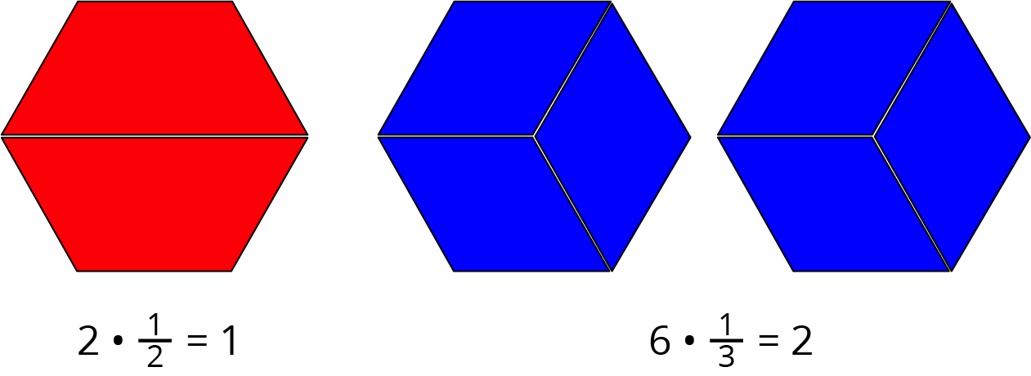
- Use pattern blocks to represent each multiplication equation. Remember that a hexagon represents 1 whole.
  - $3⋅\frac{1}{6}=\frac{1}{2}$
  - $2⋅\frac{3}{2}=3$
- Answer the questions. If you get stuck, consider using pattern blocks.
  - How many $\frac{1}{2}$s are in 4?
  - How many $\frac{2}{3}$s are in 2?
  - How many $\frac{1}{6}$s are in $1\frac{1}{2}$?

Lesson 4 Summary
Some problems that involve equal-sized groups also involve fractions. Here is an example: “How many $\frac{1}{6}$ are in 2?” We can express this question with multiplication and division equations. $?⋅\frac{1}{6}=2$ $2÷\frac{1}{6}=?$
Pattern-block diagrams can help us make sense of such problems. Here is a set of pattern blocks.
If the hexagon represents 1 whole, then a triangle must represent $\frac{1}{6}$, because 6 triangles make 1 hexagon. We can use the triangle to represent the $\frac{1}{6}$ in the problem.
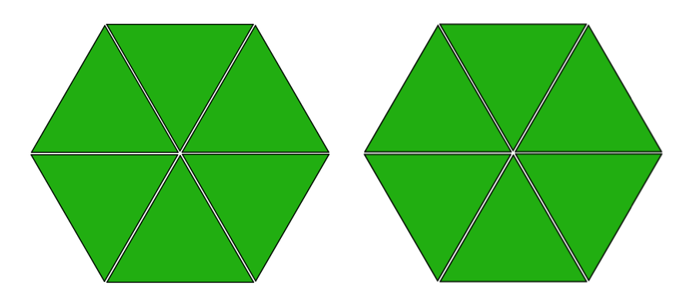
Twelve triangles make 2 hexagons, which means there are 12 groups of $\frac{1}{6}$ in 2.
If we write the 12 in the place of the “?” in the original equations, we have: $12⋅\frac{1}{6}=2$
$2÷\frac{1}{6}=12$
© CC BY Open Up Resources. Adaptations CC BY IM.

