Lesson 5 Practice Problems
- Write a positive or negative number to represent each change in the high temperature.
  - Tuesday’s high temperature was 4 degrees less than Monday’s high temperature.
  - Wednesday’s high temperature was 3.5 degrees less than Tuesday’s high temperature.
  - Thursday’s high temperature was 6.5 degrees more than Wednesday’s high temperature.
  - Friday’s high temperature was 2 degrees less than Thursday’s high temperature.
- Decide which of the following quantities can be represented by a positive number and which can be represented by a negative number. Give an example of a quantity with the opposite sign in the same situation.
  - Tyler’s puppy gained 5 pounds.
  - The aquarium leaked 2 gallons of water.
  - Andre received a gift of $10.
  - Kiran gave a gift of $10.
  - A climber descended 550 feet.
- Make up a situation where a quantity is changing.
  - Explain what it means to have a negative change.
  - Explain what it means to have a positive change.
  - Give an example of each.

  - On the number line, label the points that are 4 units away from 0.
  - 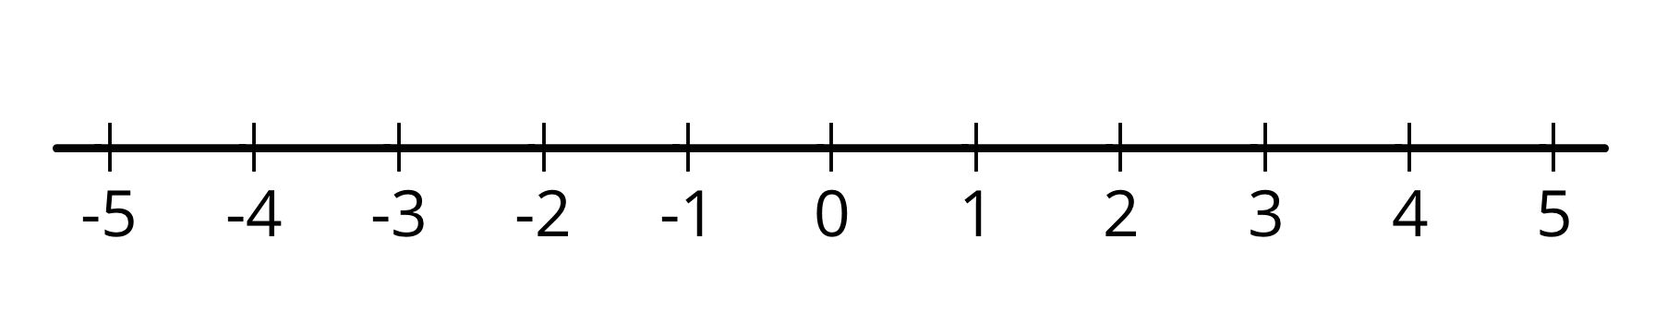
  - If you fold the number line so that a vertical crease goes through 0, the points you label would match up. Explain why this happens.
  - On the number line, label the points that are $\frac{5}{2}$ units from 0. What is the distance between these points?
- (From Unit 7, Lesson 2.)
- Evaluate each expression.
  - $2^{3}⋅3$
  - $\frac{4^{2}}{2}$
  - $3^{1}$
  - $6^{2}÷4$
  - $2^{3}−2$
  - ${10}^{2}+5^{2}$
- (From Unit 6, Lesson 12.)
© CC BY Open Up Resources. Adaptations CC BY IM.

