Lesson 13 Practice Problems
- Here is data that shows a student's scores for 10 rounds of a video game.
- 130
- 150
- 120
- 170
- 130
- 120
- 160
- 160
- 190
- 140
- What is the median score?
  - 125
  - 145
  - 147
  - 150
- When he sorts the class’s scores on the last test, the teacher notices that exactly 12 students scored better than Clare and exactly 12 students scored worse than Clare. Does this mean that Clare’s score on the test is the median? Explain your reasoning.
- The medians of the following dot plots are 6, 12, 13, and 15, but not in that order. Match each dot plot with its median.
- 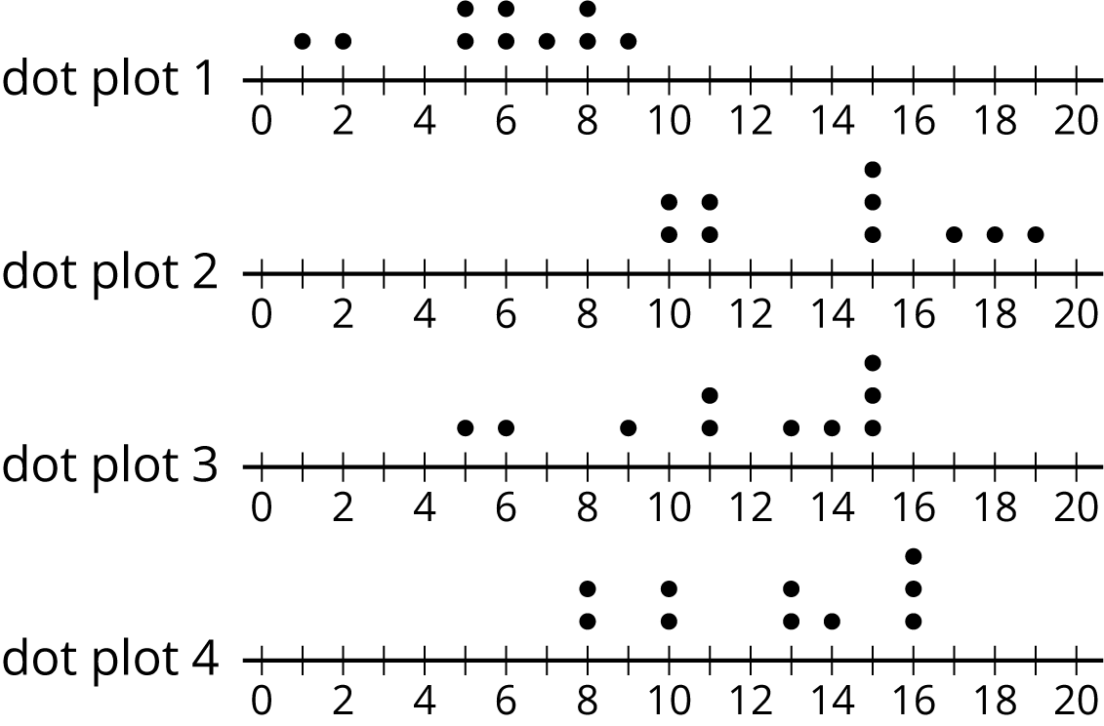
- Invent a data set with five numbers that has a mean of 10 and a median of 12.
- Ten sixth-grade students reported the hours of sleep they get on nights before a school day. Their responses are recorded in the dot plot.
- 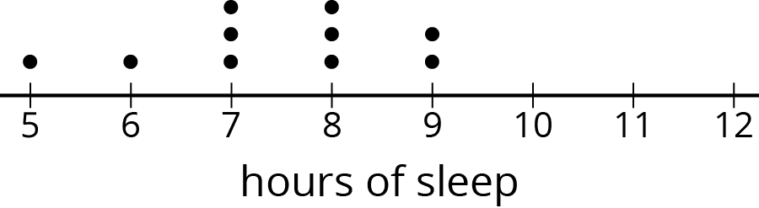
- Looking at the dot plot, Lin estimated the mean number of hours of sleep to be 8.5 hours. Noah's estimate was 7.5 hours. Diego's estimate was 6.5 hours.
- Which estimate do you think is best? Explain how you know.
- (From Unit 8, Lesson 10.)
- In one study of wild bears, researchers measured the weights, in pounds, of 143 wild bears that ranged in age from newborn to 15 years old. The data were used to make this histogram.
  - What can you say about the heaviest bear in this group?
  - What is a typical weight for the bears in this group?
  - Do more than half of the bears in this group weigh less than 250 pounds?
  - If weight is related to age, with older bears tending to have greater body weights, would you say that there were more old bears or more young bears in the group? Explain your reasoning.
- 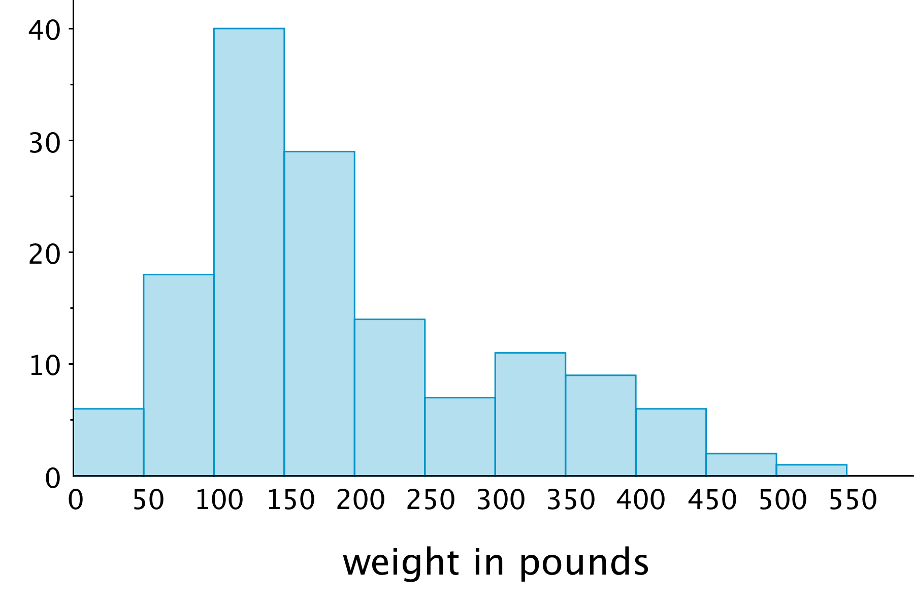
- (From Unit 8, Lesson 8.)
© CC BY Open Up Resources. Adaptations CC BY IM.

