Lesson 5 Practice Problems
- Select all parallelograms that have a correct height labeled for the given base.
- 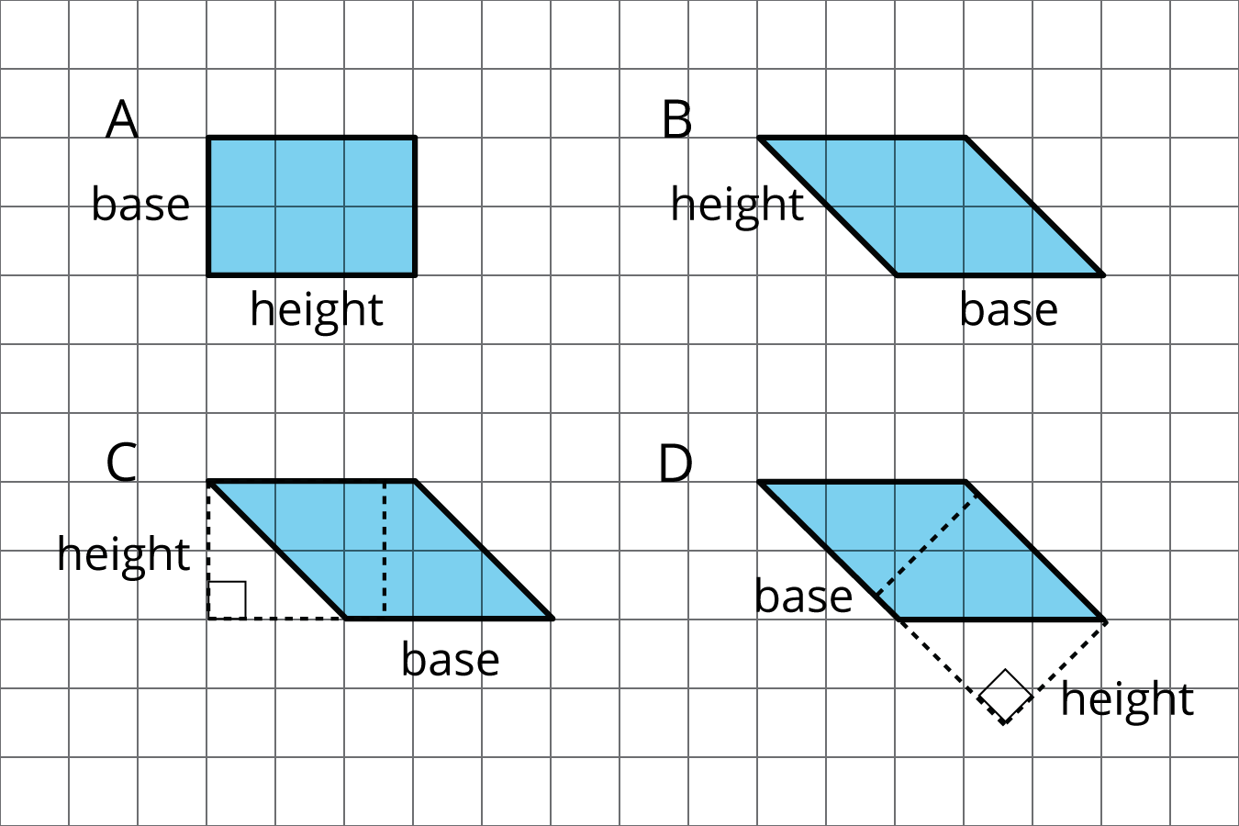
  - A
  - B
  - C
  - D
- The side labeled $b$ has been chosen as the base for this parallelogram.
- 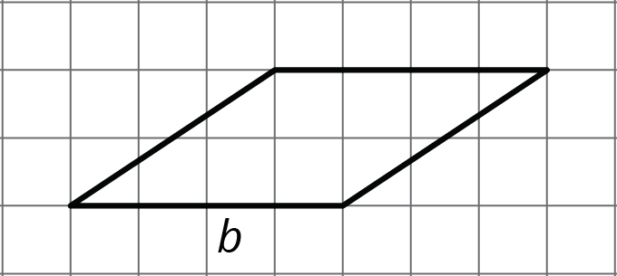
- Draw a segment showing the height corresponding to that base.
- Find the area of each parallelogram.
- 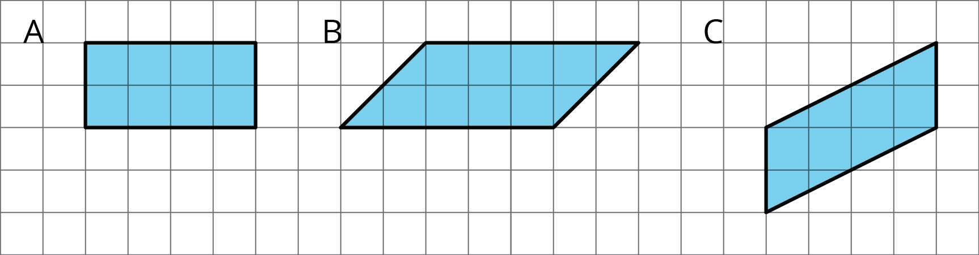
- If the side that is 6 units long is the base of this parallelogram, what is its corresponding height?
- 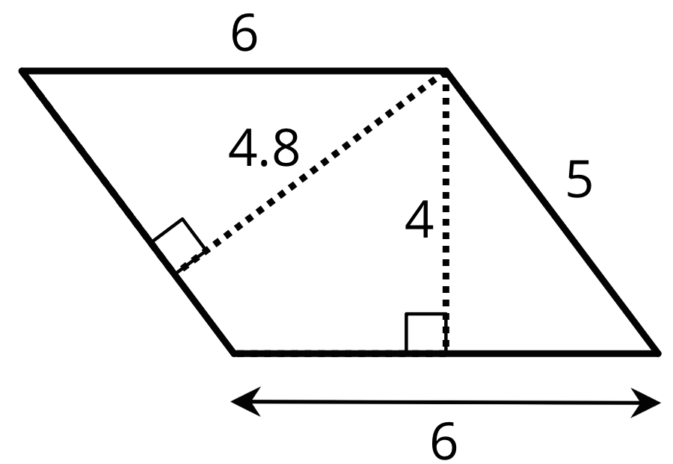
  - 6 units
  - 4.8 units
  - 4 units
  - 5 units
- Find the area of each parallelogram.
- 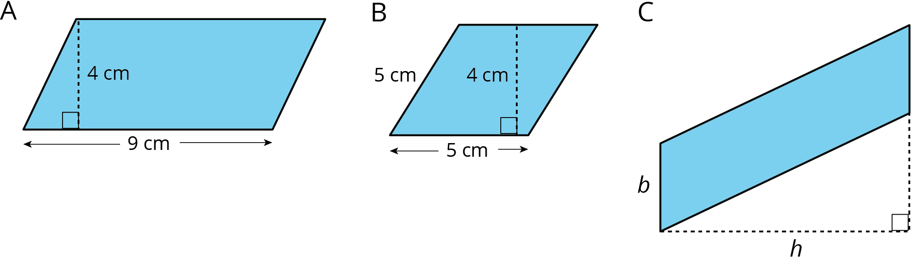

- Do you agree with each of these statements? Explain your reasoning.
  - A parallelogram has six sides.
  - Opposite sides of a parallelogram are parallel.
  - A parallelogram can have one pair or two pairs of parallel sides.
  - All sides of a parallelogram have the same length.
  - All angles of a parallelogram have the same measure.
- (From Unit 1, Lesson 4.)
- A square with an area of 1 square meter is decomposed into 9 identical small squares. Each small square is decomposed into two identical triangles.
  - What is the area, in square meters, of 6 triangles? If you get stuck, consider drawing a diagram.
  - How many triangles are needed to compose a region that is $1\frac{1}{2}$ square meters?
- (From Unit 1, Lesson 2.)
© CC BY Open Up Resources. Adaptations CC BY IM.

