Lesson 6 Practice Problems
- Which three of these parallelograms have the same area as each other?
- 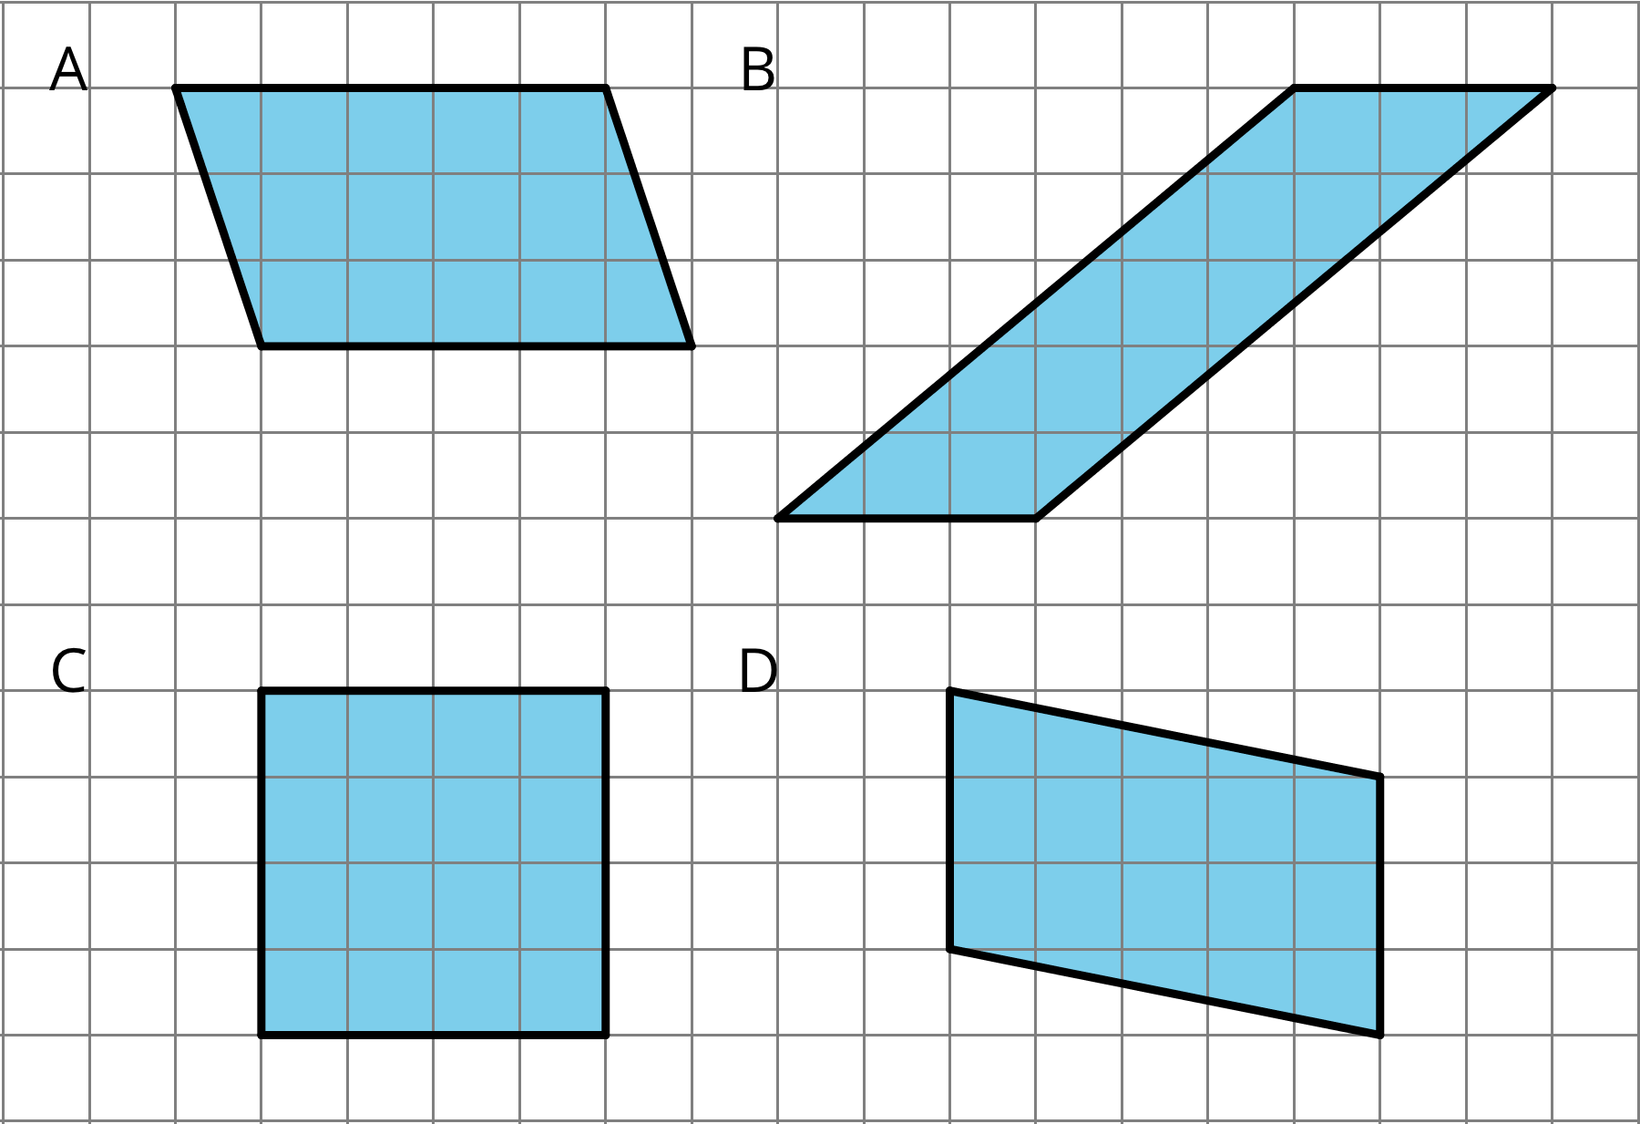
  - A
  - B
  - C
  - D
- Which pair of base and height produces the greatest area? All measurements are in centimeters.
  - $b=4$, $h=3.5$
  - $b=0.8$, $h=20$
  - $b=6$, $h=2.25$
  - $b=10$, $h=1.4$
- Here are the areas of three parallelograms. Use them to find the missing length (labeled with a "?") on each parallelogram.
- A: 10 square units
- B: 21 square units
- C: 25 square units
- 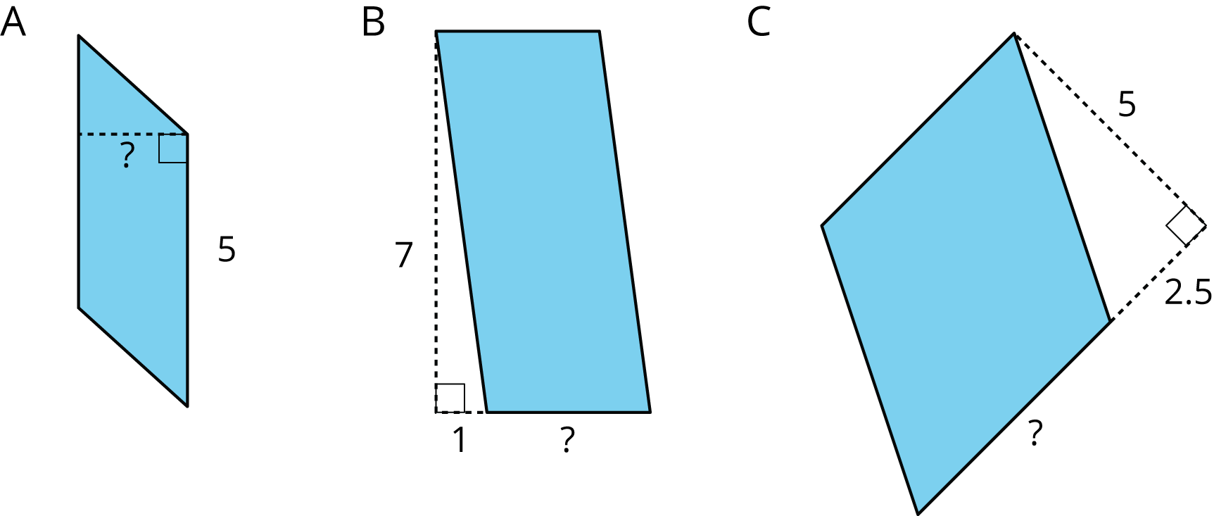

- The Dockland Building in Hamburg, Germany is shaped like a parallelogram.
- 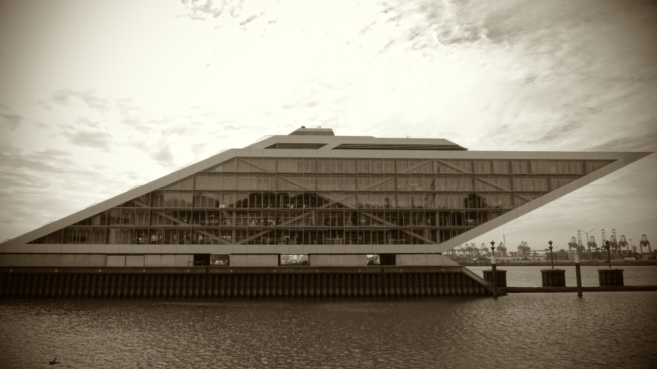
- If the length of the building is 86 meters and its height is 55 meters, what is the area of this face of the building?

- Select all segments that could represent a corresponding height if the side $m$ is the base.
- 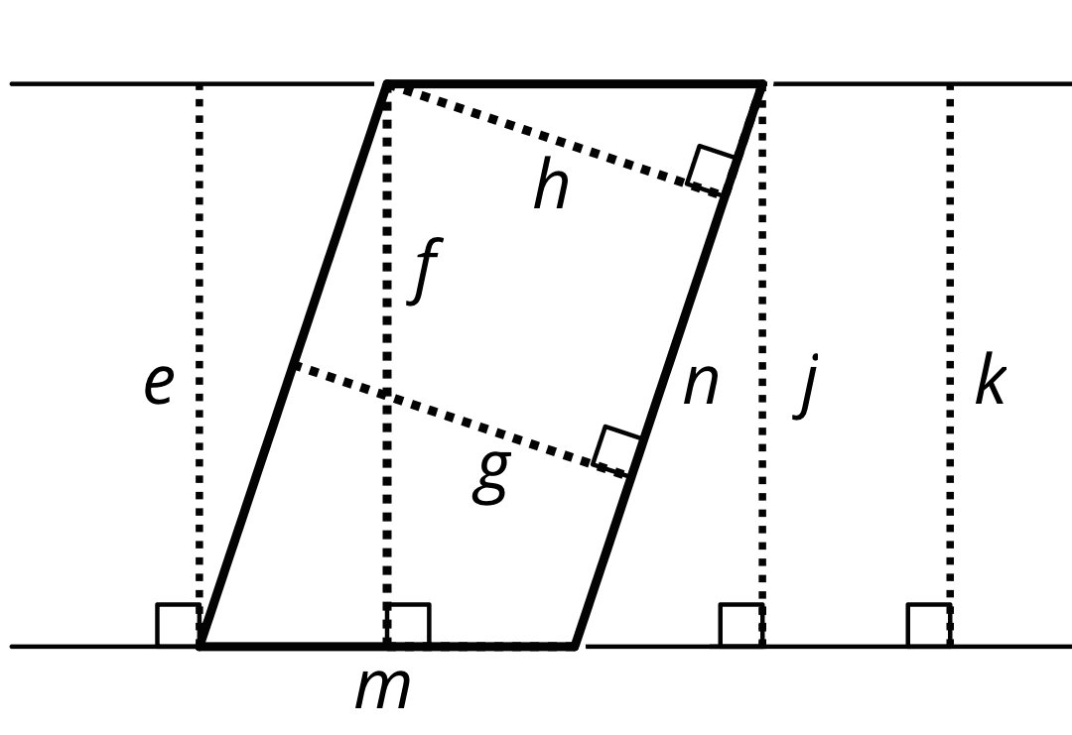
  - e
  - f
  - g
  - h
  - j
  - k
  - n
- (From Unit 1, Lesson 5.)
- Find the area of the shaded region. All measurements are in centimeters. Show your reasoning.
- 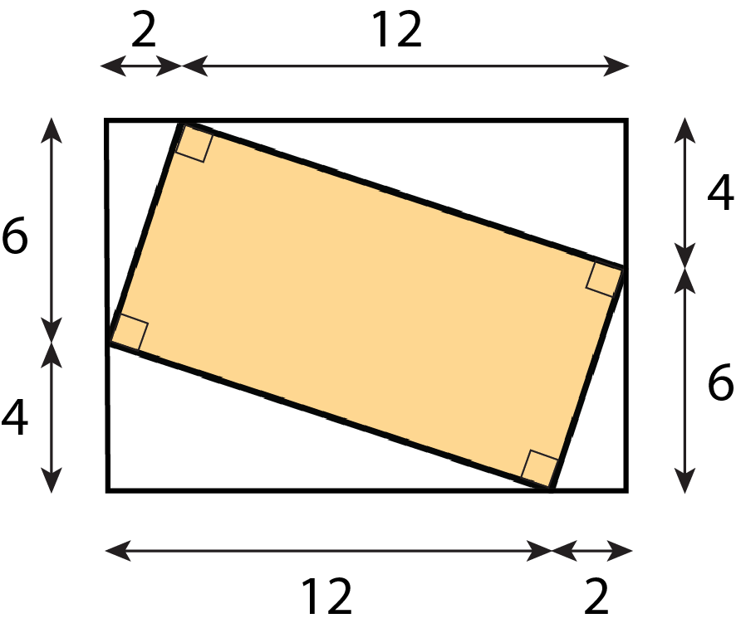
- (From Unit 1, Lesson 3.)
© CC BY Open Up Resources. Adaptations CC BY IM.

