Lesson 10 Practice Problems
- For each triangle, a base is labeled $b$. Draw a line segment that shows its corresponding height. Use an index card to help you draw a straight line.
- 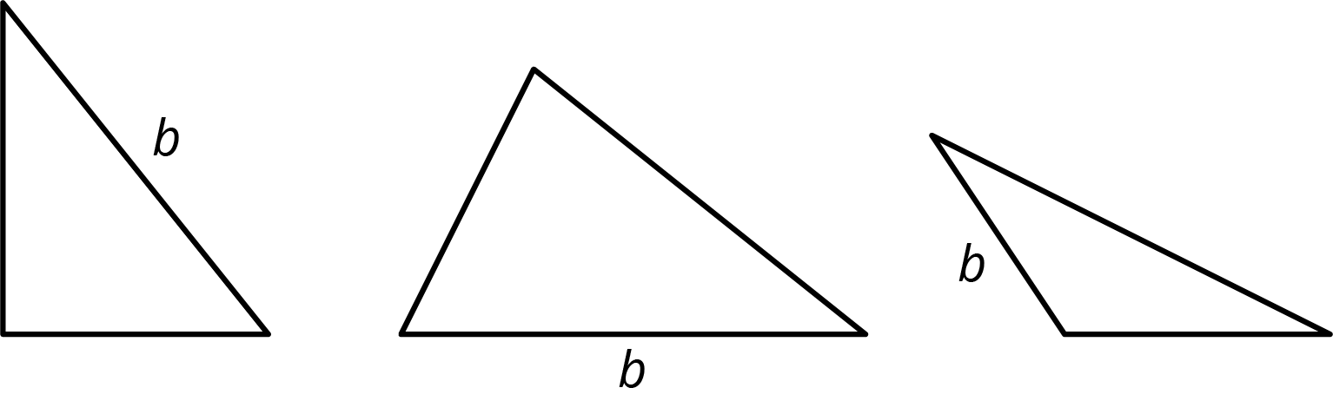
- Select all triangles that have an area of 8 square units. Explain how you know.
- 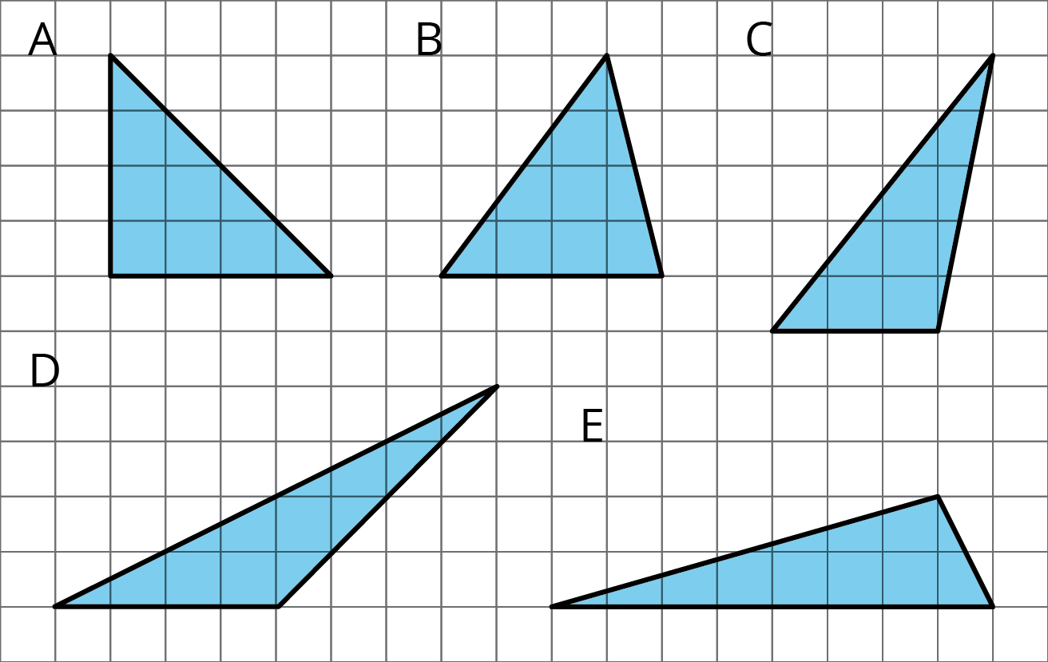
- Find the area of the triangle. Show your reasoning.
- 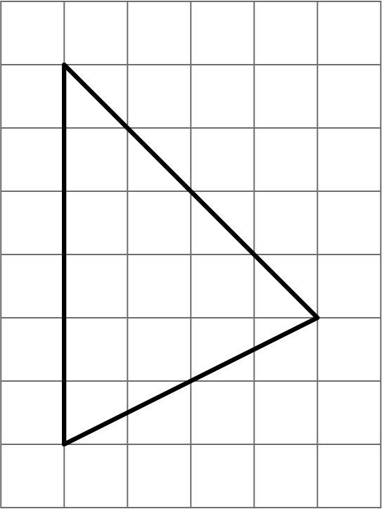
- If you get stuck, carefully consider which side of the triangle to use as the base.
- Can side $d$ be the base for this triangle? If so, which length would be the corresponding height? If not, explain why not.
- 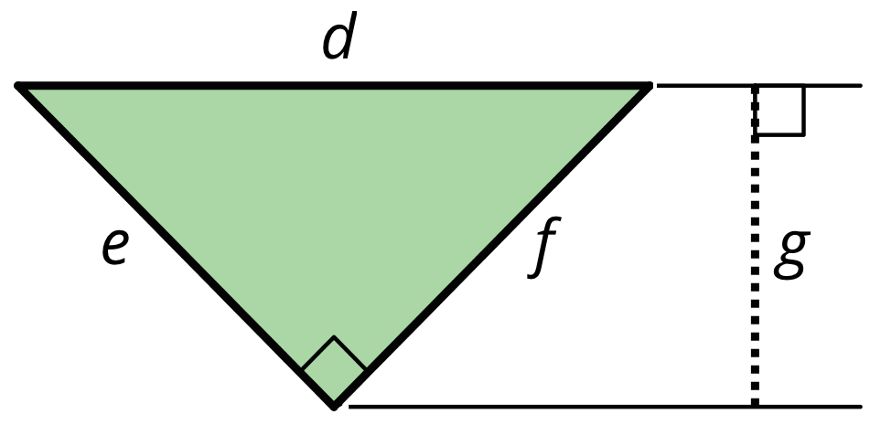

- Find the area of this shape. Show your reasoning.
- 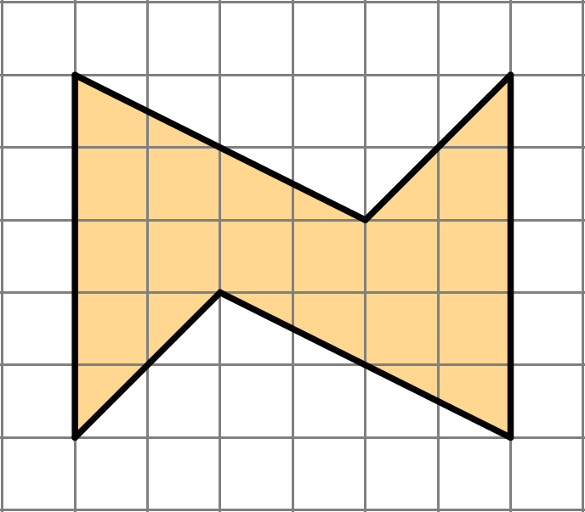
- (From Unit 1, Lesson 3.)
- On the grid, sketch two different parallelograms that have equal area. Label a base and height of each and explain how you know the areas are the same.
- (From Unit 1, Lesson 6.)
© CC BY Open Up Resources. Adaptations CC BY IM.

