Lesson 14 Practice Problems
- Can this net be assembled into a cube? Explain how you know. Label parts of the net with letters or numbers if it helps your explanation.

  - What polyhedron can be assembled from this net? Explain how you know.
  - 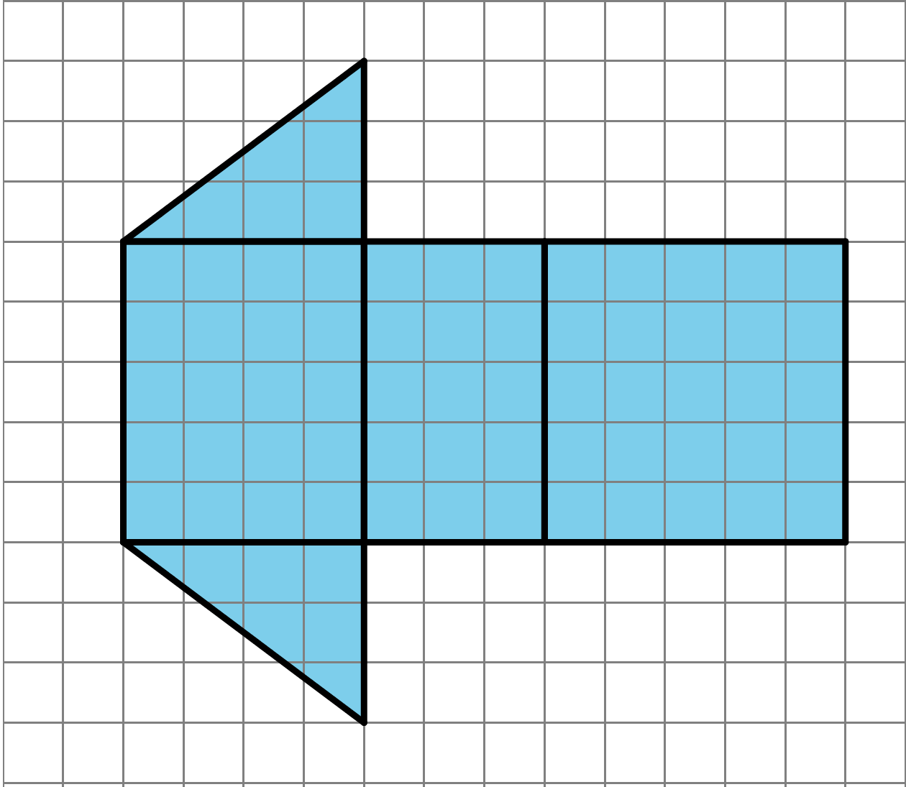
  - Find the surface area of this polyhedron. Show your reasoning.
- Here are two nets. Mai said that both nets can be assembled into the same triangular prism. Do you agree? Explain or show your reasoning.
- 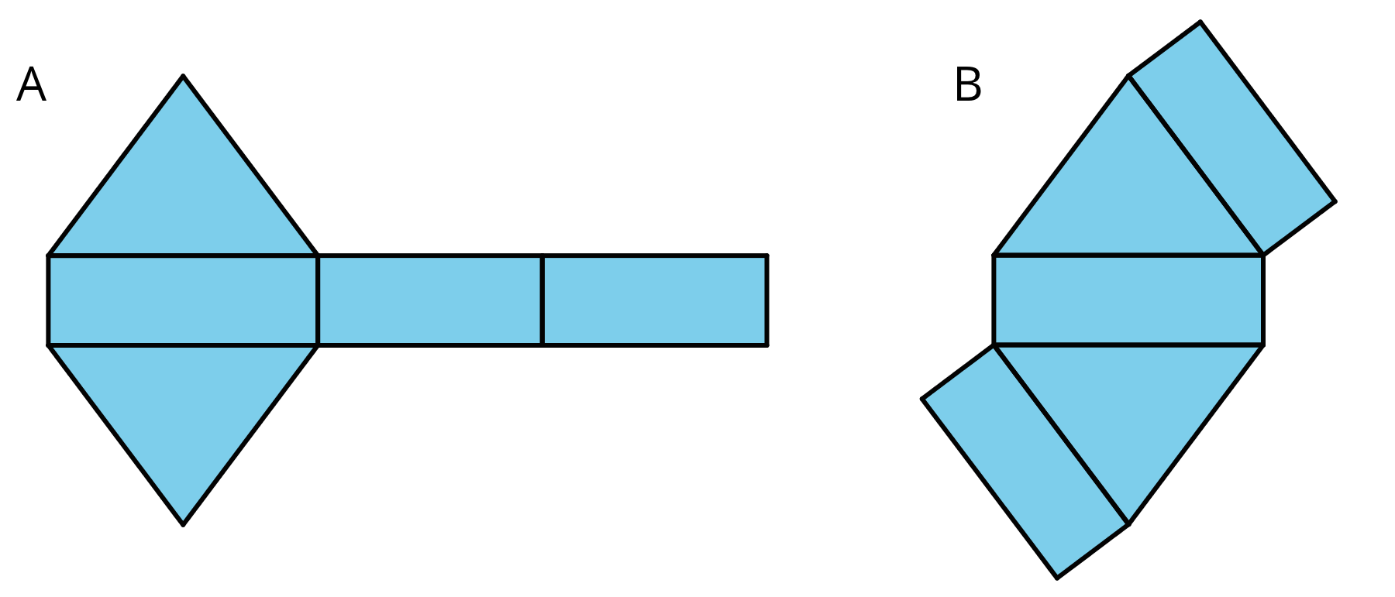

- Here are two three-dimensional figures.
- Tell whether each of the following statements describes Figure A, Figure B, both, or neither.
- 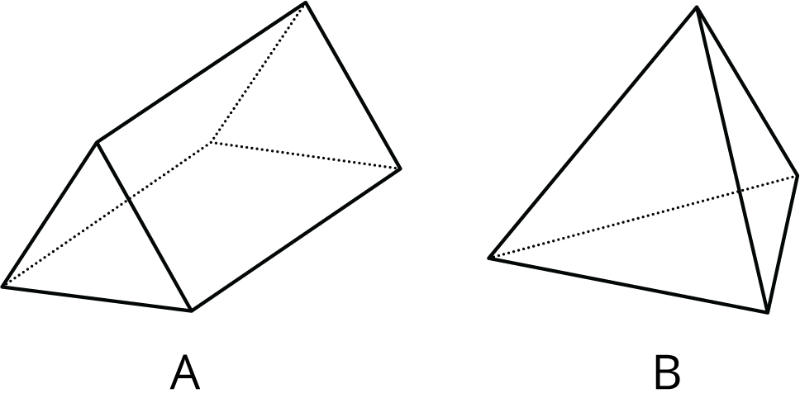
  - This figure is a polyhedron.
  - This figure has triangular faces.
  - There are more vertices than edges in this figure.
  - This figure has rectangular faces.
  - This figure is a pyramid.
  - There is exactly one face that can be the base for this figure.
  - The base of this figure is a triangle.
  - This figure has two identical and parallel faces that can be the base.
- (From Unit 1, Lesson 13.)
- Select all units that can be used for surface area.
  - square meters
  - feet
  - centimeters
  - cubic inches
  - square inches
  - square feet
- (From Unit 1, Lesson 12.)
- Find the area of this polygon. Show your reasoning.
- 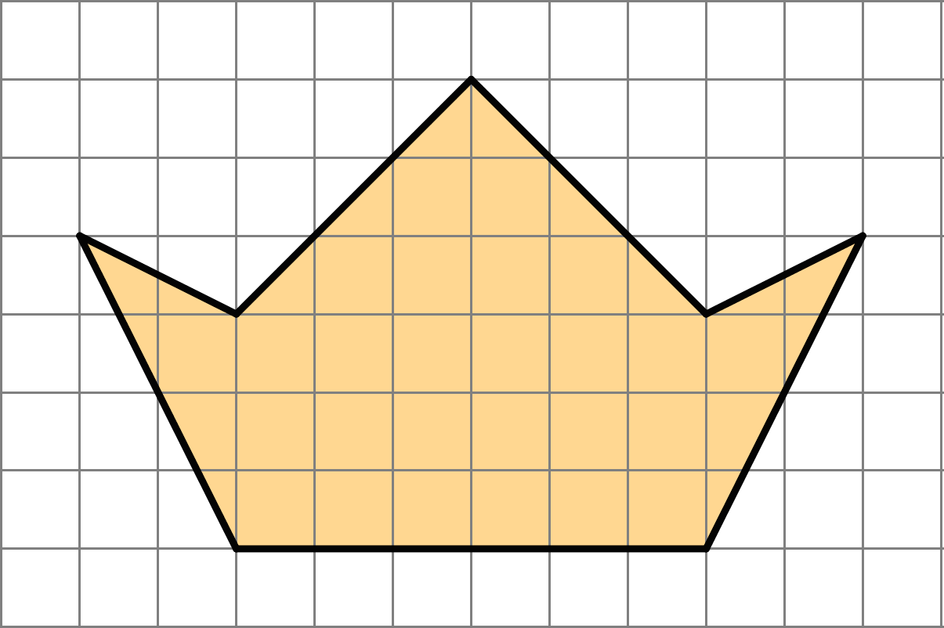
- (From Unit 1, Lesson 11.)
© CC BY Open Up Resources. Adaptations CC BY IM.

