Unit 5 Lesson 3: Adding and Subtracting Decimals with Few Non-Zero Digits

1 Do the Zeros Matter? (Warm up)

Student Task Statement
- Evaluate mentally: $1.009+0.391$
- Decide if each equation is true or false. Be prepared to explain your reasoning.
  - $34.56000=34.56$
  - $25=25.0$
  - $2.405=2.45$

2 Calculating Sums (Optional)

Images for Launch

Student Task Statement
- Andre and Jada drew base-ten diagrams to represent $0.007+0.004$. Andre drew 11 small rectangles. Jada drew only two figures: a square and a small rectangle.
  - If both students represented the sum correctly, what value does each small rectangle represent? What value does each square represent?
  - Draw or describe a diagram that could represent the sum $0.008+0.07$.
- Here are two calculations of $0.2+0.05$. Which is correct? Explain why one is correct and the other is incorrect.
- Compute each sum. If you get stuck, consider drawing base-ten diagrams to help you.

  - 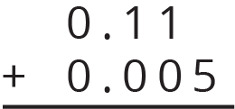
  - $0.209+0.01$
  - $10.2+1.1456$

Activity Synthesis
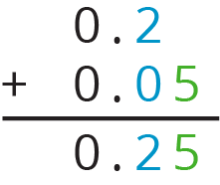

3 Subtracting Decimals of Different Lengths

Images for Launch

Student Task Statement
Diego and Noah drew different diagrams to represent $0.4−0.03$. Each rectangle represents 0.1. Each square represents 0.01.
- Diego started by drawing 4 rectangles to represent 0.4. He then replaced 1 rectangle with 10 squares and crossed out 3 squares to represent subtraction of 0.03, leaving 3 rectangles and 7 squares in his diagram.
- 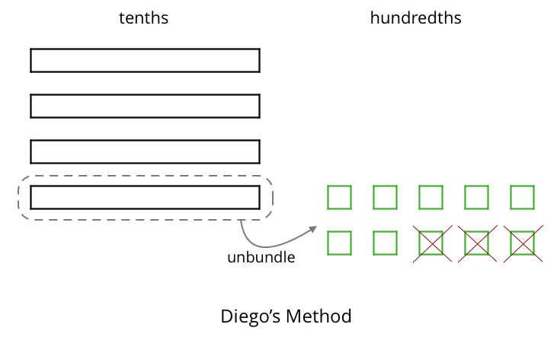
- Noah started by drawing 4 rectangles to represent 0.4. He then crossed out 3 rectangles to represent the subtraction, leaving 1 rectangle in his diagram.
- 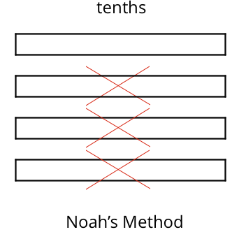
- Do you agree that either diagram correctly represents $0.4−0.03$? Discuss your reasoning with a partner.
- Elena also drew a diagram to represent $0.4−0.03$. She started by drawing 4 rectangles. She then replaced all 4 rectangles with 40 squares and crossed out 3 squares to represent subtraction of 0.03, leaving 37 squares in her diagram. Is her diagram correct? Discuss your reasoning with a partner.
- 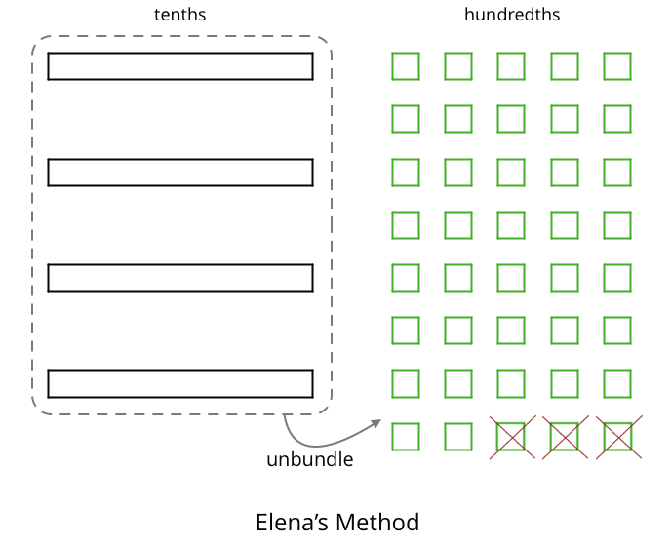
- Find each difference. Explain or show your reasoning.
  - $0.3−0.05$
  - $2.1−0.4$
  - $1.03−0.06$
  - $0.02−0.007$

Activity Synthesis
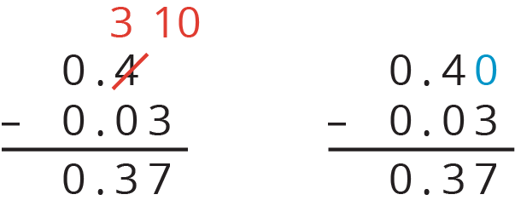
© CC BY Open Up Resources. Adaptations CC BY IM.

