Unit 2 Lesson 10: Comparing Situations by Examining Ratios

1 Treadmills (Warm up)

Student Task Statement
Mai and Jada each ran on a treadmill. The treadmill display shows the distance, in miles, each person ran and the amount of time it took them, in minutes and seconds.
Here is Mai’s treadmill display:
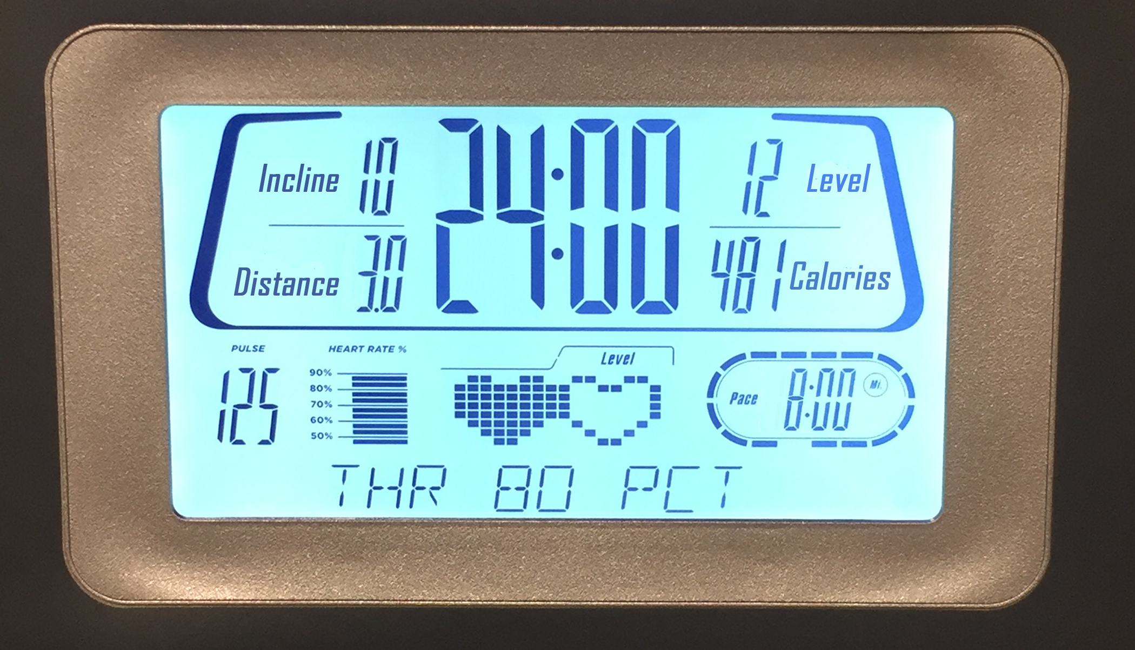
Here is Jada’s treadmill display:
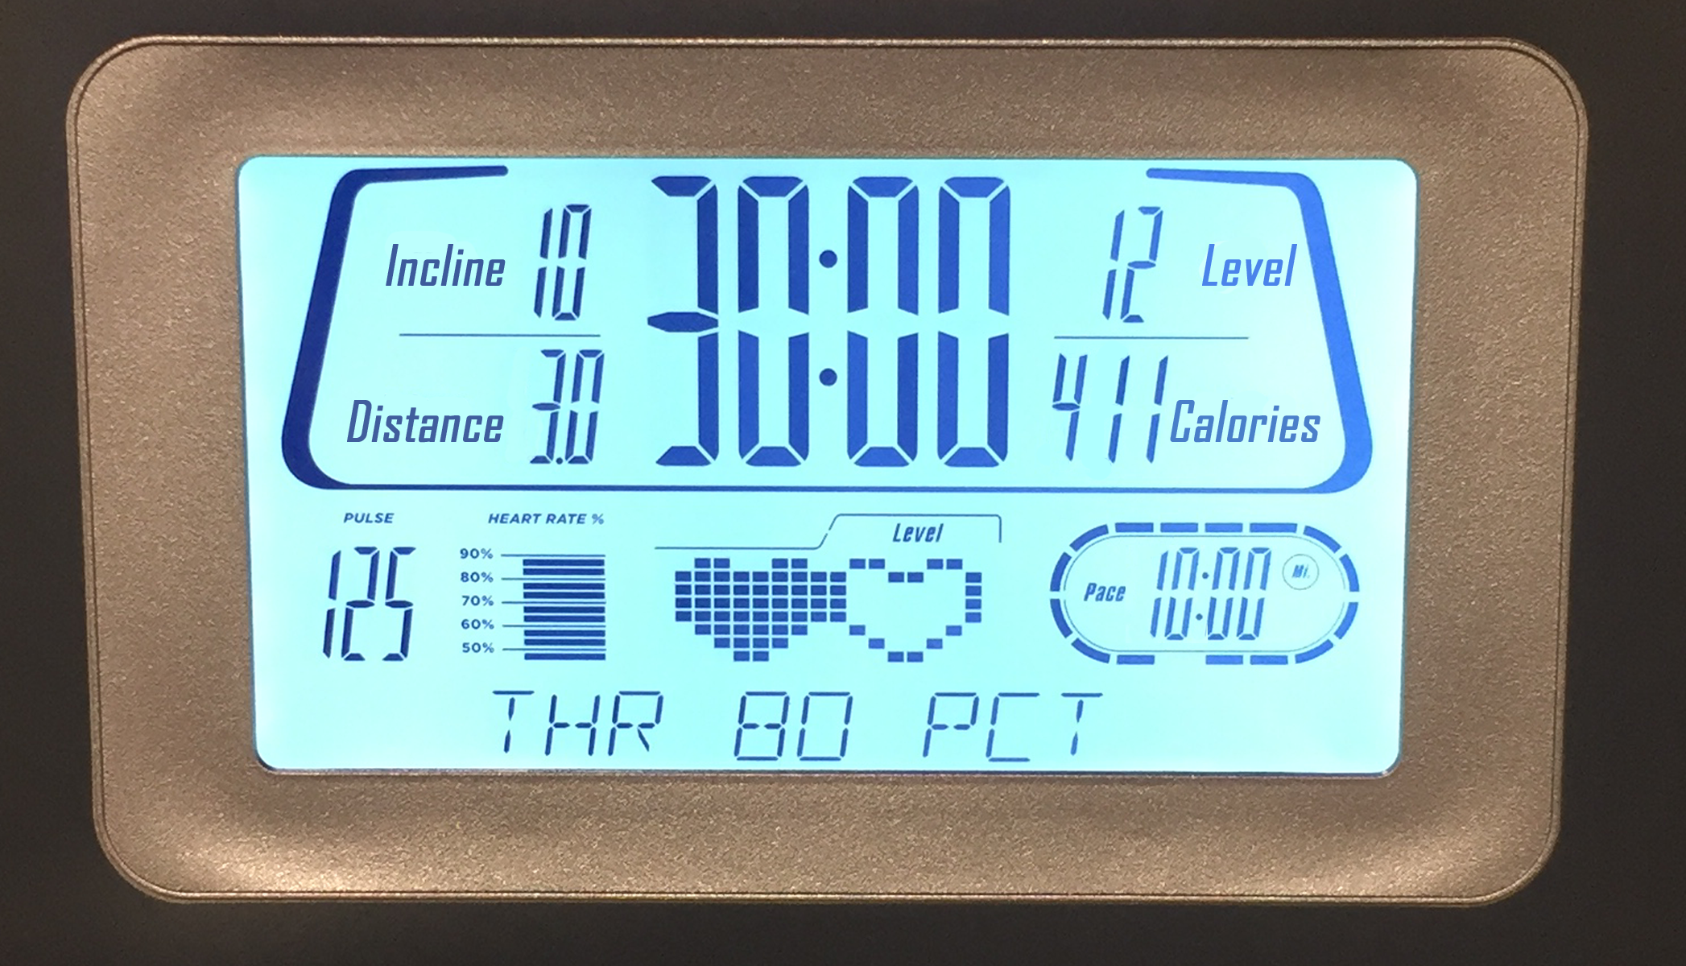
- What is the same about their workouts? What is different about their workouts?
- If each person ran at a constant speed the entire time, who was running faster? Explain your reasoning.

2 Concert Tickets

Student Task Statement
Diego paid $47 for 3 tickets to a concert. Andre paid $141 for 9 tickets to a concert. Did they pay at the same rate? Explain your reasoning.

3 Sparkling Orange Juice

Student Task Statement
Lin and Noah each have their own recipe for making sparkling orange juice.
- Lin mixes 3 liters of orange juice with 4 liters of soda water.
- Noah mixes 4 liters of orange juice with 5 liters of soda water.
How do the two mixtures compare in taste? Explain your reasoning.
© CC BY Open Up Resources. Adaptations CC BY IM.

