Unit 2 Lesson 1: Introducing Ratios and Ratio Language

1 What Kind and How Many? (Warm up)

Student Task Statement
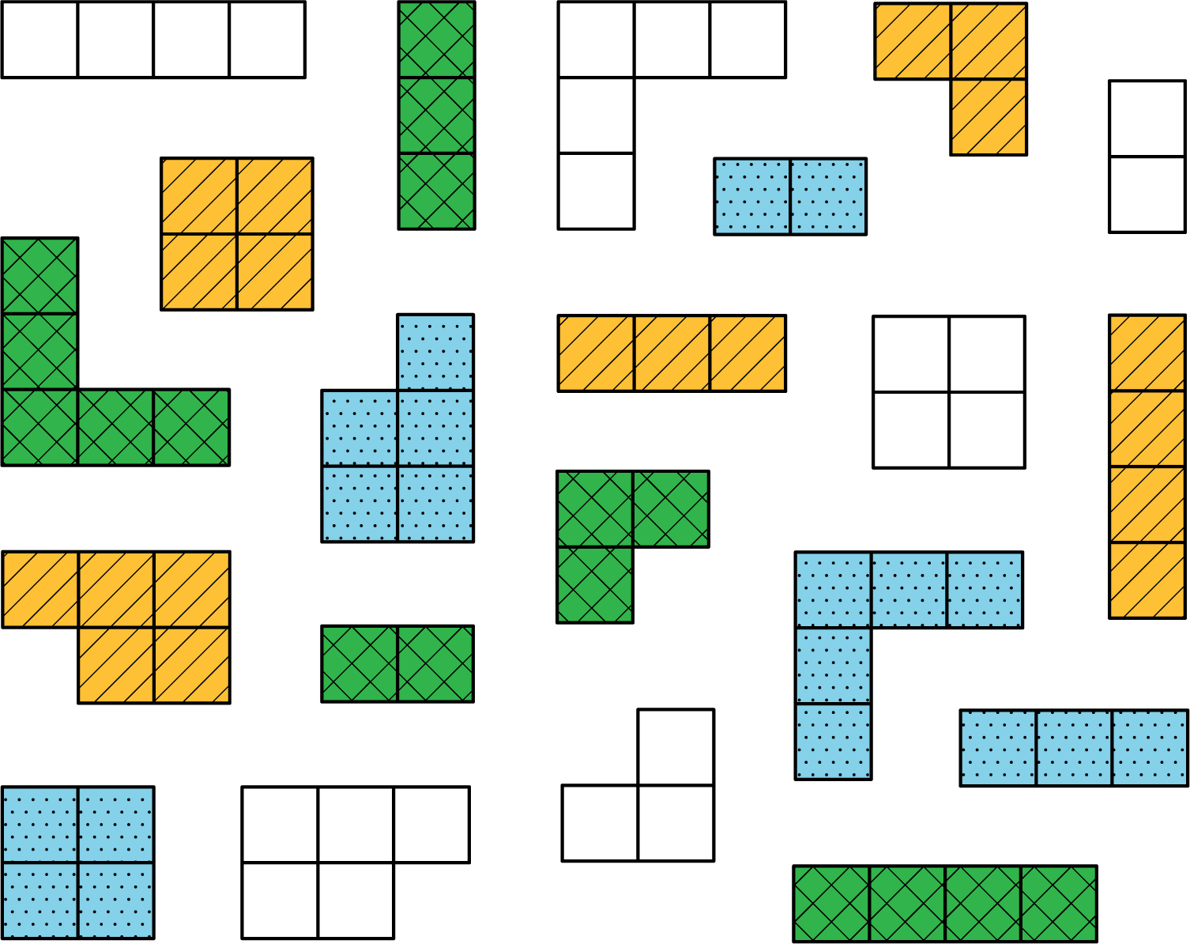
Think of different ways you could sort these figures. What categories could you use? How many groups would you have?

2 The Teacher’s Collection

Images for Launch
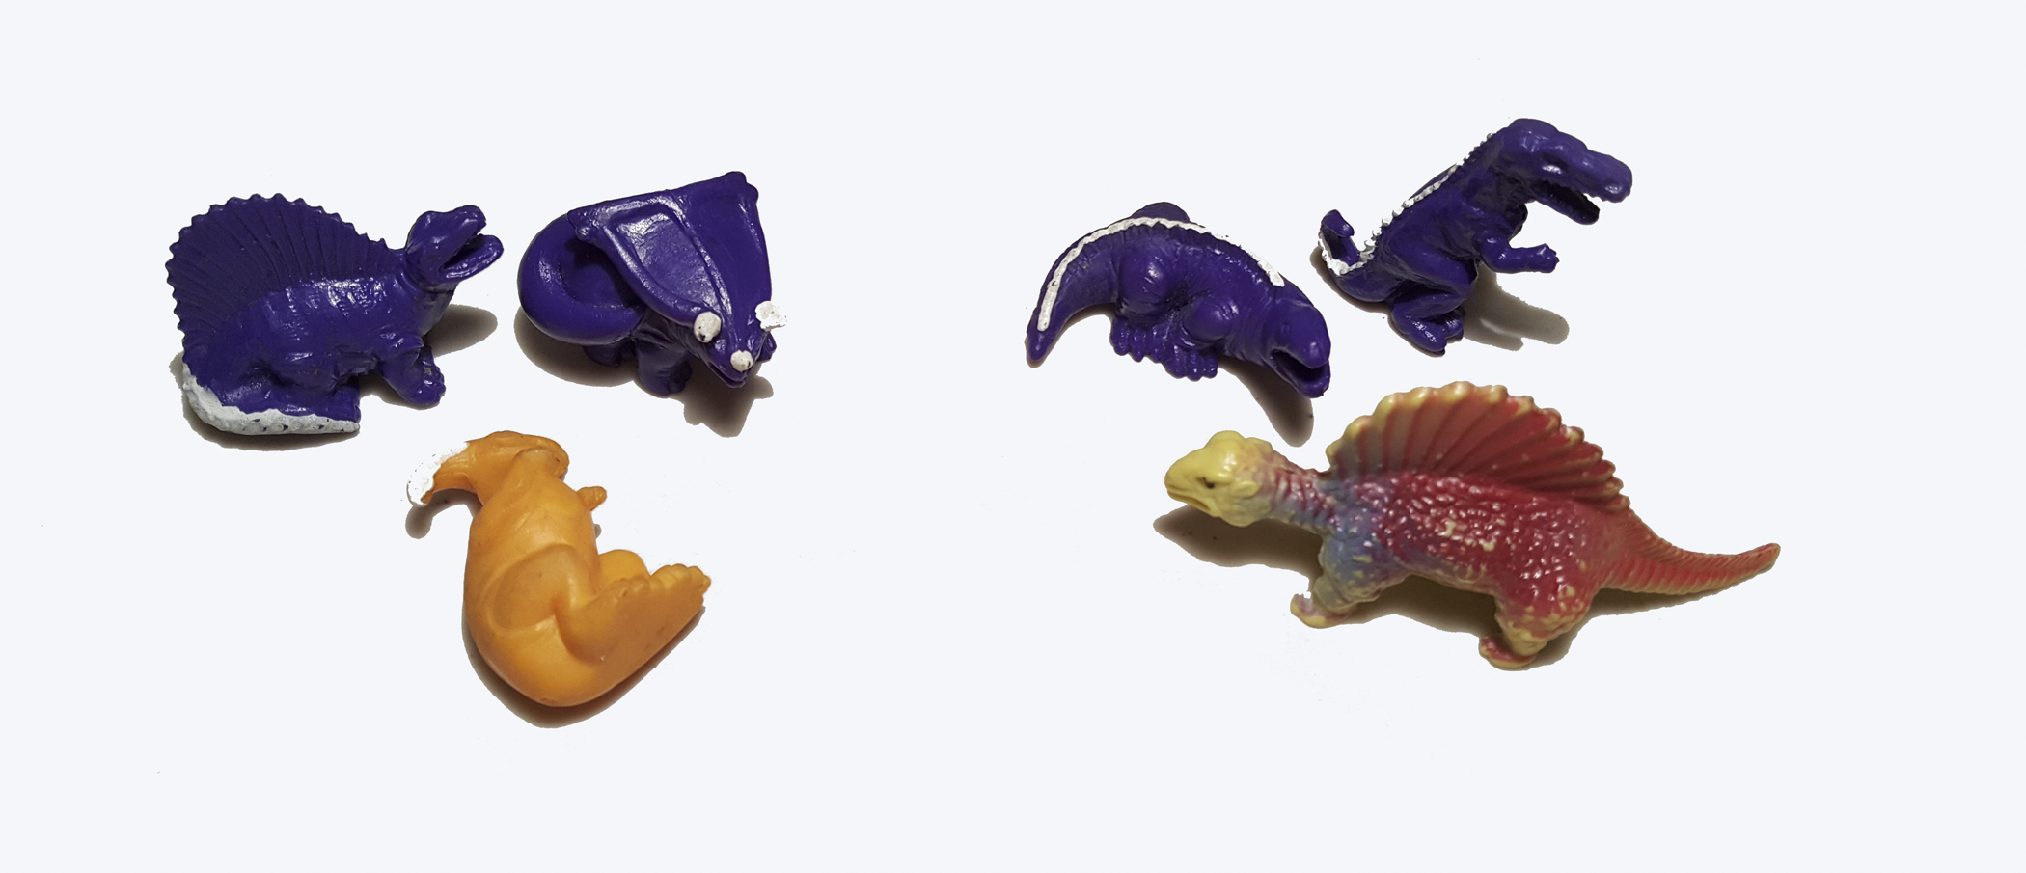

Student Task Statement
- Think of a way to sort your teacher’s collection into two or three categories. Count the items in each category, and record the information in the table.
- category name
- category amount
- Pause here so your teacher can review your work.
- Write at least two sentences that describe ratios in the collection. Remember, there are many ways to write a ratio:
  - The ratio of one category to another category is ________ to ________.
  - The ratio of one category to another category is ________ : ________.
  - There are _______ of one category for every _______ of another category.

3 The Student’s Collection

Student Task Statement
- Sort your collection into three categories. You can experiment with different ways of arranging these categories. Then, count the items in each category, and record the information in the table.
- category name
- category amount
- Write at least two sentences that describe ratios in the collection. Remember, there are many ways to write a ratio:
  - The ratio of one category to another category is ________ to ________.
  - The ratio of one category to another category is ________ : ________.
  - There are _______ of one category for every _______ of another category.
- Pause here so your teacher can review your sentences.
- Make a visual display of your items that clearly shows one of your statements. Be prepared to share your display with the class.

Images for Activity Synthesis
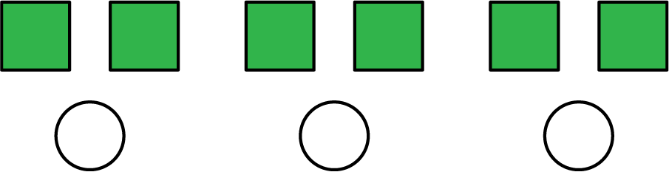
© CC BY Open Up Resources. Adaptations CC BY IM.

