Lesson 14: Comparing Mean and Median
Let's compare the mean and median of data sets.

14.1: Heights of Presidents
Here are two dot plots. The first dot plot shows the heights of the first 22 U.S. presidents. The second dot plot shows the heights of the next 22 presidents.
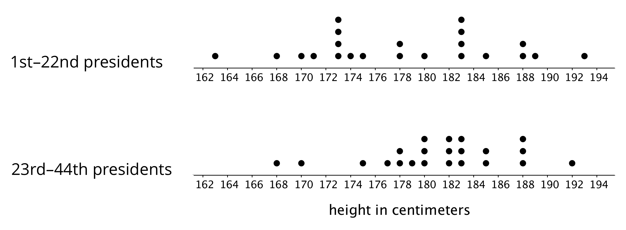
Based on the two dot plots, decide if you agree or disagree with each of the following statements. Be prepared to explain your reasoning.
- The median height of the first 22 presidents is 178 centimeters.
- The mean height of the first 22 presidents is about 183 centimeters.
- A typical height for a president in the second group is about 182 centimeters.
- U.S. presidents have become taller over time.
- The heights of the first 22 presidents are more alike than the heights of the second 22 presidents.
- The MAD of the second data set is greater than the MAD of the first set.

14.2: The Tallest and the Smallest in the World
Your teacher will provide the height data for your class. Use the data to complete the following questions.
- Find the mean height of your class in centimeters.
- Find the median height in centimeters. Show your reasoning.
- Suppose that the world’s tallest adult, who is 251 centimeters tall, joined your class.
  - Discuss the following questions with your group and explain your reasoning.
    - How would the mean height of the class change?
    - How would the median height change?
  - Find the new mean.
  - Find the new median.
  - Which measure of center—the mean or the median—changed more when this new person joined the class? Explain why the value of one measure changed more than the other.
- The world’s smallest adult is 63 centimeters tall. Suppose that the world’s tallest and smallest adults both joined your class.
  - Discuss the following questions with your group and explain your reasoning.
    - How would the mean height of the class change from the original mean?
    - How would the median height change from the original median?
  - Find the new mean.
  - Find the new median.
  - How did the measures of center—the mean and the median—change when these two people joined the class? Explain why the values of the mean and median changed the way they did.

14.3: Mean or Median?
- Your teacher will give you six cards. Each has either a dot plot or a histogram. Sort the cards into two piles based on the distributions shown. Be prepared to explain your reasoning.
- Discuss your sorting decisions with another group. Did you have the same cards in each pile? If so, did you use the same sorting categories? If not, how are your categories different?
- Pause here for a class discussion.
- Use the information on the cards to answer the following questions.
  - Card A: What is a typical age of the dogs being treated at the animal clinic?
  - Card B: What is a typical number of people in the Irish households?
  - Card C: What is a typical travel time for the New Zealand students?
  - Card D: Would 15 years old be a good description of a typical age of the people who attended the birthday party?
  - Card E: Is 15 minutes or 24 minutes a better description of a typical time it takes the students in South Africa to get to school?
  - Card F: Would 21.3 years old be a good description of a typical age of the people who went on a field trip to Washington, D.C.?
- How did you decide which measure of center to use for the dot plots on Cards A–C? What about for those on Cards D–F?

Are you ready for more?
Most teachers use the mean to calculate a student’s final grade, based on that student’s scores on tests, quizzes, homework, projects, and other graded assignments.
Diego thinks that the median might be a better way to measure how well a student did in a course. Do you agree with Diego? Explain your reasoning.

Lesson 14 Summary
Both the mean and the median are ways of measuring the center of a distribution. They tell us slightly different things, however.
The dot plot shows the weights of 30 cookies. The mean weight is 21 grams (marked with a triangle). The median weight is 20.5 grams (marked with a diamond).
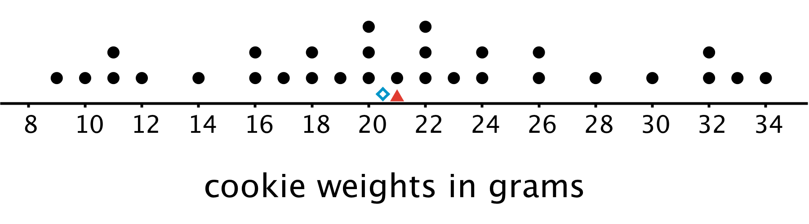
The mean tells us that if the weights of all cookies were distributed so that each one weighed the same, that weight would be 21 grams. We could also think of 21 grams as a balance point for the weights of all of the cookies in the set.
The median tells us that half of the cookies weigh more than 20.5 grams and half weigh less than 20.5 grams. In this case, both the mean and the median could describe a typical cookie weight because they are fairly close to each other and to most of the data points.
Here is a different set of 30 cookies. It has the same mean weight as the first set, but the median weight is 23 grams.
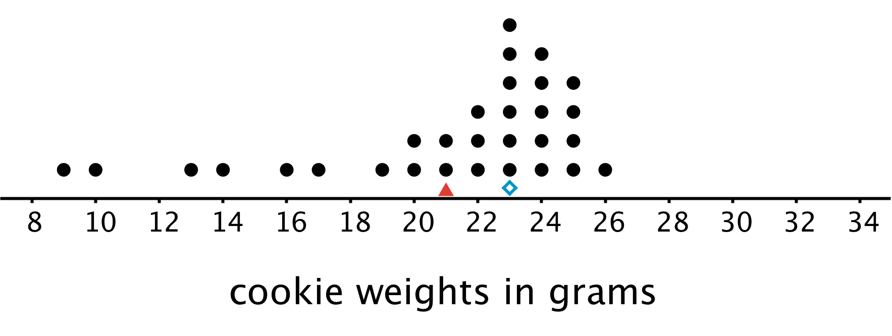
In this case, the median is closer to where most of the data points are clustered and is therefore a better measure of center for this distribution. That is, it is a better description of a typical cookie weight. The mean weight is influenced (in this case, pulled down) by a handful of much smaller cookies, so it is farther away from most data points.
In general, when a distribution is symmetrical or approximately symmetrical, the mean and median values are close. But when a distribution is not roughly symmetrical, the two values tend to be farther apart.
© CC BY Open Up Resources. Adaptations CC BY IM.

