Lesson 15 Practice Problems
- A pool in the shape of a rectangular prism is being filled with water. The length and width of the pool is 24 feet and 15 feet. If the height of the water in the pool is $1\frac{1}{3}$ feet, what is the volume of the water in cubic feet?
- A rectangular prism measures $2\frac{2}{5}$ inches by $3\frac{1}{5}$ inches by 2 inch.
  - Priya said, “It takes more cubes with edge length$\frac{2}{5}$ inch than cubes with edge length $\frac{1}{5}$ inch to pack the prism.” Do you agree with Priya? Explain or show your reasoning.
  - How many cubes with edge length $\frac{1}{5}$ inch fit in the prism? Show your reasoning.
  - Explain how you can use your answer in the previous question to find the volume of the prism in cubic inches.

  - Here is a right triangle. What is its area?
  - What is the height $h$ for the base that is $\frac{5}{4}$ units long? Show your reasoning.
- 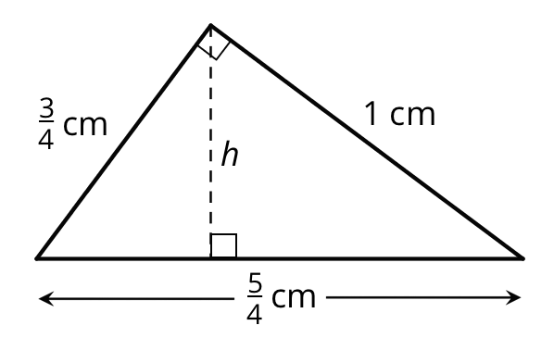
- (From Unit 4, Lesson 14.)
- To give their animals essential minerals and nutrients, farmers and ranchers often have a block of salt—called “salt lick”—available for their animals to lick.
  - A rancher is ordering a box of cube-shaped salt licks. The edge lengths of each salt lick are $\frac{5}{12}$ foot. Is the volume of one salt lick greater or less than 1 cubic foot? Explain your reasoning.
  - 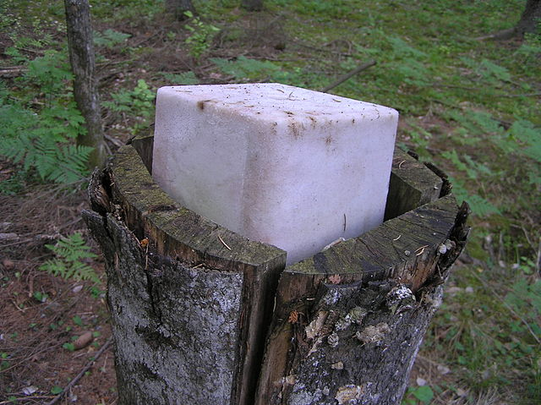
  - The box that contains the salt lick is $1\frac{1}{4}$ feet by $1\frac{2}{3}$ feet by $\frac{5}{6}$ feet. How many cubes of salt lick fit in the box? Explain or show your reasoning.

  - How many groups of $\frac{1}{3}$ inch are in $\frac{3}{4}$ inch?
  - How many inches are in $1\frac{2}{5}$ groups of $1\frac{2}{3}$ inches?
- (From Unit 4, Lesson 12.)
- Here is a table that shows the ratio of flour to water in an art paste. Complete the table with values in equivalent ratios.
- cups of flour | - cups of water
- 1 | - $\frac{1}{2}$
- 4
 | - 3
- $\frac{1}{2}$
- (From Unit 2, Lesson 12.)
© CC BY Open Up Resources. Adaptations CC BY IM.

