## Unit 2 Lesson 12: Navigating a Table of Equivalent Ratios

### 1 Number Talk: Multiplying by a Unit Fraction (Warm up)

#### Student Task Statement

Find the product mentally.

### 2 Comparing Taco Prices

#### Student Task Statement

| number of tacos | price in dollars |
| --- | --- |
|  |  |
|  |  |
|  |  |
|  |  |
|  |  |

Use the table to help you solve these problems. Explain or show your reasoning.

1. Noah bought 4 tacos and paid $6. At this rate, how many tacos could he buy for $15?
2. Jada’s family bought 50 tacos for a party and paid $72. Were Jada’s tacos the same price as Noah’s tacos?

### 3 Hourly Wages

#### Student Task Statement

Lin is paid $90 for 5 hours of work. She used the table to calculate how much she would be paid at this rate for 8 hours of work.

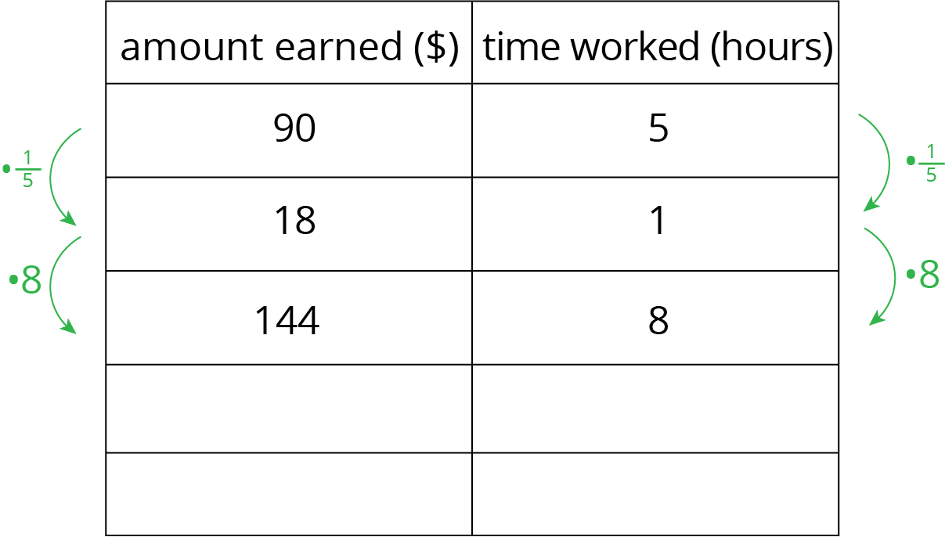

1. What is the meaning of the 18 that appears in the table?
2. Why was the number used as a multiplier?
3. Explain how Lin used this table to solve the problem.
4. At this rate, how much would Lin be paid for 3 hours of work? For 2.1 hours of work?

### 4 Zeno’s Memory Card (Optional)

#### Student Task Statement

In 2016, 128 gigabytes (GB) of portable computer memory cost $32.

1. Here is a double number line that represents the situation:

* 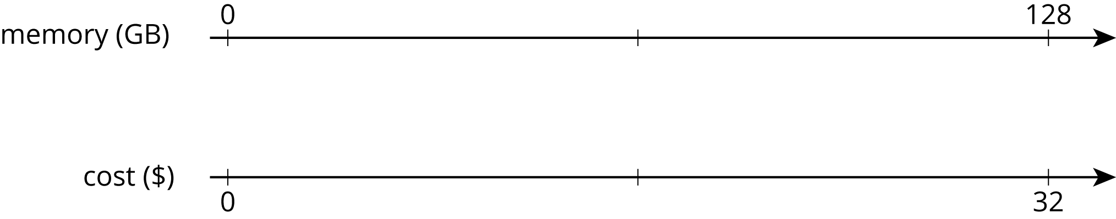
* One set of tick marks has already been drawn to show the result of multiplying 128 and 32 each by . Label the amount of memory and the cost for these tick marks.
* Next, keep multiplying by and drawing and labeling new tick marks, until you can no longer clearly label each new tick mark with a number.

1. Here is a table that represents the situation. Find the cost of 1 gigabyte. You can use as many rows as you need.

| * memory (gigabytes) | * cost (dollars) |
| --- | --- |
| * 128 | * 32 |
|  |  |
|  |  |
|  |  |
|  |  |
|  |  |
|  |  |
|  |  |

1. Did you prefer the double number line or the table for solving this problem? Why?



© CC BY Open Up Resources. Adaptations CC BY IM.