Unit 5 Lesson 10: Using Long Division

1 Number Talk: Estimating Quotients (Warm up)

Student Task Statement
Estimate these quotients mentally.
$500÷7$
$1,​394÷9$

2 Lin Uses Long Division

Student Task Statement
Lin has a method of calculating quotients that is different from Elena’s method and Andre’s method. Here is how she found the quotient of $657÷3$:
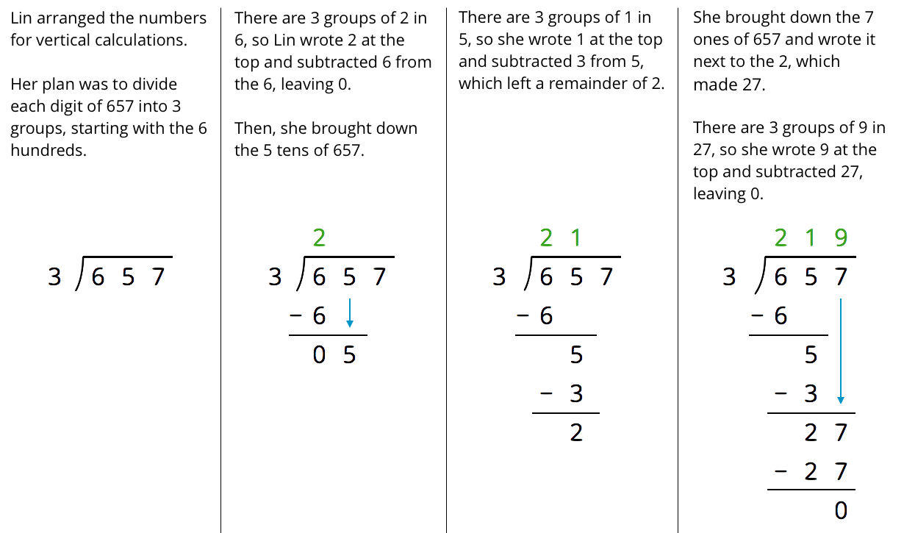
- Discuss with your partner how Lin’s method is similar to and different from drawing base-ten diagrams or using the partial quotients method.
  - Lin subtracted $3⋅2,$ then $3⋅1$, and lastly $3⋅9$. Earlier, Andre subtracted $3⋅200,$ then $3⋅10$, and lastly $3⋅9$. Why did they have the same quotient?
  - In the third step, why do you think Lin wrote the 7 next to the remainder of 2 rather than adding 7 and 2 to get 9?
- Lin’s method is called long division. Use this method to find the following quotients. Check your answer by multiplying it by the divisor.
  - $846÷3$
  - $1,​816÷4$
  - $768÷12$

Activity Synthesis
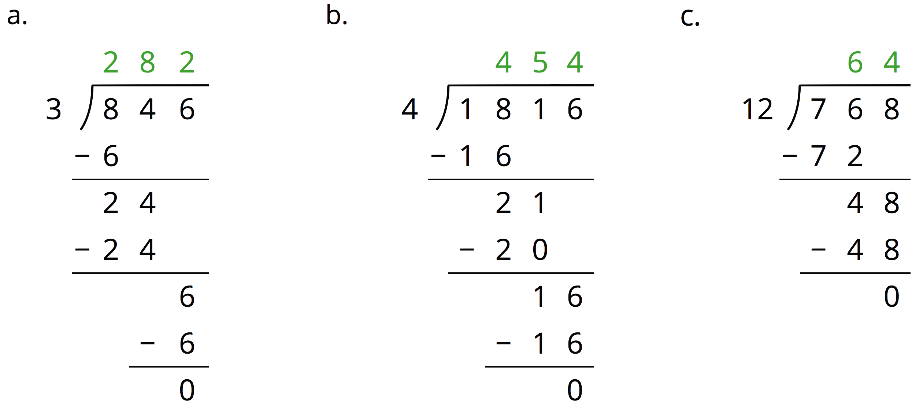

3 Dividing Whole Numbers (Optional)

Student Task Statement
- Find each quotient.
  - $633÷3$
  - $1001÷7$
  - $2996÷14$
- Here is Priya’s calculation of $906÷3$.
- 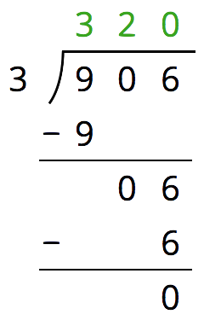
  - Priya wrote 320 for the value of $906÷3$. Check her answer by multiplying it by 3. What product do you get and what does it tell you about Priya’s answer?
  - Describe Priya’s mistake, then show the correct calculation and answer.
© CC BY Open Up Resources. Adaptations CC BY IM.

