Lesson 2: Corresponding Parts and Scale Factors
Let’s describe features of scaled copies.

2.1: Number Talk: Multiplying by a Unit Fraction
Find each product mentally.
$\frac{1}{4}⋅32$
$\left(7.2\right)⋅\frac{1}{9}$
$\frac{1}{4}⋅\left(5.6\right)$

2.2: Corresponding Parts
Here is a figure and two copies, each with some points labeled.
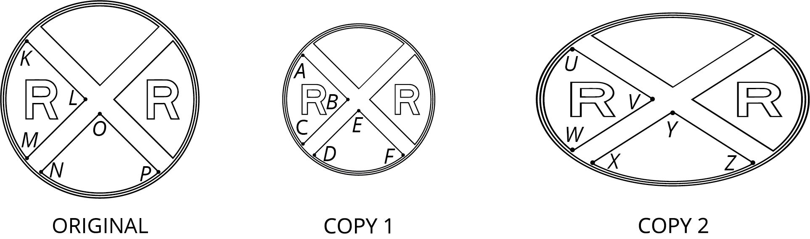
- Complete this table to show corresponding parts in the three figures.
- original | - copy 1 | - copy 2
- point $P$
- segment $LM$
 | - segment $EF$
 |  | - point $W$
- angle $KLM$
 |  | - angle $XYZ$
- Is either copy a scaled copy of the original figure? Explain your reasoning.
- Use tracing paper to compare angle $KLM$ with its corresponding angles in Copy 1 and Copy 2. What do you notice?
- Use tracing paper to compare angle $NOP$ with its corresponding angles in Copy 1 and Copy 2. What do you notice?

2.3: Scaled Triangles
Here is Triangle O, followed by a number of other triangles.
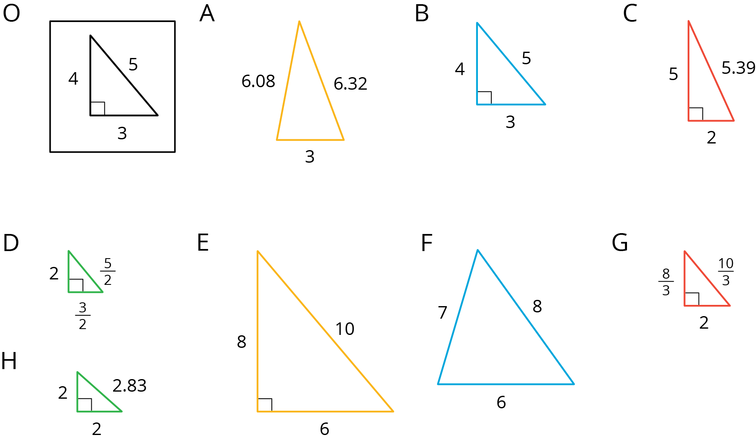
Your teacher will assign you two of the triangles to look at.
- For each of your assigned triangles, is it a scaled copy of Triangle O? Be prepared to explain your reasoning.
- As a group, identify all the scaled copies of Triangle O in the collection. Discuss your thinking. If you disagree, work to reach an agreement.
- List all the triangles that are scaled copies in the table. Record the side lengths that correspond to the side lengths of Triangle O listed in each column.
- Triangle O | - 3 | - 4 | - 5
- Explain or show how each copy has been scaled from the original (Triangle O).

Are you ready for more?
Choose one of the triangles that is not a scaled copy of Triangle O. Describe how you could change at least one side to make a scaled copy, while leaving at least one side unchanged.

Lesson 2 Summary
A figure and its scaled copy have corresponding parts, or parts that are in the same position in relation to the rest of each figure. These parts could be points, segments, or angles. For example, Polygon 2 is a scaled copy of Polygon 1.
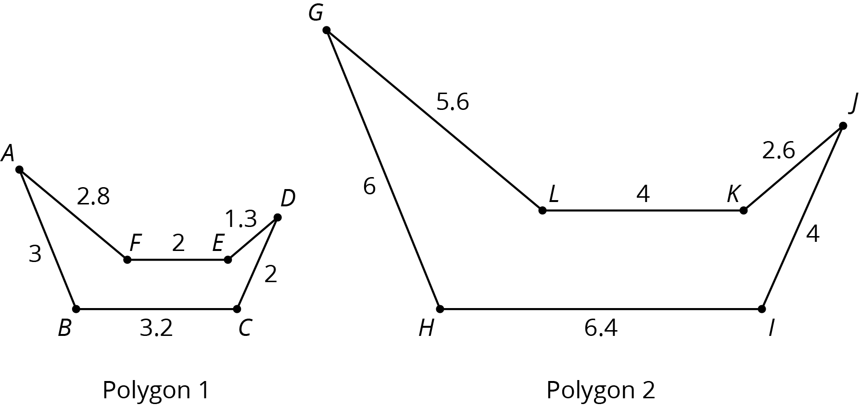
- Each point in Polygon 1 has a corresponding point in Polygon 2.
For example, point $B$ corresponds to point $H$ and point $C$ corresponds to point $I$.
- Each segment in Polygon 1 has a corresponding segment in Polygon 2.
For example, segment $AF$ corresponds to segment $GL$.
- Each angle in Polygon 1 also has a corresponding angle in Polygon 2.
For example, angle $DEF$ corresponds to angle $JKL$.
The scale factor between Polygon 1 and Polygon 2 is 2, because all of the lengths in Polygon 2 are 2 times the corresponding lengths in Polygon 1. The angle measures in Polygon 2 are the same as the corresponding angle measures in Polygon 1. For example, the measure of angle $JKL$ is the same as the measure of angle $DEF$.
© CC BY Open Up Resources. Adaptations CC BY IM.

