Lesson 15 Practice Problems
- The coordinates of a rectangle are $\left(3,0\right)$, $\left(3,\text{-}5\right)$, $\left(\text{-}4,0\right)$ and $\left(\text{-}4,\text{-}5\right)$
  - What is the length and width of this rectangle?
  - What is the perimeter of the rectangle?
  - What is the area of the rectangle?
- Draw a square with one vertex on the point $\left(\text{-}3,5\right)$ and a perimeter of 20 units. Write the coordinates of each other vertex.
- 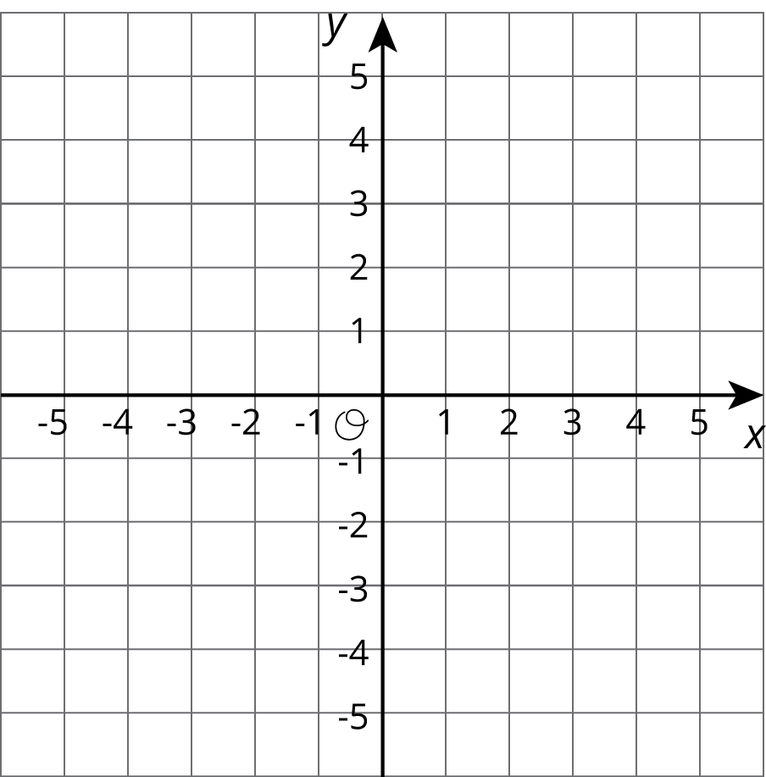

  - Plot and connect the following points to form a polygon.
  - $\left(\text{-}3,2\right),\left(2,2\right),\left(2,\text{-}4\right),\left(\text{-}1,\text{-}4\right),\left(\text{-}1,\text{-}2\right),\left(\text{-}3,\text{-}2\right),\left(\text{-}3,2\right)$
  - 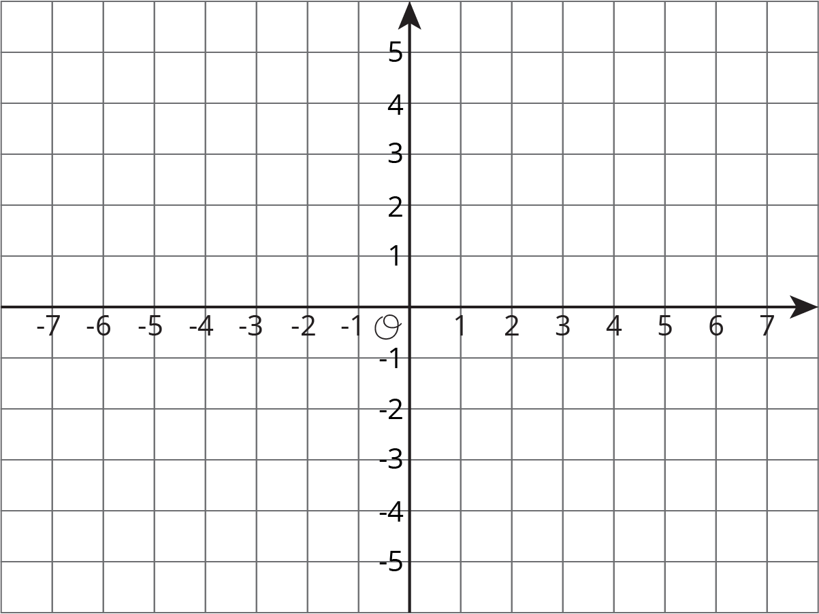
  - Find the perimeter of the polygon.
- For each situation, select all the equations that represent it. Choose one equation and solve it.
  - Jada’s cat weighs 3.45 kg. Andre’s cat weighs 1.2 kg more than Jada’s cat. How much does Andre’s cat weigh?
  - $x=3.45+1.2$
  - $x=3.45−1.2$
  - $x+1.2=3.45$
  - $x−1.2=3.45$
  - Apples cost $1.60 per pound at the farmer’s market. They cost 1.5 times as much at the grocery store. How much do the apples cost per pound at the grocery store?
  - $y=\left(1.5\right)⋅\left(1.60\right)$
  - $y=1.60÷1.5$
  - $\left(1.5\right)y=1.60$
  - $\frac{y}{1.5}=1.60$
- (From Unit 6, Lesson 4.)
© CC BY Open Up Resources. Adaptations CC BY IM.

