Lesson 6: Scaling and Area
Let's build scaled shapes and investigate their areas.

6.1: Scaling a Pattern Block
Your teacher will give you some pattern blocks. Work with your group to build the scaled copies described in each question.
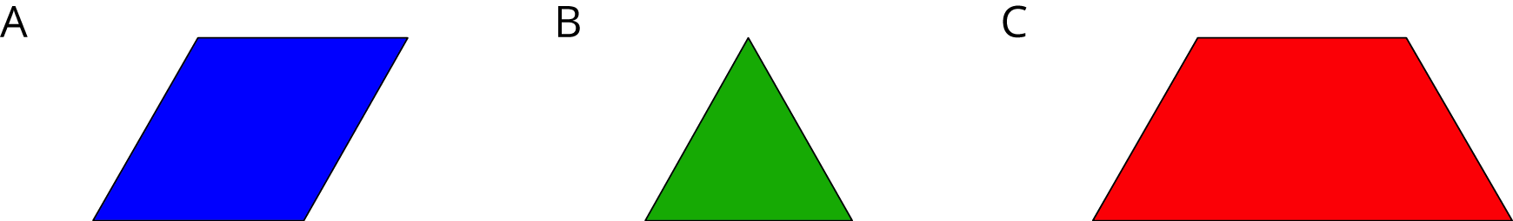
- How many blue rhombus blocks does it take to build a scaled copy of Figure A:
  - Where each side is twice as long?
  - Where each side is 3 times as long?
  - Where each side is 4 times as long?
- How many green triangle blocks does it take to build a scaled copy of Figure B:
  - Where each side is twice as long?
  - Where each side is 3 times as long?
  - Using a scale factor of 4?
- How many red trapezoid blocks does it take to build a scaled copy of Figure C:
  - Using a scale factor of 2?
  - Using a scale factor of 3?
  - Using a scale factor of 4?

6.2: Scaling More Pattern Blocks
Your teacher will assign your group one of these figures.
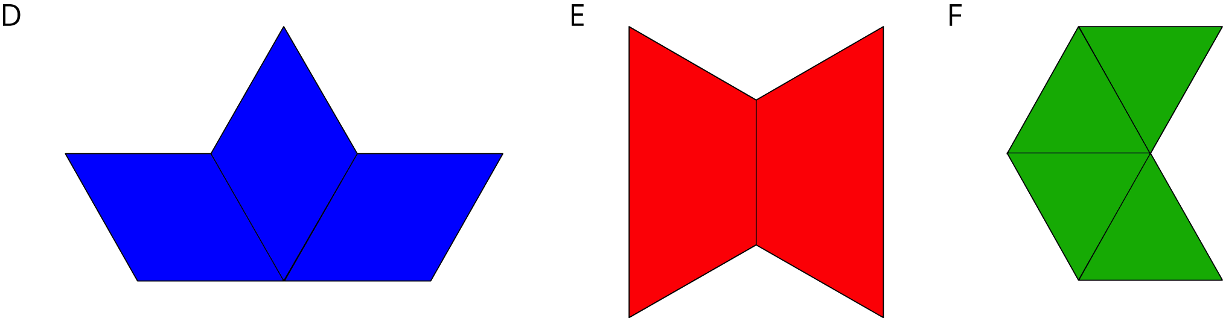
- Build a scaled copy of your assigned shape using a scale factor of 2. Use the same shape blocks as in the original figure. How many blocks did it take?
- Your classmate thinks that the scaled copies in the previous problem will each take 4 blocks to build. Do you agree or disagree? Explain you reasoning.
- Start building a scaled copy of your assigned figure using a scale factor of 3. Stop when you can tell for sure how many blocks it would take. Record your answer.
- How many blocks would it take to build scaled copies of your figure using scale factors 4, 5, and 6? Explain or show your reasoning.
- How is the pattern in this activity the same as the pattern you saw in the previous activity? How is it different?

Are you ready for more?
- How many blocks do you think it would take to build a scaled copy of one yellow hexagon where each side is twice as long? Three times as long?
- Figure out a way to build these scaled copies.
- Do you see a pattern for the number of blocks used to build these scaled copies? Explain your reasoning.

6.3: Area of Scaled Parallelograms and Triangles
- Your teacher will give you a figure with measurements in centimeters. What is the area of your figure? How do you know?
- Work with your partner to draw scaled copies of your figure, using each scale factor in the table. Complete the table with the measurements of your scaled copies.
- scale factor | - base (cm) | - height (cm) | - area (cm²)
- 1
- 2
- 3
- $\frac{1}{2}$
- $\frac{1}{3}$

- Compare your results with a group that worked with a different figure. What is the same about your answers? What is different?
- If you drew scaled copies of your figure with the following scale factors, what would their areas be? Discuss your thinking. If you disagree, work to reach an agreement. Be prepared to explain your reasoning.
- scale factor | - area (cm²)
- 5
- $\frac{3}{5}$

Lesson 6 Summary
Scaling affects lengths and areas differently. When we make a scaled copy, all original lengths are multiplied by the scale factor. If we make a copy of a rectangle with side lengths 2 units and 4 units using a scale factor of 3, the side lengths of the copy will be 6 units and 12 units, because $2⋅3=6$ and $4⋅3=12$.
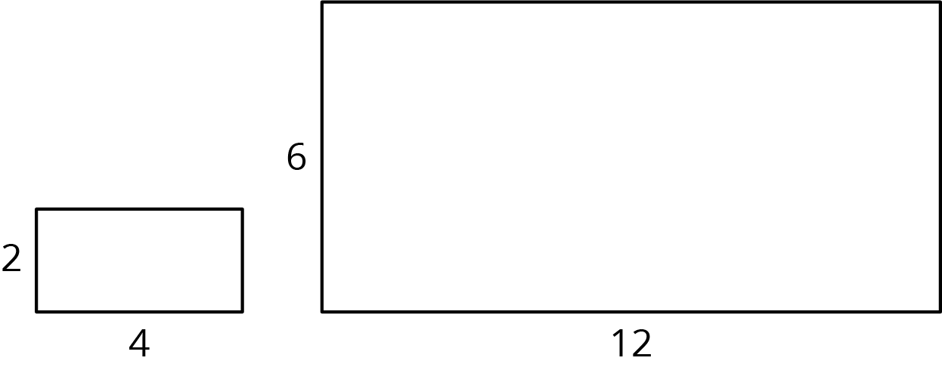
The area of the copy, however, changes by a factor of (scale factor)². If each side length of the copy is 3 times longer than the original side length, then the area of the copy will be 9 times the area of the original, because $3⋅3$, or $3^{2}$, equals 9.
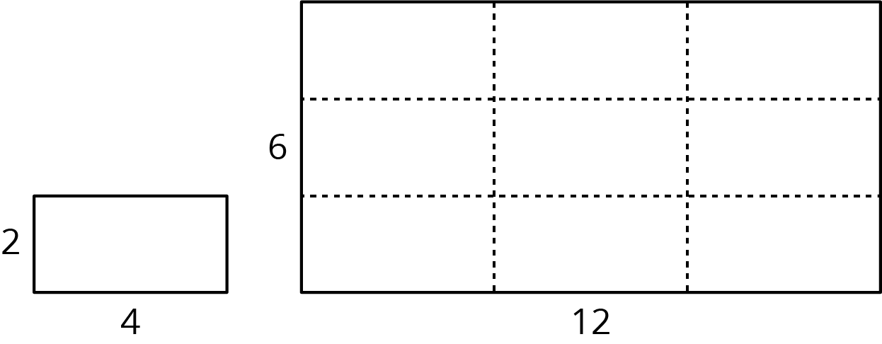
In this example, the area of the original rectangle is 8 units² and the area of the scaled copy is 72 units², because $9⋅8=72$. We can see that the large rectangle is covered by 9 copies of the small rectangle, without gaps or overlaps. We can also verify this by multiplying the side lengths of the large rectangle: $6⋅12=72$.
Lengths are one-dimensional, so in a scaled copy, they change by the scale factor. Area is two-dimensional, so it changes by the square of the scale factor. We can see this is true for a rectangle with length $l$ and width $w$. If we scale the rectangle by a scale factor of $s$, we get a rectangle with length $s⋅l$ and width $s⋅w$. The area of the scaled rectangle is $A=\left(s⋅l\right)⋅\left(s⋅w\right)$, so $A=\left(s^{2}\right)⋅\left(l⋅w\right)$. The fact that the area is multiplied by the square of the scale factor is true for scaled copies of other two-dimensional figures too, not just for rectangles.
© CC BY Open Up Resources. Adaptations CC BY IM.

