Lesson 6 Practice Problems
- On the grid, draw a scaled copy of Polygon Q using a scale factor of 2. Compare the perimeter and area of the new polygon to those of Q.
- 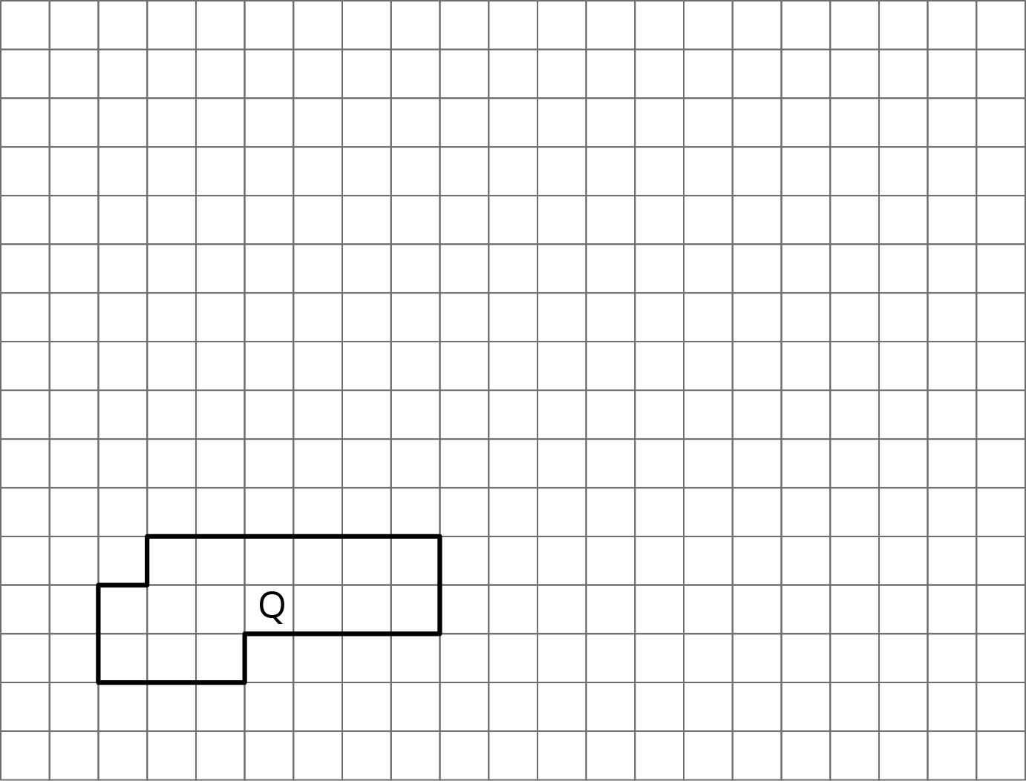
- A right triangle has an area of 36 square units.
- If you draw scaled copies of this triangle using the scale factors in the table, what will the areas of these scaled copies be? Explain or show your reasoning.
- scale factor | - area (units²)
- 1 | - 36
- 2
- 3
- 5
- $\frac{1}{2}$
- $\frac{2}{3}$
- Diego drew a scaled version of a Polygon P and labeled it Q.
- 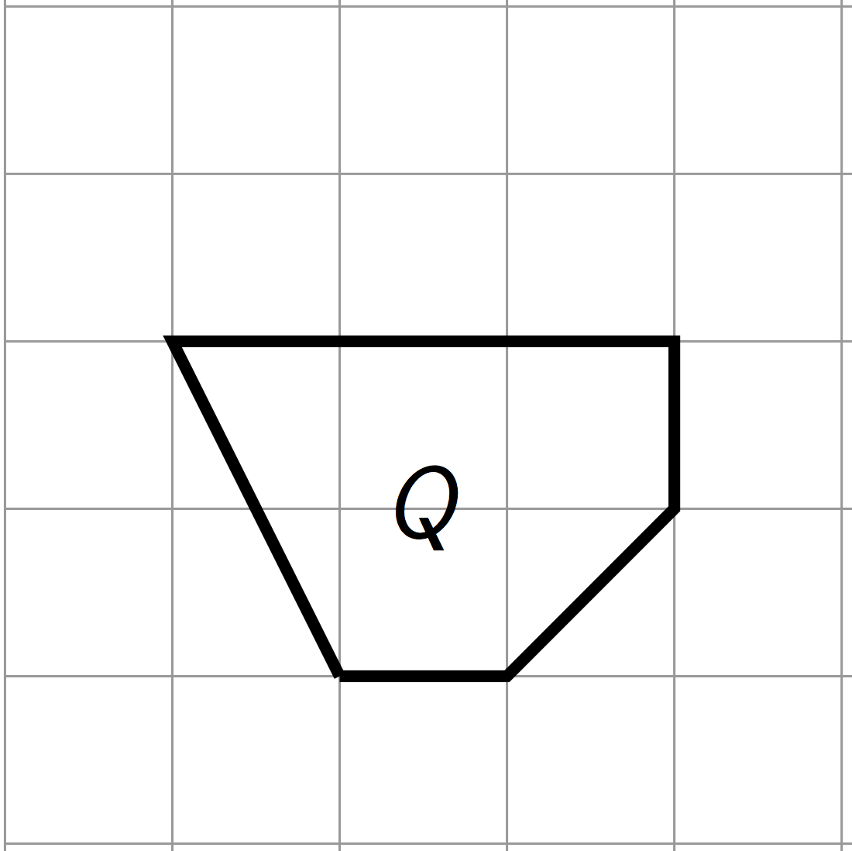
- If the area of Polygon P is 72 square units, what scale factor did Diego use to go from P to Q? Explain your reasoning.
- Here is an unlabeled polygon, along with its scaled copies Polygons A–D. For each copy, determine the scale factor. Explain how you know.
- 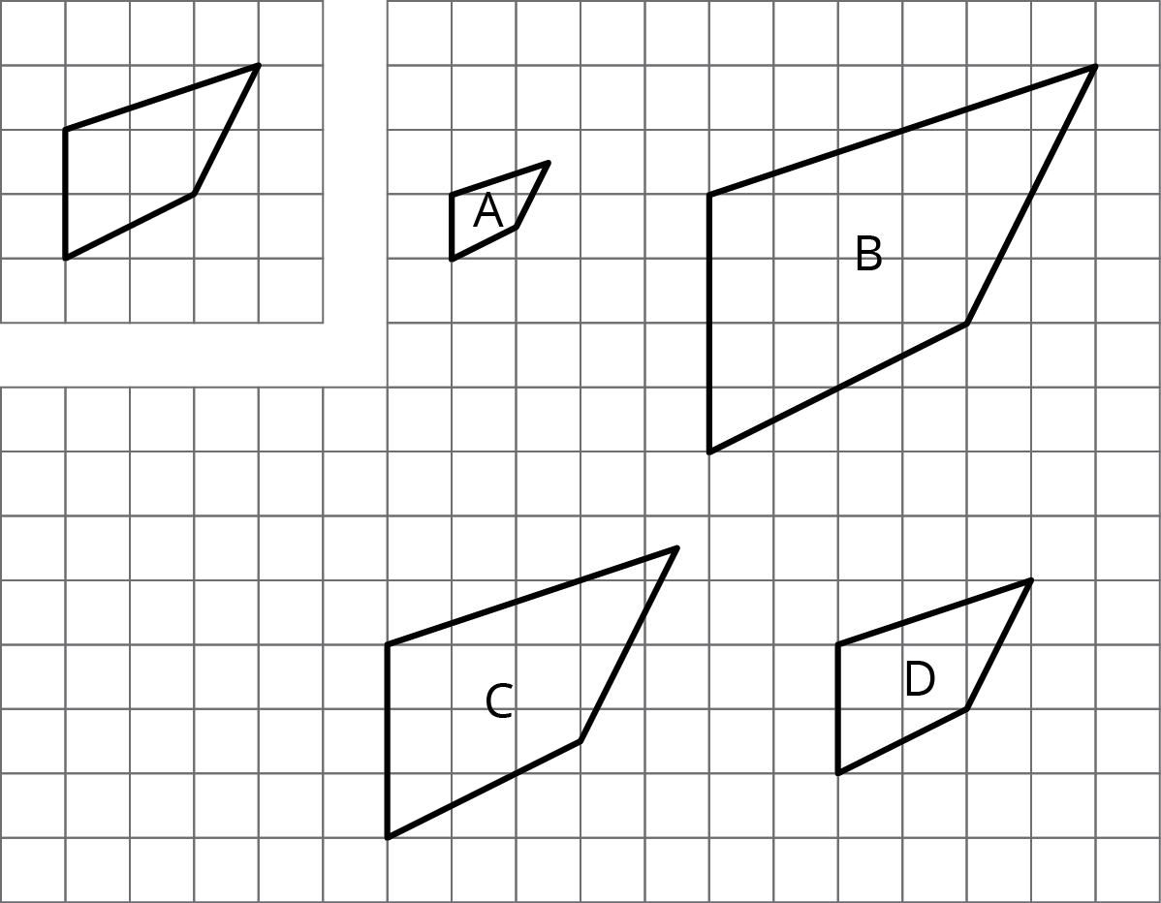
- (From Unit 1, Lesson 2.)
- Solve each equation mentally.
  - $\frac{1}{7}⋅x=1$
  - $x⋅\frac{1}{11}=1$
  - $1÷\frac{1}{5}=x$
- (From Unit 1, Lesson 5.)
© CC BY Open Up Resources. Adaptations CC BY IM.

