Lesson 13: Benchmark Percentages
Let’s contrast percentages and fractions.

13.1: What Percentage Is Shaded?
What percentage of each diagram is shaded?
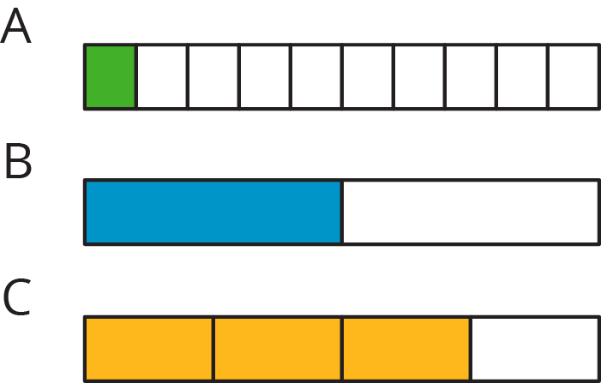

13.2: Liters, Meters, and Hours

  - How much is 50% of 10 liters of milk?
  - How far is 50% of a 2,000-kilometer trip?
  - How long is 50% of a 24-hour day?
  - How can you find 50% of any number?

  - How far is 10% of a 2,000-kilometer trip?
  - How much is 10% of 10 liters of milk?
  - How long is 10% of a 24-hour day?
  - How can you find 10% of any number?

  - How long is 75% of a 24-hour day?
  - How far is 75% of a 2,000-kilometer trip?
  - How much is 75% of 10 liters of milk?
  - How can you find 75% of any number?
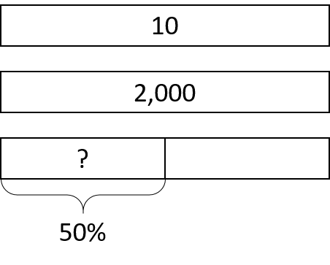

13.3: Nine is . . .
Explain how you can calculate each value mentally.
- 9 is 50% of what number?
- 9 is 25% of what number?
- 9 is 10% of what number?
- 9 is 75% of what number?
- 9 is 150% of what number?
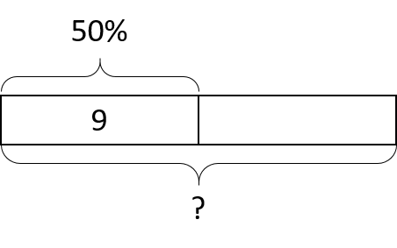

13.4: Matching the Percentage
Match the percentage that describes the relationship between each pair of numbers. One percentage will be left over. Be prepared to explain your reasoning.
- 7 is what percentage of 14?
- 5 is what percentage of 20?
- 3 is what percentage of 30?
- 6 is what percentage of 8?
- 20 is what percentage of 5?
- 4%
- 10%
- 25%
- 50%
- 75%
- 400%

Are you ready for more?
- What percentage of the world’s current population is under the age of 14?
- How many people is that?
- How many people are 14 or older?

Lesson 13 Summary
Certain percentages are easy to think about in terms of fractions.
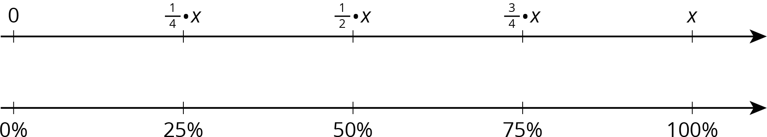
- 25% of a number is always $\frac{1}{4}$ of that number.
For example, 25% of 40 liters is $\frac{1}{4}⋅40$ or 10 liters.
- 50% of a number is always $\frac{1}{2}$ of that number.
For example, 50% of 82 kilometers $\frac{1}{2}⋅82$ or 41 kilometers.
- 75% of a number is always $\frac{3}{4}$ of that number.
For example, 75% of 1 pound is $\frac{3}{4}$ pound.
- 10% of a number is always $\frac{1}{10}$ of that number.
For example, 10% of 95 meters is 9.5 meters.
- We can also find multiples of 10% using tenths.
For example, 70% of a number is always $\frac{7}{10}$ of that number, so 70% of 30 days is $\frac{7}{10}⋅30$ or 21 days.
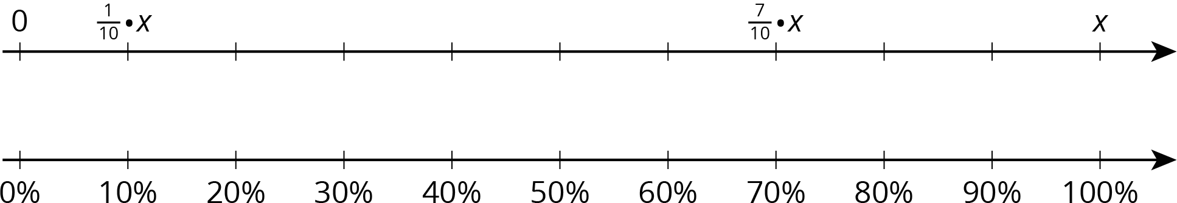
© CC BY Open Up Resources. Adaptations CC BY IM.

