Lesson 14: Solving Percentage Problems
Let’s solve more percentage problems.

14.1: Number Talk: Multiplication with Decimals
Find the products mentally.
$6⋅\left(0.8\right)⋅2$
$\left(4.5\right)⋅\left(0.6\right)⋅4$

14.2: Coupons
Han and Clare go shopping, and they each have a coupon. Answer each question and show your reasoning.
- Han buys an item with a normal price of $15, and uses a 10% off coupon. How much does he save by using the coupon?
- 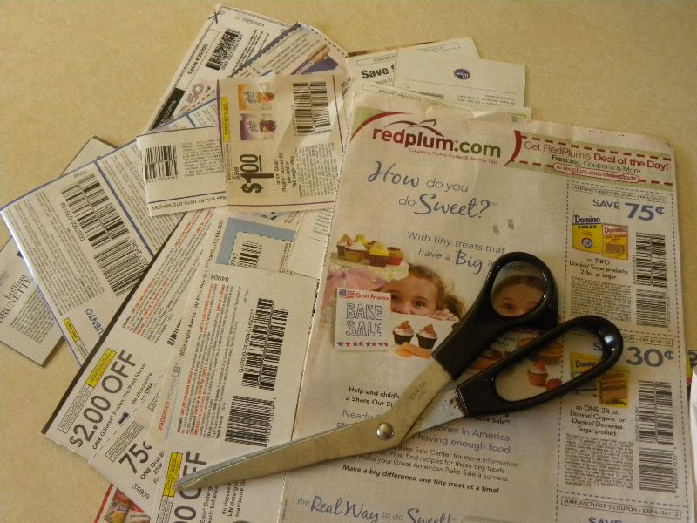
- Clare buys an item with a normal price of $24, but saves $6 by using a coupon. For what percentage off is this coupon?

Are you ready for more?
Clare paid full price for an item. Han bought the same item for 80% of the full price. Clare said, “I can’t believe I paid 125% of what you paid, Han!” Is what she said true? Explain.

14.3: Info Gap: Music Devices
Your teacher will give you either a problem card or a data card. Do not show or read your card to your partner.
If your teacher gives you the problem card:
- Silently read your card and think about what information you need to be able to answer the question.
- Ask your partner for the specific information that you need.
- Explain how you are using the information to solve the problem.
- Continue to ask questions until you have enough information to solve the problem.
- Share the problem card and solve the problem independently.
- Read the data card and discuss your reasoning.
If your teacher gives you the data card:
- Silently read your card.
- Ask your partner “What specific information do you need?” and wait for them to ask for information.
- If your partner asks for information that is not on the card, do not do the calculations for them. Tell them you don’t have that information.
- Before sharing the information, ask “Why do you need that information?” Listen to your partner’s reasoning and ask clarifying questions.
- Read the problem card and solve the problem independently.
- Share the data card and discuss your reasoning.

Lesson 14 Summary
A pot can hold 36 liters of water. What percentage of the pot is filled when it contains 9 liters of water?
Here are two different ways to solve this problem:
- Using a double number line:
- 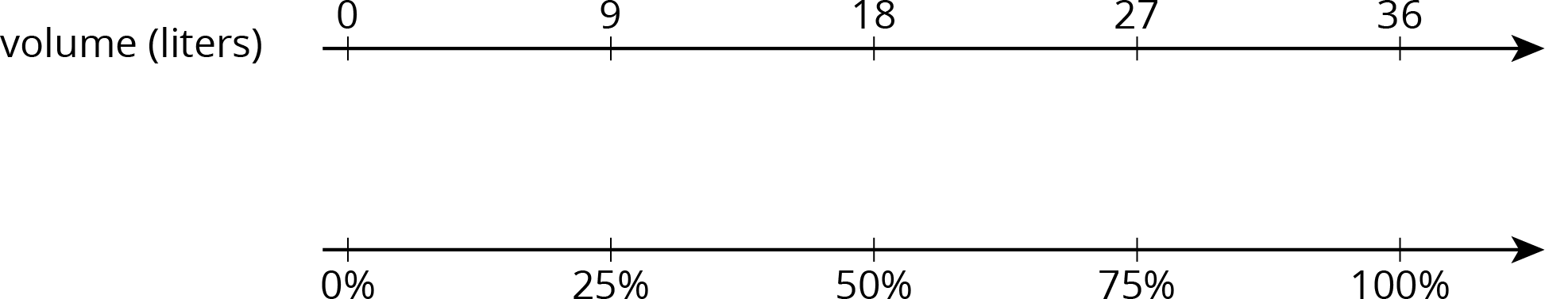
- We can divide the distance between 0 and 36 into four equal intervals, so 9 is $\frac{1}{4}$ of 36, or 9 is 25% of 36.
- Using a table:
- 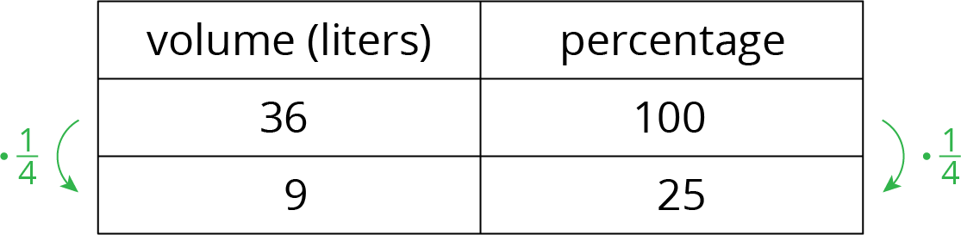
© CC BY Open Up Resources. Adaptations CC BY IM.

