Unit 1 Lesson 2: Finding Area by Decomposing and Rearranging

1 What is Area? (Warm up)

Student Task Statement
You may recall that the term area tells us something about the number of squares inside a two-dimensional shape.
- Here are four drawings that each show squares inside a shape. Select all drawings whose squares could be used to find the area of the shape. Be prepared to explain your reasoning.
- 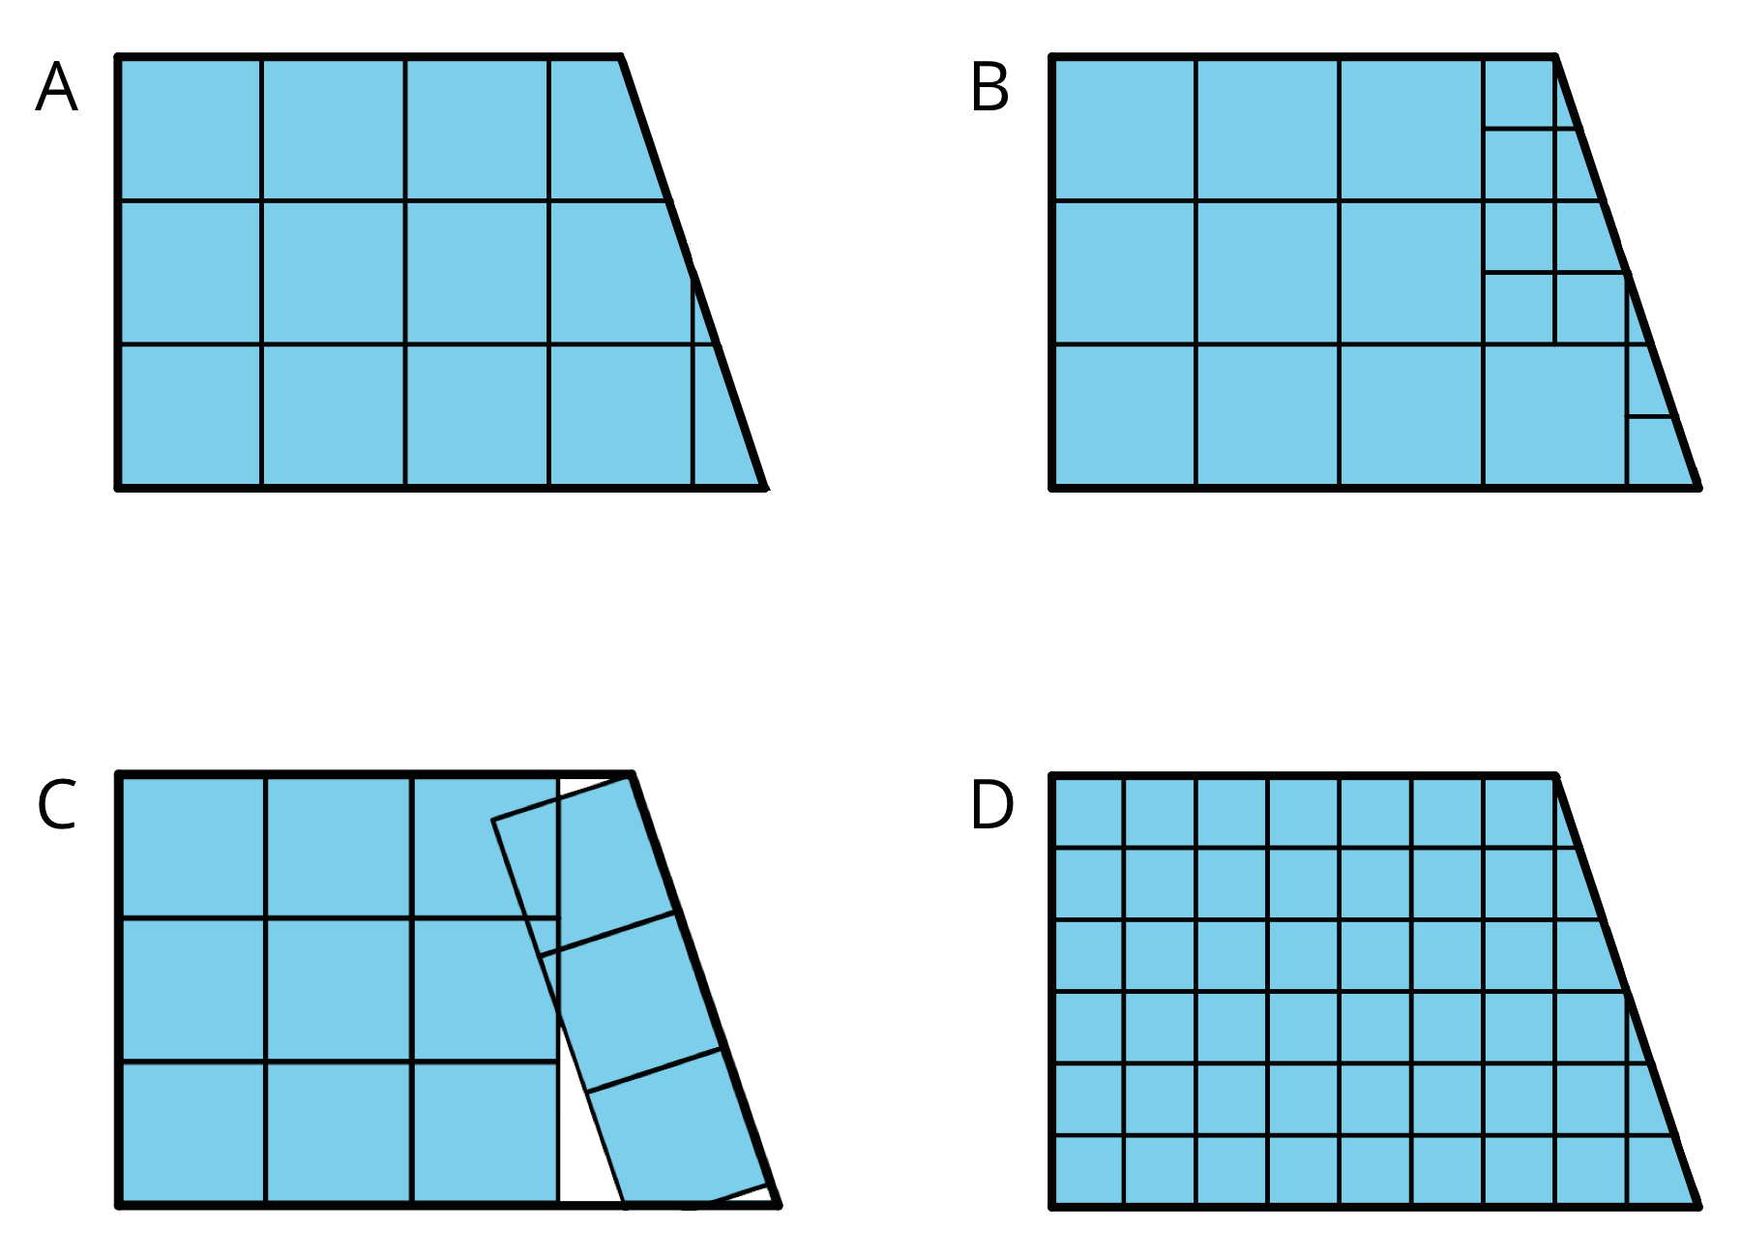
- Write a definition of area that includes all the information that you think is important.

2 Composing Shapes

Student Task Statement
Your teacher will give you one square and some small, medium, and large right triangles. The area of the square is 1 square unit.
- Notice that you can put together two small triangles to make a square. What is the area of the square composed of two small triangles? Be prepared to explain your reasoning.
- Use your shapes to create a new shape with an area of 1 square unit that is not a square. Trace your shape.
- Use your shapes to create a new shape with an area of 2 square units. Trace your shape.
- Use your shapes to create a different shape with an area of 2 square units. Trace your shape.
- Use your shapes to create a new shape with an area of 4 square units. Trace your shape.

Activity Synthesis
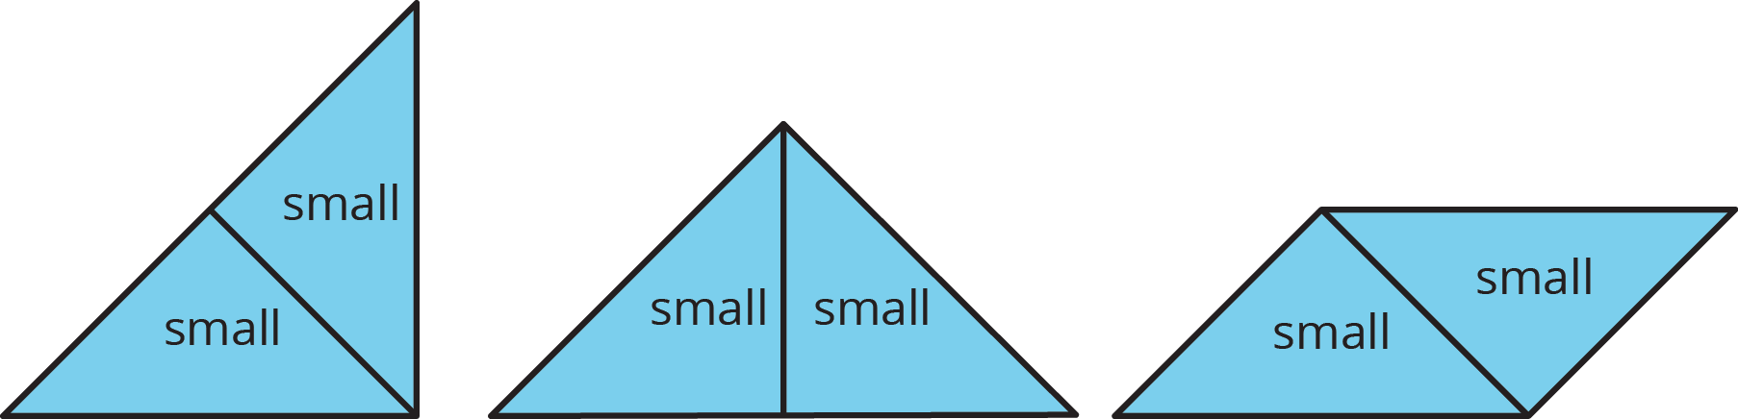

3 Tangram Triangles (Optional)

Student Task Statement
Recall that the area of the square you saw earlier is 1 square unit. Complete each statement and explain your reasoning.
- The area of the small triangle is _________ square units. I know this because . . .
- The area of the medium triangle is _________ square units. I know this because . . .
- The area of the large triangle is _________ square units. I know this because . . .

Images for Activity Synthesis
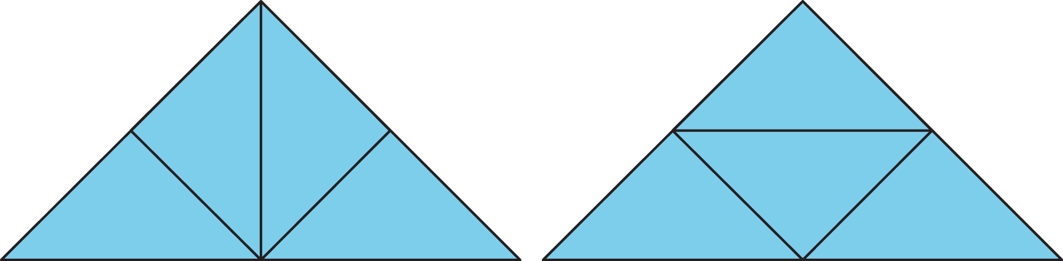
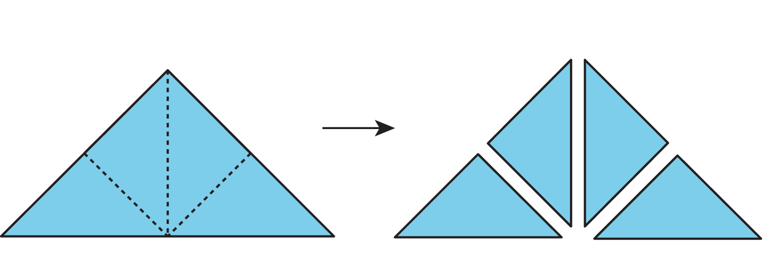
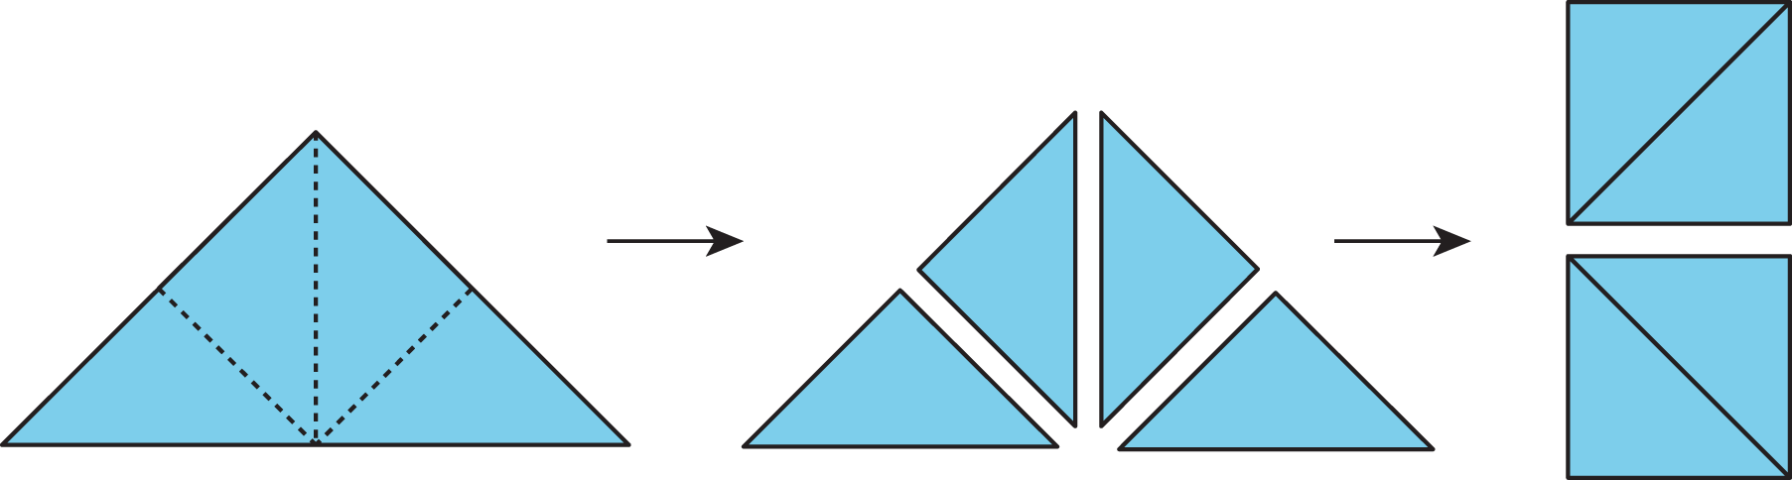
© CC BY Open Up Resources. Adaptations CC BY IM.

