Unit 4 Lesson 13: Rectangles with Fractional Side Lengths

1 Areas of Squares (Warm up)

Student Task Statement
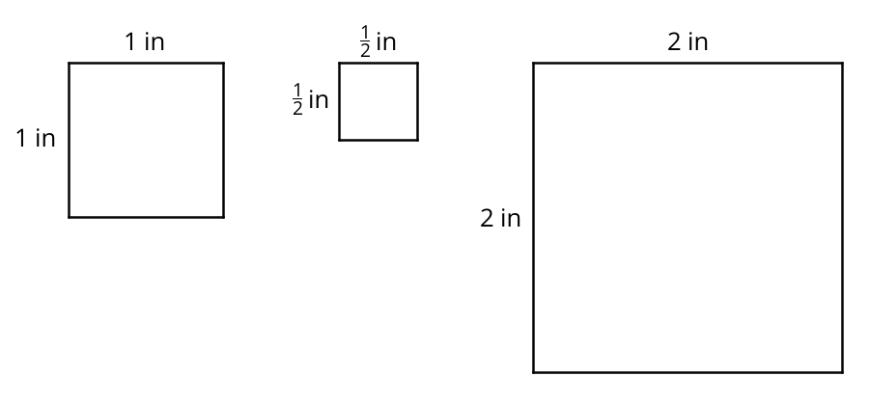
- What do you notice about the areas of the squares?
- Kiran says “A square with side lengths of $\frac{1}{3}$ inch has an area of $\frac{1}{3}$ square inches.” Do you agree? Explain or show your reasoning.

2 Areas of Squares and Rectangles

Student Task Statement
Your teacher will give you graph paper and a ruler.
- On the graph paper, draw a square with side lengths of 1 inch. Inside this square, draw another square with side lengths of $\frac{1}{4}$ inch.
- Use your drawing to answer the questions.
  - How many squares with side lengths of $\frac{1}{4}$ inch can fit in a square with side lengths of 1 inch?
  - What is the area of a square with side lengths of $\frac{1}{4}$ inch? Explain or show your reasoning.
- On the graph paper, draw a rectangle that is $3\frac{1}{2}$ inches by $2\frac{1}{4}$ inches.
- For each question, write a division expression and then find the answer.
  - How many $\frac{1}{4}$-inch segments are in a length of $3\frac{1}{2}$ inches?
  - How many $\frac{1}{4}$-inch segments are in a length of $2\frac{1}{4}$ inches?
- Use your drawing to show that a rectangle that is $3\frac{1}{2}$ inches by $2\frac{1}{4}$ inches has an area of $7\frac{7}{8}$ square inches.

Activity Synthesis
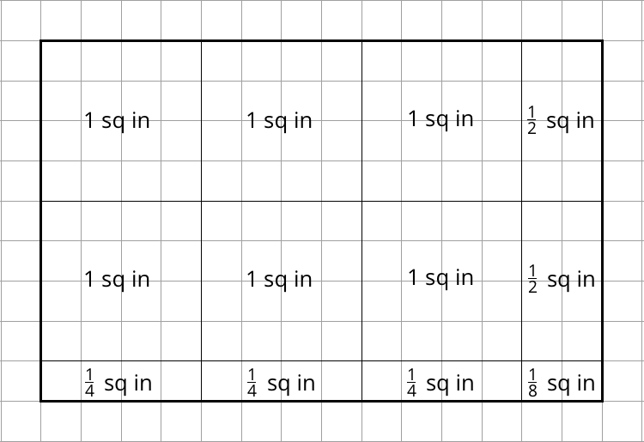
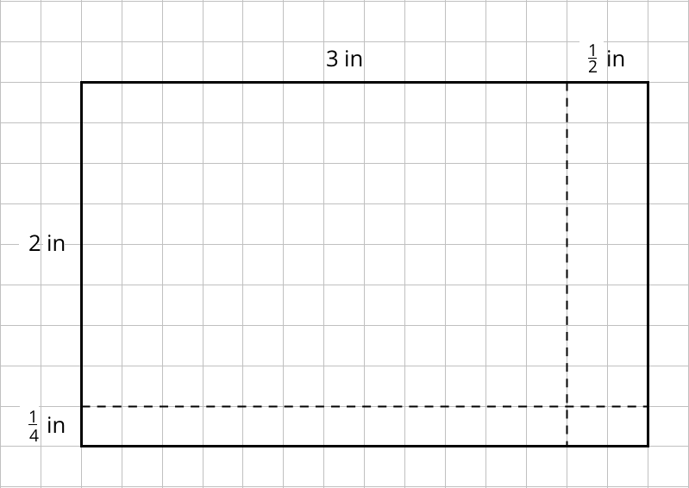

3 Areas of Rectangles (Optional)

Student Task Statement
Each of these multiplication expressions represents the area of a rectangle.
$2⋅4$
$2\frac{1}{2}⋅4$
$2⋅4\frac{3}{4}$
$2\frac{1}{2}⋅4\frac{3}{4}$
- All regions shaded in light blue have the same area. Match each diagram to the expression that you think represents its area. Be prepared to explain your reasoning.
- 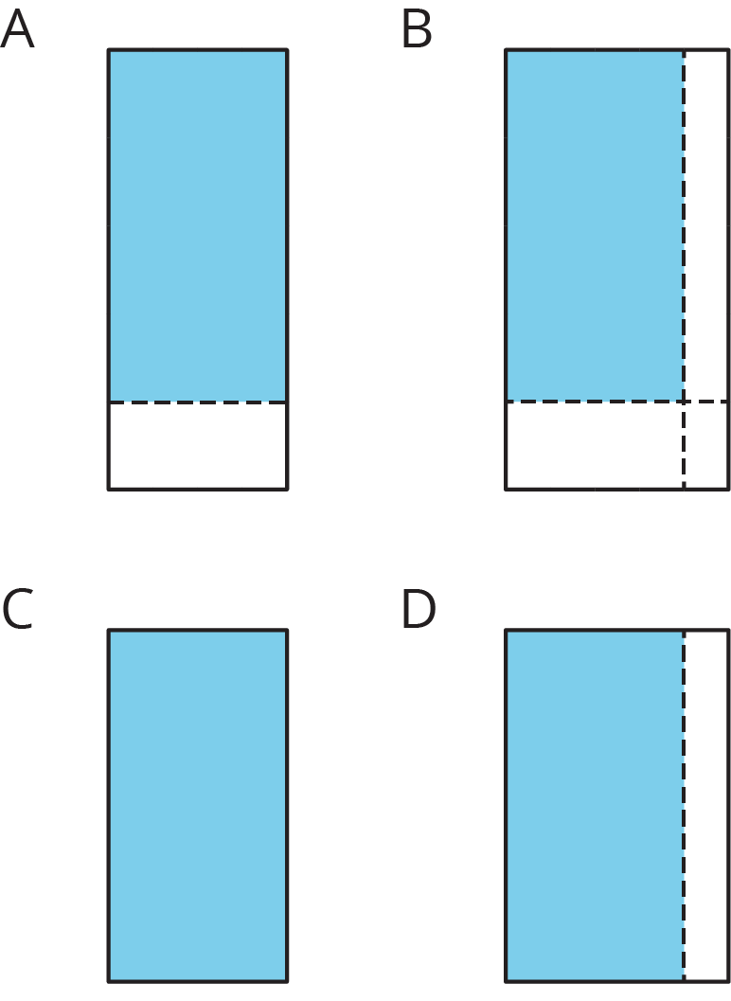
- Use the diagram that matches $2\frac{1}{2}⋅4\frac{3}{4}$ to show that the value of $2\frac{1}{2}⋅4\frac{3}{4}$ is $11\frac{7}{8}$.

4 How Many Would it Take? (Part 2)

Student Task Statement
Noah would like to cover a rectangular tray with rectangular tiles. The tray has a width of $11\frac{1}{4}$ inches and an area of $50\frac{5}{8}$ square inches.
- Find the length of the tray in inches.
- If the tiles are $\frac{3}{4}$ inch by $\frac{9}{16}$ inch, how many would Noah need to cover the tray completely, without gaps or overlaps? Explain or show your reasoning.
- Draw a diagram to show how Noah could lay the tiles. Your diagram should show how many tiles would be needed to cover the length and width of the tray, but does not need to show every tile.

Activity Synthesis
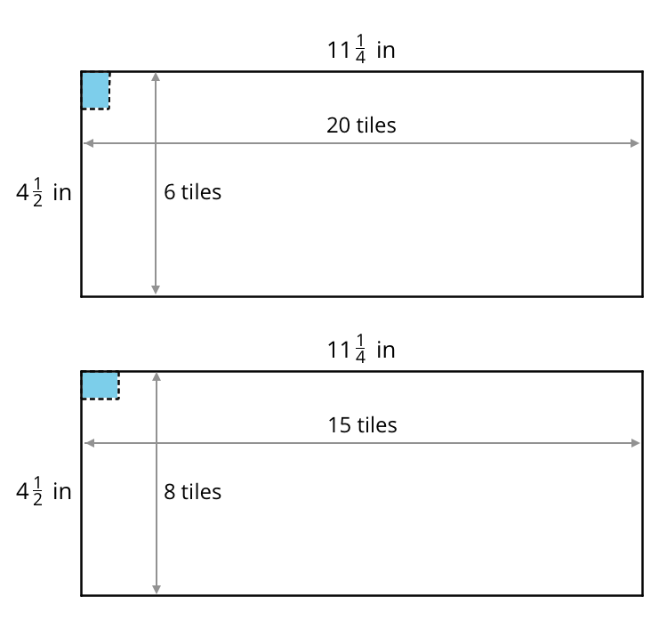
© CC BY Open Up Resources. Adaptations CC BY IM.

