Unit 4 Lesson 14: Fractional Lengths in Triangles and Prisms

1 Area of Triangle (Warm up)

Student Task Statement
Find the area of Triangle A in square centimeters. Show your reasoning.
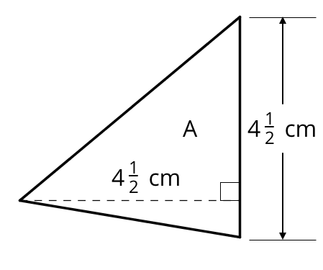

2 Bases and Heights of Triangles

Student Task Statement
- The area of Triangle B is 8 square units. Find the length of $b$. Show your reasoning.
- 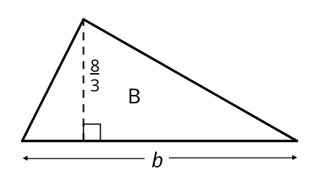
- The area of Triangle C is $\frac{54}{5}$ square units. What is the length of $h$? Show your reasoning.
- 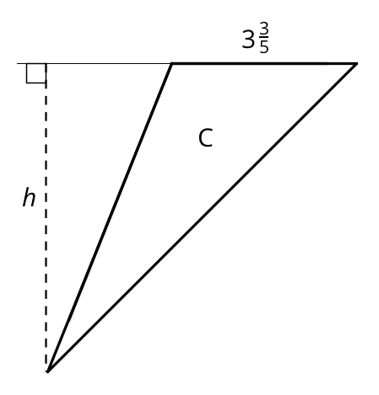

3 Volumes of Cubes and Prisms

Student Task Statement
Your teacher will give you cubes that have edge lengths of $\frac{1}{2}$ inch.
- Here is a drawing of a cube with edge lengths of 1 inch.
- 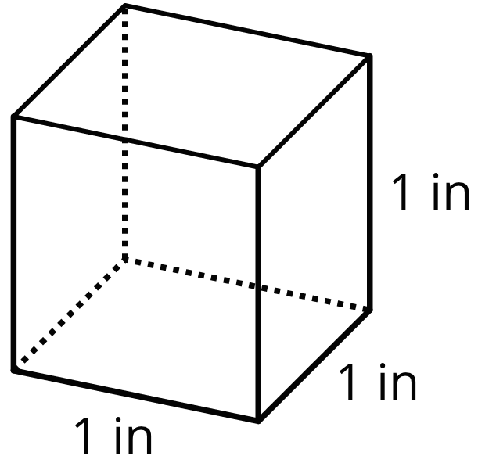
  - How many cubes with edge lengths of $\frac{1}{2}$ inch are needed to fill this cube?
  - What is the volume, in cubic inches, of a cube with edge lengths of $\frac{1}{2}$ inch? Explain or show your reasoning.
- Four cubes are piled in a single stack to make a prism. Each cube has an edge length of $\frac{1}{2}$ inch. Sketch the prism, and find its volume in cubic inches.
- Use cubes with an edge length of $\frac{1}{2}$ inch to build prisms with the lengths, widths, and heights shown in the table.
  - For each prism, record in the table how many $\frac{1}{2}$-inch cubes can be packed into the prism and the volume of the prism.
- prism  length (in) | - prism  width (in) | - prism  height (in) | - number of $\frac{1}{2}$-inch  cubes in prism | - volume of  prism (in³)
- $\frac{1}{2}$ | - $\frac{1}{2}$ | - $\frac{1}{2}$
- 1 | - 1 | - $\frac{1}{2}$
- 2 | - 1 | - $\frac{1}{2}$
- 2 | - 2 | - 1
- 4 | - 2 | - $\frac{3}{2}$
- 5 | - 4 | - 2
- 5 | - 4 | - $2\frac{1}{2}$
  - Examine the values in the table. What do you notice about the relationship between the edge lengths of each prism and its volume?
- What is the volume of a rectangular prism that is $1\frac{1}{2}$ inches by $2\frac{1}{4}$ inches by 4 inches? Show your reasoning.
© CC BY Open Up Resources. Adaptations CC BY IM.

