Lesson 5 Practice Problems
- The diameter of a bike wheel is 27 inches. If the wheel makes 15 complete rotations, how far does the bike travel?
- The wheels on Kiran's bike are 64 inches in circumference. How many times do the wheels rotate if Kiran rides 300 yards?
- The numbers are measurements of radius, diameter, and circumference of circles A and B. Circle A is smaller than circle B. Which number belongs to which quantity?
- 2.5, 5, 7.6, 15.2, 15.7, 47.7
- (From Unit 3, Lesson 4.)
- Circle A has circumference $2\frac{2}{3}$ m. Circle B has a diameter that is $1\frac{1}{2}$ times as long as Circle A’s diameter. What is the circumference of Circle B?
- (From Unit 3, Lesson 3.)
- The length of segment $AE$ is 5 centimeters.
- 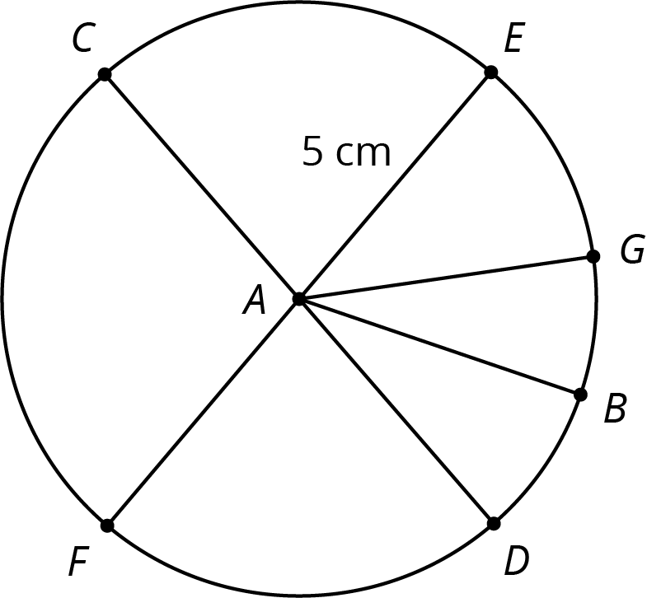
  - What is the length of segment $CD$?
  - What is the length of segment $AB$?
  - Name a segment that has the same length as segment $AB$.
- (From Unit 3, Lesson 2.)
© CC BY Open Up Resources. Adaptations CC BY IM.

