Lesson 15 Practice Problems
- Here is the base of a prism.
- 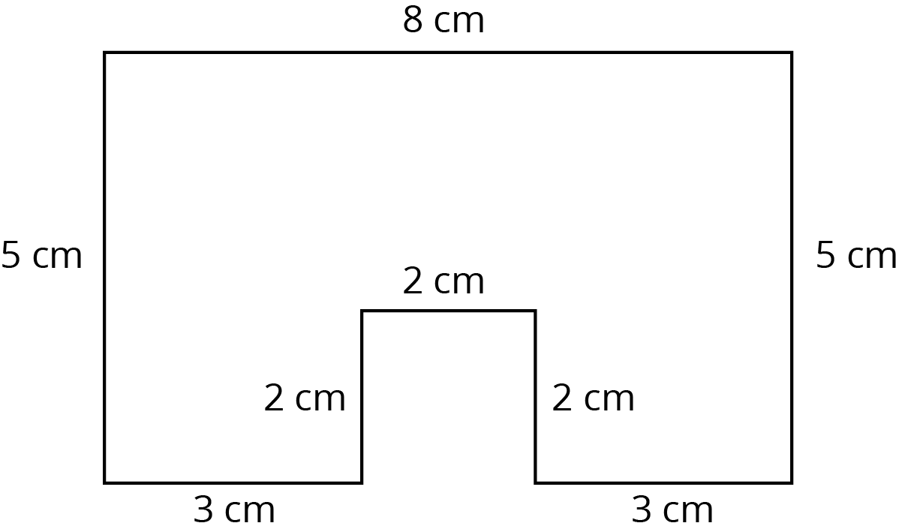
  - If the height of the prism is 5 cm, what is its surface area? What is its volume?
  - If the height of the prism is 10 cm, what is its surface area? What is its volume?
  - When the height doubled, what was the percent increase for the surface area? For the volume?
- Select all the situations where knowing the volume of an object would be more useful than knowing its surface area.
  - Determining the amount of paint needed to paint a barn.
  - Determining the monetary value of a piece of gold jewelry.
  - Filling an aquarium with buckets of water.
  - Deciding how much wrapping paper a gift will need.
  - Packing a box with watermelons for shipping.
  - Charging a company for ad space on your race car.
  - Measuring the amount of gasoline left in the tank of a tractor.
- Han draws a triangle with a ${50}^{∘}$ angle, a ${40}^{∘}$ angle, and a side of length 4 cm as shown. Can you draw a different triangle with the same conditions?
- 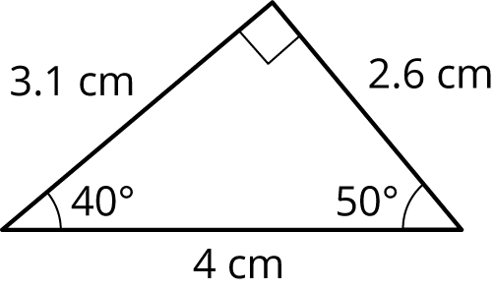

- (From Unit 7, Lesson 9.)
- Angle $H$ is half as large as angle $J$. Angle $J$ is one fourth as large as angle $K$. Angle $K$ has measure 240 degrees. What is the measure of angle $H$?
- (From Unit 7, Lesson 3.)
- The Colorado state flag consists of three horizontal stripes of equal height. The side lengths of the flag are in the ratio $2:3$. The diameter of the gold-colored disk is equal to the height of the center stripe. What percentage of the flag is gold?
- (From Unit 4, Lesson 9.)
© CC BY Open Up Resources. Adaptations CC BY IM.

