Unit 8 Lesson 13: Median

1 The Plot of the Story (Warm up)

Student Task Statement
- Here are two dot plots and two stories. Match each story with a dot plot that could represent it. Be prepared to explain your reasoning.
- 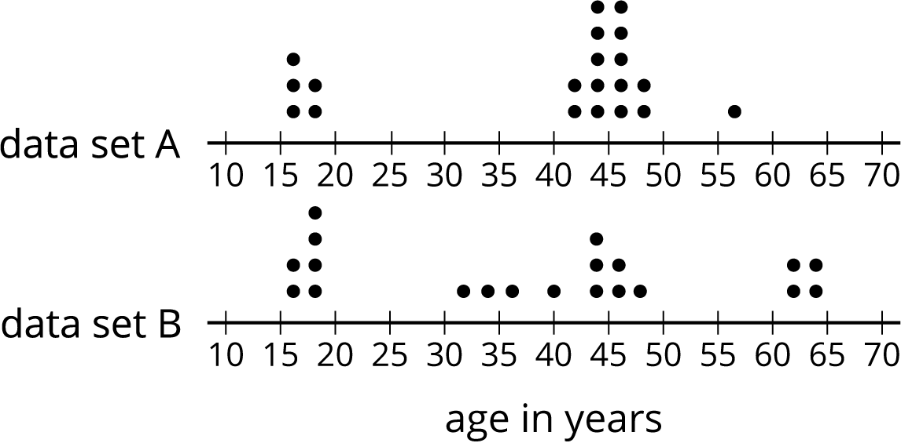

  - Twenty people—high school students, teachers, and invited guests—attended a rehearsal for a high school musical. The mean age was 38.5 years and the MAD was 16.5 years.
  - High school soccer team practice is usually watched by supporters of the players. One evening, twenty people watched the team practice. The mean age was 38.5 years and the MAD was 12.7 years.
- Another evening, twenty people watched the soccer team practice. The mean age was similar to that from the first evening, but the MAD was greater (about 20 years).
- Make a dot plot that could illustrate the distribution of ages in this story.
- 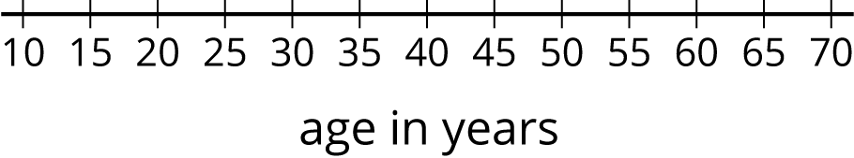

2 Siblings in the House

Student Task Statement
Here is data that shows the numbers of siblings of ten students in Tyler’s class.
1
0
2
1
7
0
2
0
1
10
- Represent the data shown with a dot plot.
- Without making any calculations, estimate the center of the data based on your dot plot. What is a typical number of siblings for these sixth-grade students? Mark the location of that number on your dot plot.
- Find the mean. Show your reasoning.

  - How does the mean compare to the value that you marked on the dot plot as a typical number of siblings? (Is it a little larger, a lot larger, exactly the same, a little smaller, or a lot smaller than your estimate?)
  - Do you think the mean summarizes the data set well? Explain your reasoning.

3 Finding the Middle

Student Task Statement
- Your teacher will give you an index card. Write your first and last names on the card. Then record the total number of letters in your name. After that, pause for additional instructions from your teacher.
- Here is the data set on numbers of siblings from an earlier activity.
- 1
- 0
- 2
- 1
- 7
- 0
- 2
- 0
- 1
- 10
  - Sort the data from least to greatest, and then find the median.
  - In this situation, do you think the median is a good measure of a typical number of siblings for this group? Explain your reasoning.
- Here is the dot plot showing the travel time, in minutes, of Elena’s bus rides to school.
- 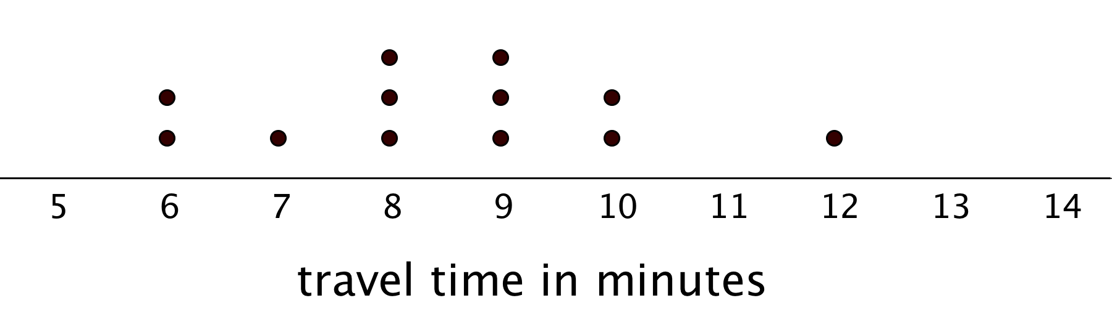
  - Find the median travel time. Be prepared to explain your reasoning.
  - What does the median tell us in this context?
© CC BY Open Up Resources. Adaptations CC BY IM.

