Unit 8 Lesson 15: Quartiles and Interquartile Range

1 Notice and Wonder: Two Parties (Warm up)

Student Task Statement
Here are dot plots that show the ages of people at two different parties. The mean of each distribution is marked with a triangle.
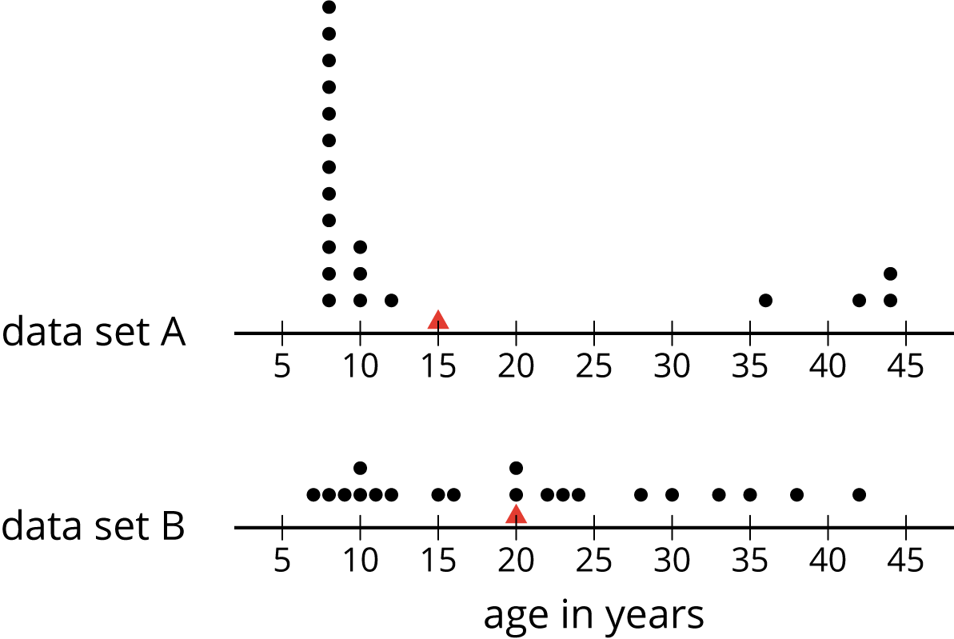
What do you notice and what do you wonder about the distributions in the two dot plots?

2 The Five-Number Summary

Student Task Statement
Here are the ages of the people at one party, listed from least to greatest.
7 | 8 | 9 | 10 | 10 | 11 | 12 | 15
16 | 20 | 20 | 22 | 23 | 24 | 28 | 30
33 | 35 | 38 | 42

  - Find the median of the data set and label it “50th percentile.” This splits the data into an upper half and a lower half.
  - Find the middle value of the lower half of the data, without including the median. Label this value “25th percentile.”
  - Find the middle value of the upper half of the data, without including the median. Label this value “75th percentile.”
- You have split the data set into four pieces. Each of the three values that split the data is called a quartile.
  - We call the 25th percentile the first quartile. Write “Q1” next to that number.
  - The median can be called the second quartile. Write “Q2” next to that number.
  - We call the 75th percentile the third quartile. Write “Q3” next to that number.
- Label the lowest value in the set “minimum” and the greatest value “maximum.”
- The values you have identified make up the five-number summary for the data set. Record them here.
- minimum: _____ Q1: _____ Q2: _____ Q3: _____ maximum: _____
- The median of this data set is 20. This tells us that half of the people at the party were 20 years old or younger, and the other half were 20 or older. What do each of these other values tell us about the ages of the people at the party?
  - the third quartile
  - the minimum
  - the maximum

Activity Synthesis
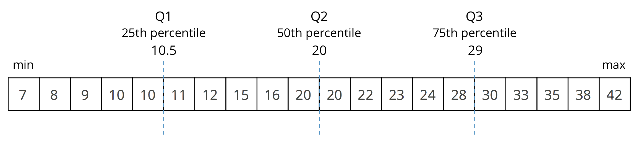

3 Range and Interquartile Range

Student Task Statement
- Here is a dot plot that shows the lengths of Elena’s bus rides to school, over 12 days.
- 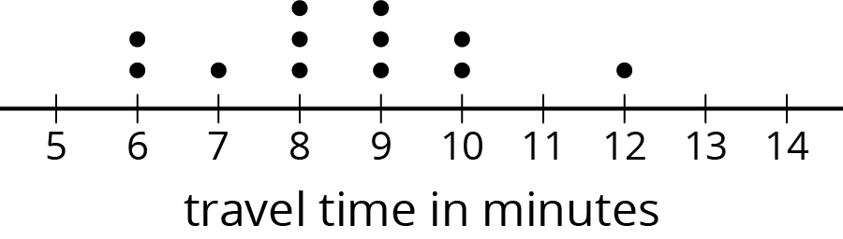
- Write the five-number summary for this data set. Show your reasoning.
- The range is one way to describe the spread of values in a data set. It is the difference between the maximum and minimum. What is the range of Elena’s travel times?
- Another way to describe the spread of values in a data set is the interquartile range (IQR). It is the difference between the upper quartile and the lower quartile.
  - What is the interquartile range (IQR) of Elena’s travel times?
  - What fraction of the data values are between the lower and upper quartiles?
- Here are two more dot plots.
- 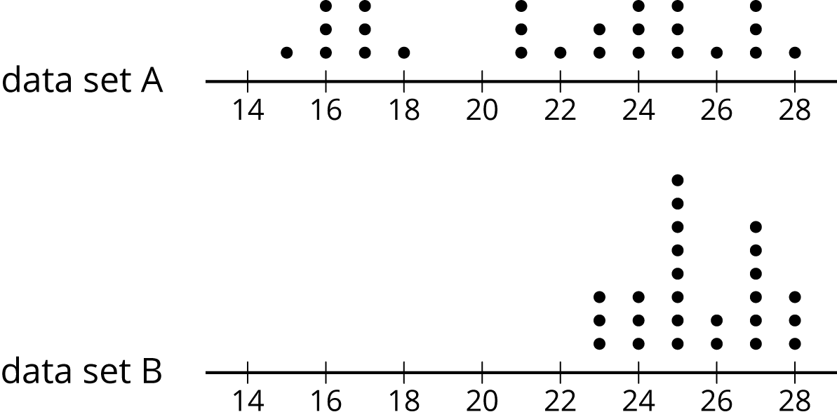
- Without doing any calculations, predict:
  - Which data set has the smaller range?
  - Which data set has the smaller IQR?
- Check your predictions by calculating the range and IQR for the data in each dot plot.
© CC BY Open Up Resources. Adaptations CC BY IM.

