Unit 8 Lesson 4: Dot Plots

1 Pizza Toppings (Part 1) (Warm up)

Student Task Statement
Fifteen customers in a pizza shop were asked, “How many toppings did you add to your cheese pizza?” Here are their responses:
1 | 2 | 1 | 3 | 0 | 1 | 1 | 2
0 | 3 | 0 | 0 | 1 | 2 | 2

- Could you use a dot plot to represent the data? Explain your reasoning.
- Complete the table.
- number of toppings | - frequency (number)
- 0
- 1
- 2
- 3

2 Pizza Toppings (Part 2)

Student Task Statement
- Use the tables from the warm-up to display the number of toppings as a dot plot. Label your drawing clearly.
- 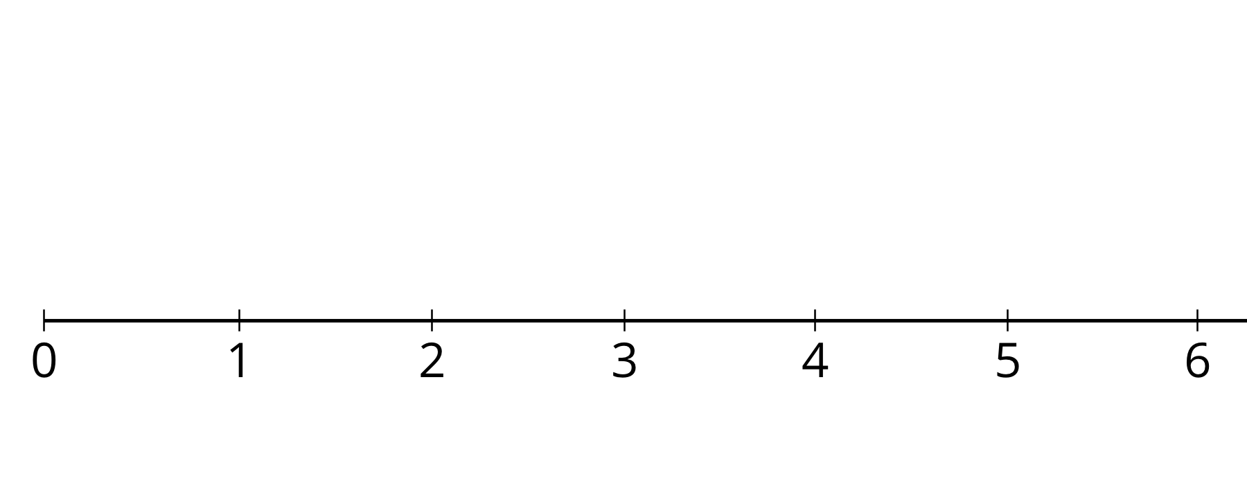
- Use your dot plot to study the distribution for number of toppings. What do you notice about the number of toppings that this group of customers ordered? Write 2–3 sentences summarizing your observations.

3 Homework Time

Student Task Statement
Twenty-five sixth-grade students answered the question: “How many hours do you generally spend on homework each week?”
This dot plot shows the number of hours per week that these 25 students reported spending on homework.
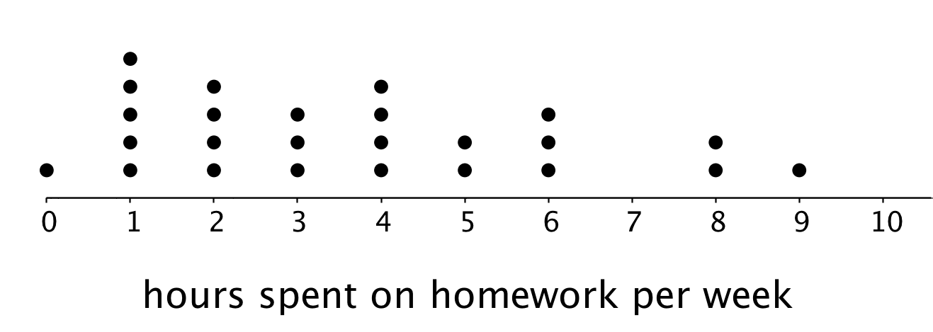
Use the dot plot to answer the following questions. For each, show or explain your reasoning.
- What percentage of the students reported spending 1 hour on homework each week?
- What percentage of the students reported spending 4 or fewer hours on homework each week?
- Would 6 hours per week be a good description of the number of hours this group of students spends on homework per week? What about 1 hour per week? Explain your reasoning.
- What value do you think would be a good description of the homework time of the students in this group? Explain your reasoning.
- Someone said, “In general, these students spend roughly the same number of hours doing homework.” Do you agree? Explain your reasoning.

Images for Activity Synthesis
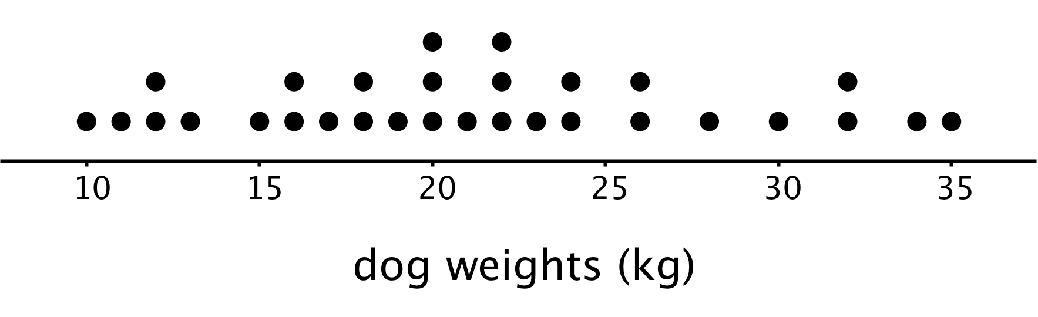
© CC BY Open Up Resources. Adaptations CC BY IM.

