Lesson 8: Measurement Error (Part 1)
Let’s check how accurate our measurements are.

8.1: How Long Are These Pencils?
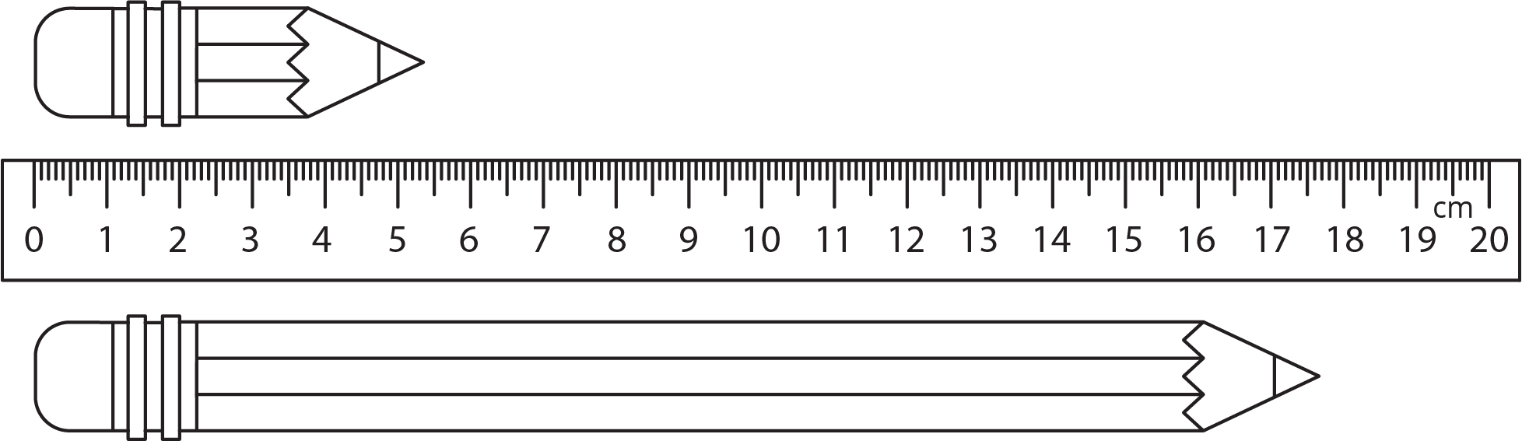
- Estimate the length of each pencil.
- How accurate are your estimates?
- For each estimate, what is the largest possible percent error?

8.2: How Long Are These Floor Boards?
A wood floor is made by laying multiple boards end to end. Each board is measured with a maximum percent error of 5%. What is the maximum percent error for the total length of the floor?
© CC BY Open Up Resources. Adaptations CC BY IM.

