Unit 7 Lesson 2: Points on the Number Line

1 A Point on the Number Line (Warm up)

Student Task Statement
Which of the following numbers could be $B$?
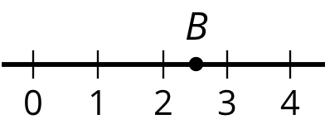

2.5
$\frac{2}{5}$
$\frac{5}{2}$
$\frac{25}{10}$
2.49

2 What’s the Temperature?

Student Task Statement
- Here are five thermometers. The first four thermometers show temperatures in Celsius. Write the temperatures in the blanks.
- 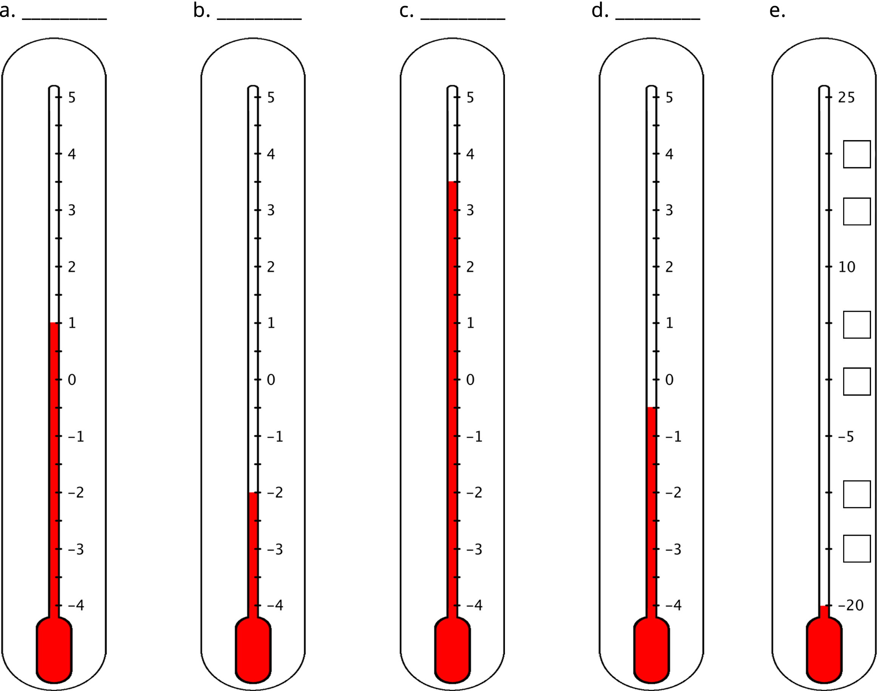
- The last thermometer is missing some numbers. Write them in the boxes.
- Elena says that the thermometer shown here reads $\text{-}{2.5}^{∘}\text{C}$ because the line of the liquid is above $\text{-}2^{∘}\text{C}$. Jada says that it is $\text{-}{1.5}^{∘}\text{C}$. Do you agree with either one of them? Explain your reasoning.
- 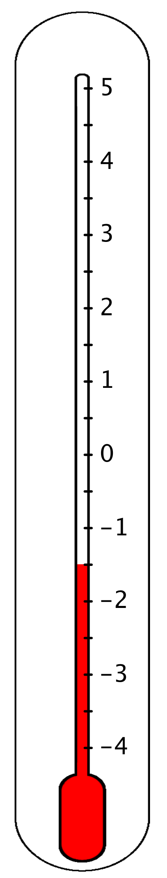
- One morning, the temperature in Phoenix, Arizona, was $8^{∘}\text{C}$ and the temperature in Portland, Maine, was ${12}^{∘}\text{C}$ cooler. What was the temperature in Portland?

3 Folded Number Lines

Student Task Statement
Your teacher will give you a sheet of tracing paper on which to draw a number line.
- Follow the steps to make your own number line.
  - Use a straightedge or a ruler to draw a horizontal line. Mark the middle point of the line and label it 0.
  - To the right of 0, draw tick marks that are 1 centimeter apart. Label the tick marks 1, 2, 3. . . 10. This represents the positive side of your number line.
  - Fold your paper so that a vertical crease goes through 0 and the two sides of the number line match up perfectly.
  - Use the fold to help you trace the tick marks that you already drew onto the opposite side of the number line. Unfold and label the tick marks -1, -2, -3. . . -10. This represents the negative side of your number line.
- Use your number line to answer these questions:
  - Which number is the same distance away from zero as is the number 4?
  - Which number is the same distance away from zero as is the number -7?
  - Two numbers that are the same distance from zero on the number line are called opposites. Find another pair of opposites on the number line.
  - Determine how far away the number 5 is from 0. Then, choose a positive number and a negative number that is each farther away from zero than is the number 5.
  - Determine how far away the number -2 is from 0. Then, choose a positive number and a negative number that is each farther away from zero than is the number -2.
- Pause here so your teacher can review your work.
- Here is a number line with some points labeled with letters. Determine the location of points $P$, $X$, and $Y$.
- 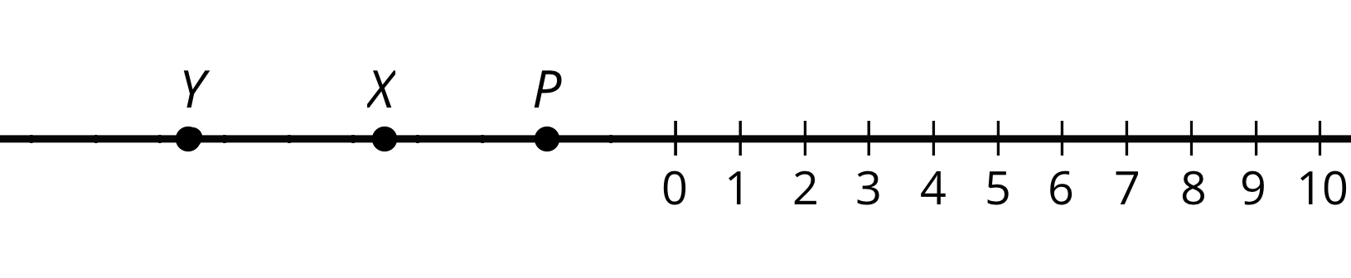
- If you get stuck, trace the number line and points onto a sheet of tracing paper, fold it so that a vertical crease goes through 0, and use the folded number line to help you find the unknown values.
© CC BY Open Up Resources. Adaptations CC BY IM.

