Unit 8 Lesson 7: Using Histograms to Answer Statistical Questions

1 Which One Doesn’t Belong: Questions (Warm up)

Student Task Statement
Here are four questions about the population of Alaska. Which question does not belong? Be prepared to explain your reasoning.
- In general, at what age do Alaska residents retire?
- At what age can Alaskans vote?
- What is the age difference between the youngest and oldest Alaska residents with a full-time job?
- Which age group is the largest part of the population: 18 years or younger, 19–25 years, 25–34 years, 35–44 years, 45–54 years, 55–64 years, or 65 years or older?

2 Measuring Earthworms

Student Task Statement
An earthworm farmer set up several containers of a certain species of earthworms so that he could learn about their lengths. The lengths of the earthworms provide information about their ages. The farmer measured the lengths of 25 earthworms in one of the containers. Each length was measured in millimeters.
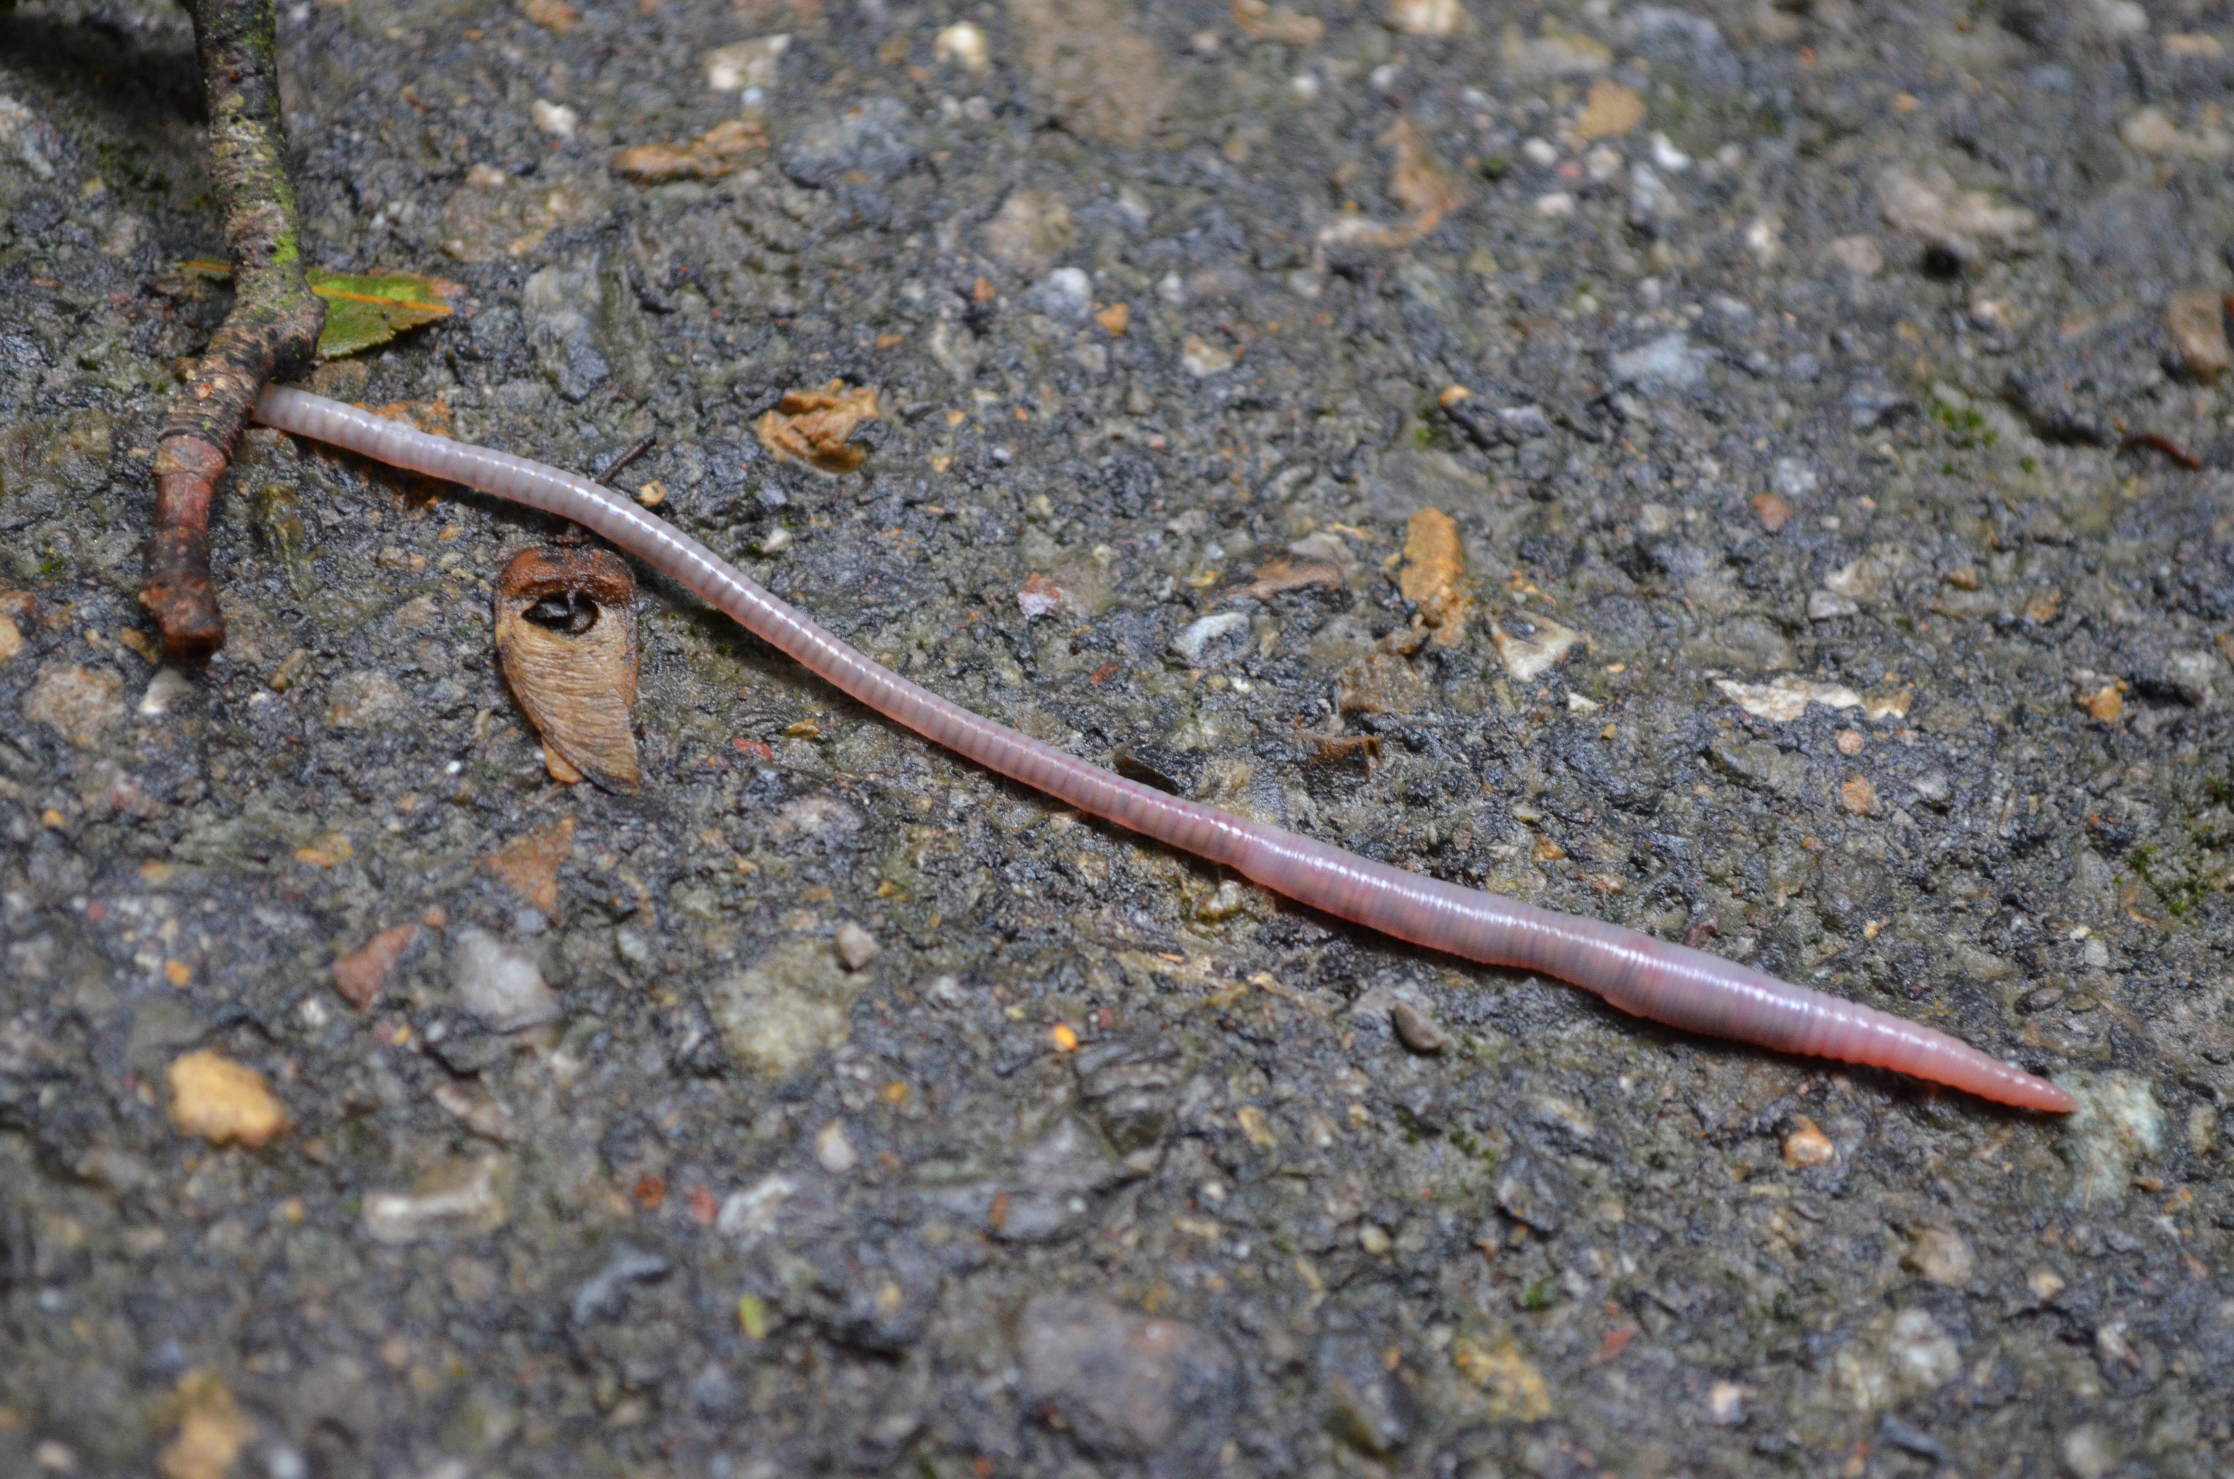
- Using a ruler, draw a line segment for each length:
  - 20 millimeters
  - 40 millimeters
  - 60 millimeters
  - 80 millimeters
  - 100 millimeters
- Here are the lengths, in millimeters, of the 25 earthworms.
- 6 | - 11 | - 18 | - 19 | - 20 | - 23 | - 23 | - 25
- 25 | - 26 | - 27 | - 27 | - 28 | - 29 | - 32 | - 33
- 41 | - 42 | - 48 | - 52 | - 54 | - 59 | - 60 | - 77
- 93

- Complete the table for the lengths of the 25 earthworms.
- length | - frequency
- 0 millimeters to less than 20 millimeters
- 20 millimeters to less than 40 millimeters
- 40 millimeters to less than 60 millimeters
- 60 millimeters to less than 80 millimeters
- 80 millimeters to less than 100 millimeters
- Use the grid and the information in the table to draw a histogram for the worm length data. Be sure to label the axes of your histogram.
- 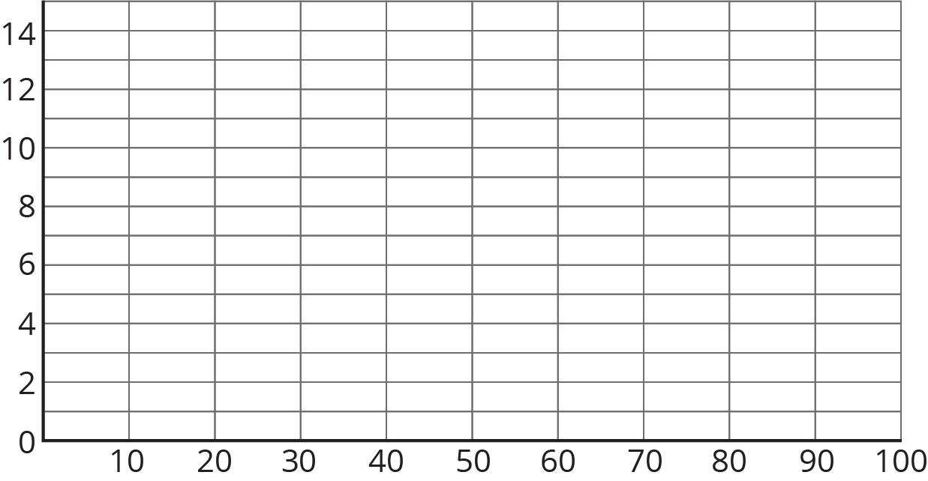
- Based on the histogram, what is a typical length for these 25 earthworms? Explain how you know.
- Write 1–2 sentences to describe the spread of the data. Do most of the worms have a length that is close to your estimate of a typical length, or are they very different in length?

3 Tall and Taller Players

Student Task Statement
Professional basketball players tend to be taller than professional baseball players.
Here are two histograms that show height distributions of 50 male professional baseball players and 50 male professional basketball players.
- Decide which histogram shows the heights of baseball players and which shows the heights of basketball players. Be prepared to explain your reasoning.
- 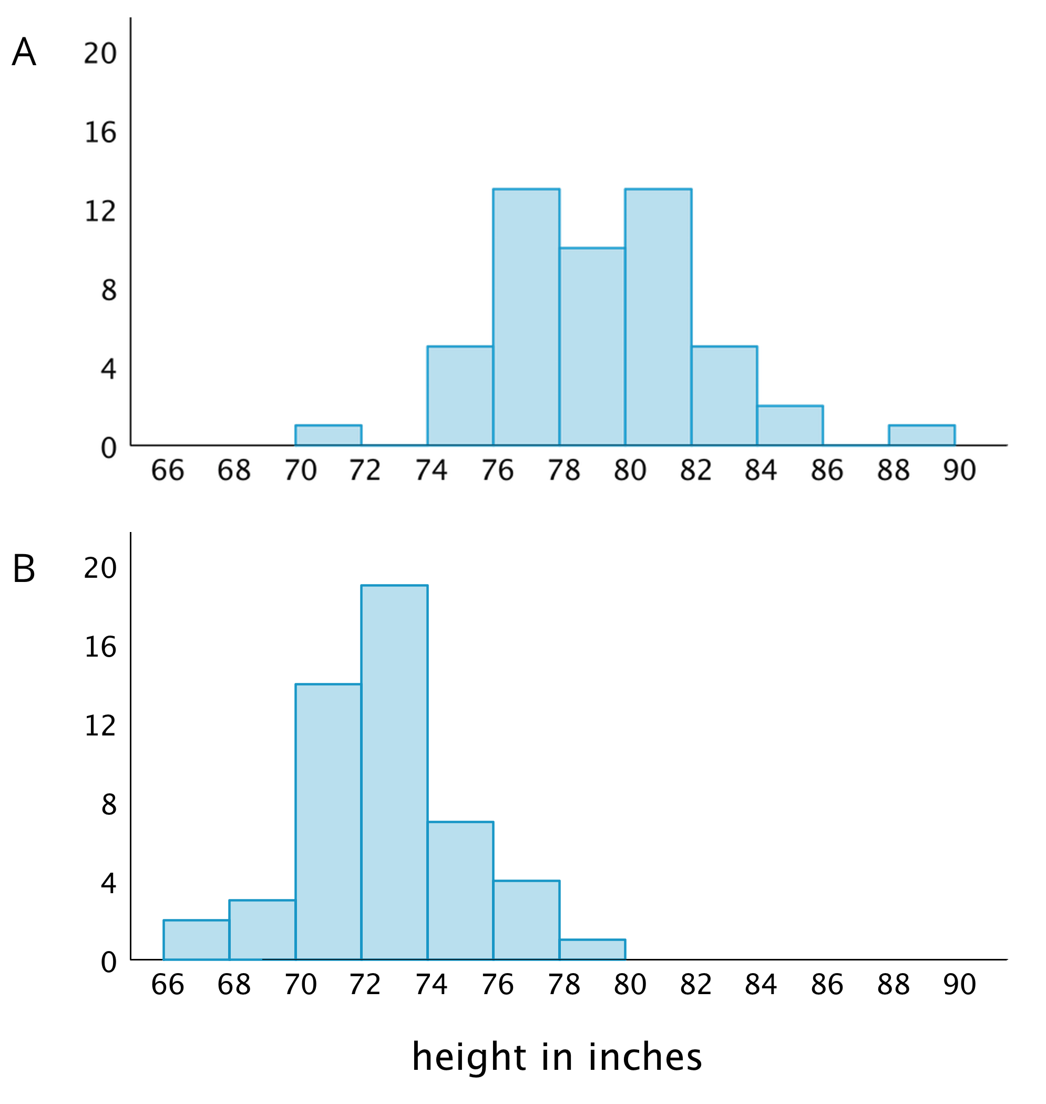
- Write 2–3 sentences that describe the distribution of the heights of the basketball players. Comment on the center and spread of the data.
- Write 2–3 sentences that describe the distribution of the heights of the baseball players. Comment on the center and spread of the data.

Images for Activity Synthesis
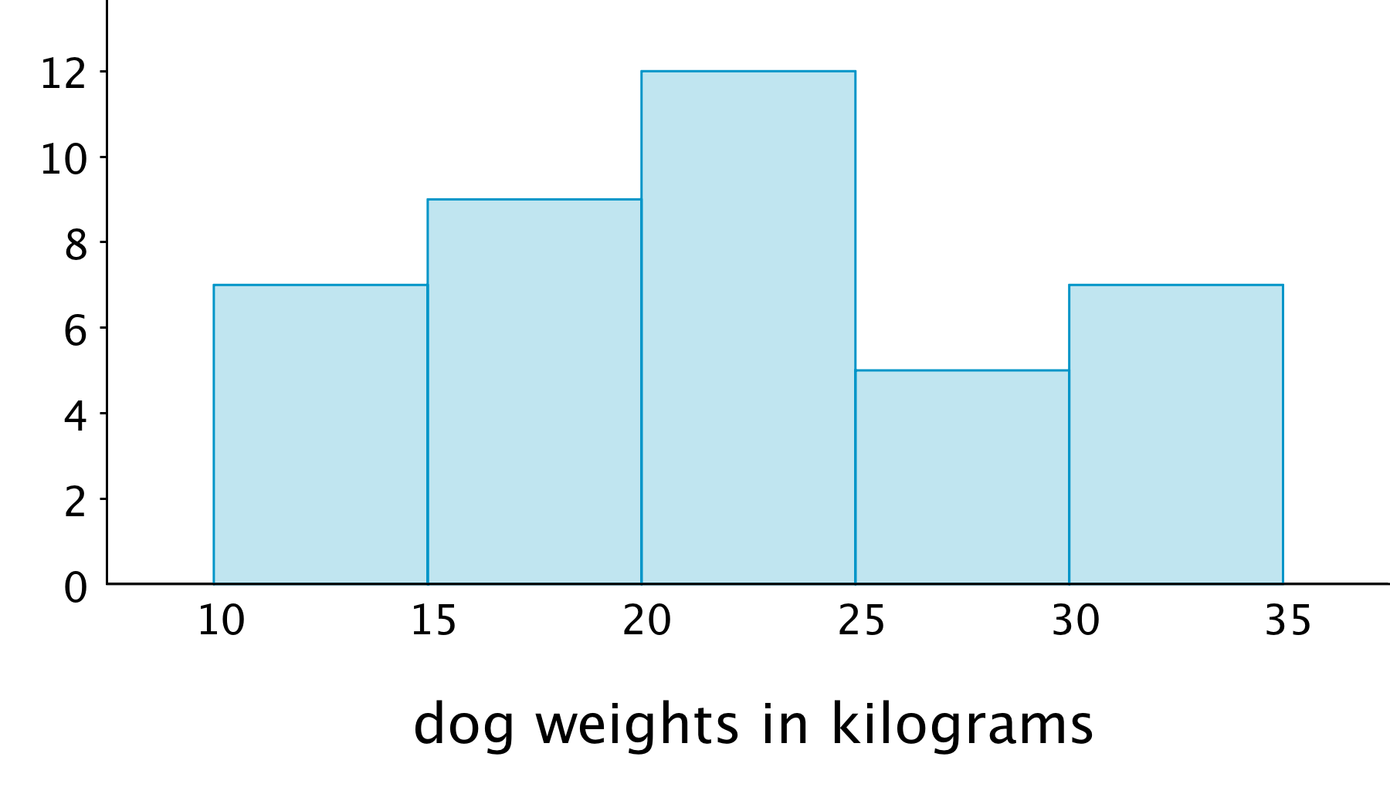
© CC BY Open Up Resources. Adaptations CC BY IM.

