## Unit 7 Lesson 1: Positive and Negative Numbers

### 1 Notice and Wonder: Memphis and Bangor (Warm up)

#### Student Task Statement

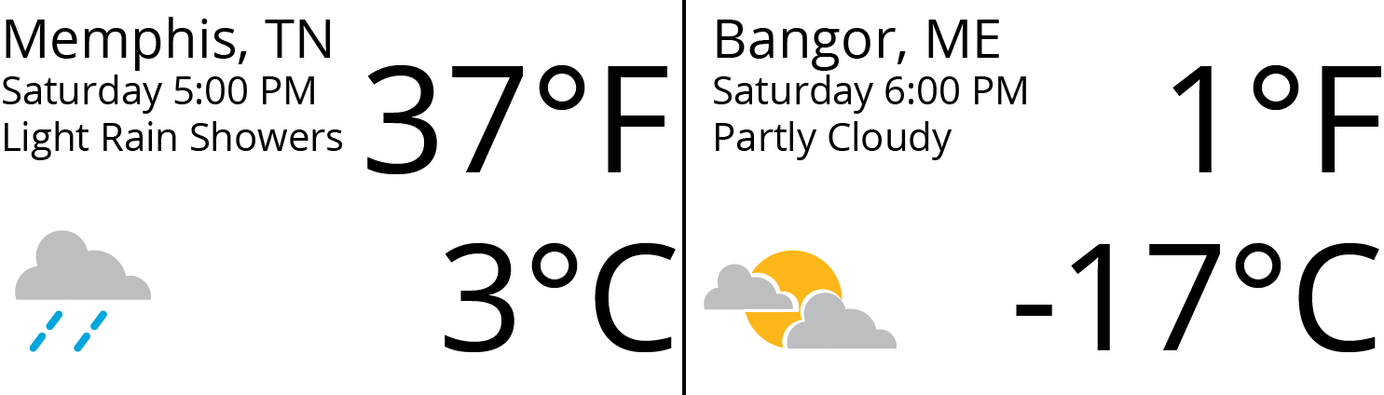

What do you notice? What do you wonder?

### 2 Above and Below Zero

#### Images for Launch

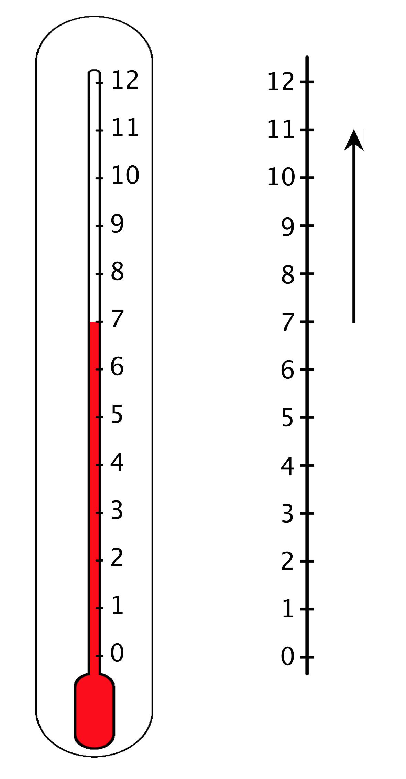

#### Student Task Statement

1. Here are three situations involving changes in temperature and three number lines. Represent each change on a number line. Then, answer the question.
   1. At noon, the temperature was 5 degrees Celsius. By late afternoon, it has risen 6 degrees Celsius. What was the temperature late in the afternoon?
   2. The temperature was 8 degrees Celsius at midnight. By dawn, it has dropped 12 degrees Celsius. What was the temperature at dawn?
   3. Water freezes at 0 degrees Celsius, but the freezing temperature can be lowered by adding salt to the water. A student discovered that adding half a cup of salt to a gallon of water lowers its freezing temperature by 7 degrees Celsius. What is the freezing temperature of the gallon of salt water?
   * 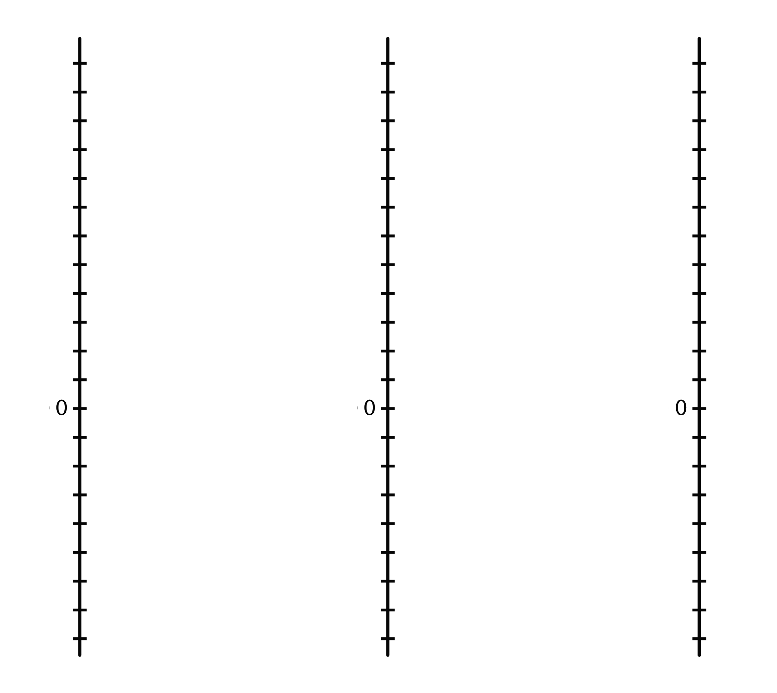
2. Discuss with a partner:
   1. How did each of you name the resulting temperature in each situation?
   2. What does it mean when the temperature is above 0? Below 0?
   3. Do numbers less than 0 make sense in other contexts? Give some specific examples to show how they do or do not make sense.

### 3 High Places, Low Places

#### Student Task Statement

1. Here is a table that shows elevations of various cities.

| * city | * elevation (feet) |
| --- | --- |
| * Harrisburg, PA | * 320 |
| * Bethell, IN | * 1,211 |
| * Denver, CO | * 5,280 |
| * Coachella, CA | * -22 |
| * Death Valley, CA | * -282 |
| * New York City, NY | * 33 |
| * Miami, FL | * 0 |

* 1. On the list of cities, which city has the second highest elevation?
  2. How would you describe the elevation of Coachella, CA in relation to sea level?
  3. How would you describe the elevation of Death Valley, CA in relation to sea level?
  4. If you are standing on a beach right next to the ocean, what is your elevation?
  5. How would you describe the elevation of Miami, FL?
  6. A city has a higher elevation than Coachella, CA. Select all numbers that could represent the city’s elevation. Be prepared to explain your reasoning.
     + -11 feet
     + -35 feet
     + 4 feet
     + -8 feet
     + 0 feet

1. Here are two tables that show the elevations of highest points on land and lowest points in the ocean. Distances are measured from sea level.

| * mountain | * continent | * elevation (meters) |
| --- | --- | --- |
| * Everest | * Asia | * 8,848 |
| * Kilimanjaro | * Africa | * 5,895 |
| * Denali | * North America | * 6,168 |
| * Pikchu Pikchu | * South America | * 5,664 |

| * trench | * ocean | * elevation (meters) |
| --- | --- | --- |
| * Mariana Trench | * Pacific | * -11,033 |
| * Puerto Rico Trench | * Atlantic | * -8,600 |
| * Tonga Trench | * Pacific | * -10,882 |
| * Sunda Trench | * Indian | * -7,725 |

* 1. Which point in the ocean is the lowest in the world? What is its elevation?
  2. Which mountain is the highest in the world? What is its elevation?
  3. If you plot the elevations of the mountains and trenches on a vertical number line, what would 0 represent? What would points above 0 represent? What about points below 0?
  4. Which is farther from sea level: the deepest point in the ocean, or the top of the highest mountain in the world? Explain.

#### Images for Activity Synthesis





© CC BY Open Up Resources. Adaptations CC BY IM.