Unit 8 Lesson 11: Variability and MAD

1 Shooting Hoops (Part 1) (Warm up)

Student Task Statement
Elena, Jada, and Lin enjoy playing basketball during recess. Lately, they have been practicing free throws. They record the number of baskets they make out of 10 attempts. Here are their data sets for 12 school days.
Elena
4
5
1
6
9
7
2
8
3
3
5
7
Jada
2
4
5
4
6
6
4
7
3
4
8
7
Lin
3
6
6
4
5
5
3
5
4
6
6
7
- Calculate the mean number of baskets each player made, and compare the means. What do you notice?
- What do the means tell us in this context?

2 Shooting Hoops (Part 2)

Student Task Statement
Here are the dot plots showing the number of baskets Elena, Jada, and Lin each made over 12 school days.
- On each dot plot, mark the location of the mean with a triangle ($Δ$). Then, contrast the dot plot distributions. Write 2–3 sentences to describe the shape and spread of each distribution.
- 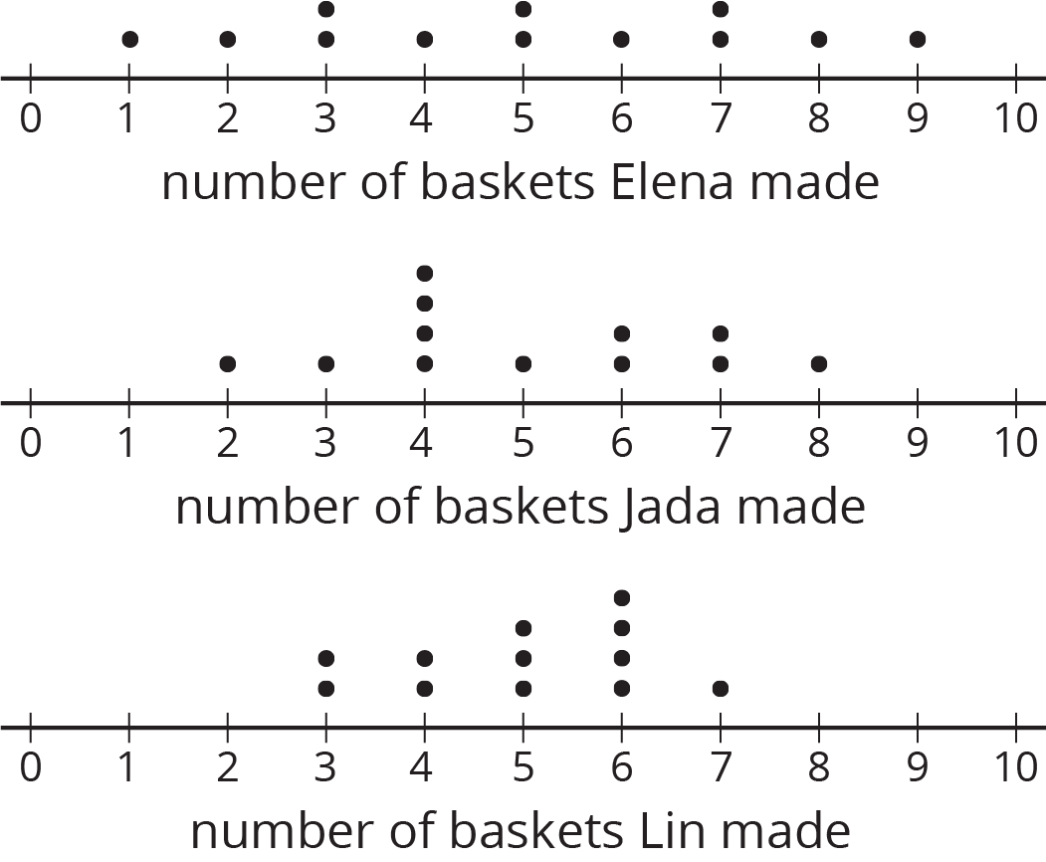

- Discuss the following questions with your group. Explain your reasoning.
  - Would you say that all three students play equally well?
  - Would you say that all three students play equally consistently?
  - If you could choose one player to be on your basketball team based on their records, who would you choose?

3 Shooting Hoops (Part 3)

Student Task Statement
The tables show Elena, Jada, and Lin’s basketball data from an earlier activity. Recall that the mean of Elena’s data, as well as that of Jada and Lin’s data, was 5.
- Record the distance between each of Elena’s scores and the mean.
- Elena | - 4 | - 5 | - 1 | - 6 | - 9 | - 7 | - 2 | - 8 | - 3 | - 3 | - 5 | - 7
- distance from 5 | - 1 |  |  | - 1
- Now find the average of the distances in the table. Show your reasoning and round your answer to the nearest tenth.
- This value is the mean absolute deviation (MAD) of Elena’s data.
- Elena’s MAD: _________
- Find the mean absolute deviation of Jada’s data. Round it to the nearest tenth.
- Jada | - 2 | - 4 | - 5 | - 4 | - 6 | - 6 | - 4 | - 7 | - 3 | - 4 | - 8 | - 7
- distance from 5
- Jada’s MAD: _________
- Find the mean absolute deviation of Lin’s data. Round it to the nearest tenth.
- Lin | - 3 | - 6 | - 6 | - 4 | - 5 | - 5 | - 3 | - 5 | - 4 | - 6 | - 6 | - 7
- distance from 5
- Lin’s MAD: _________
- Compare the MADs and dot plots of the three students’ data. Do you see a relationship between each student’s MAD and the distribution on her dot plot? Explain your reasoning.
- 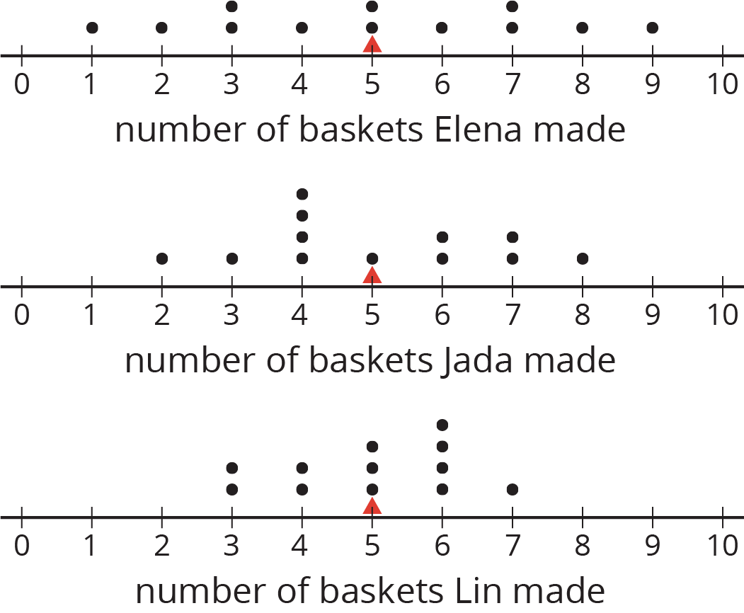

4 Game of 22 (Optional)

Student Task Statement
Your teacher will give your group a deck of cards. Shuffle the cards, and put the deck face down on the playing surface.
- To play: Draw 3 cards and add up the values. An ace is a 1. A jack, queen, and king are each worth 10. Cards 2–10 are each worth their face value. If your sum is anything other than 22 (either above or below 22), say: “My sum deviated from 22 by ____ ,” or “My sum was off from 22 by ____ .”
- To keep score: Record each sum and each distance from 22 in the table. After five rounds, calculate the average of the distances. The player with the lowest average distance from 22 wins the game.
player A | round 1 | round 2 | round 3 | round 4 | round 5
sum of cards
distance from 22
Average distance from 22: ____________
player B | round 1 | round 2 | round 3 | round 4 | round 5
sum of cards
distance from 22
Average distance from 22: ____________
player C | round 1 | round 2 | round 3 | round 4 | round 5
sum of cards
distance from 22
Average distance from 22: ____________
Whose average distance from 22 is the smallest? Who won the game?
© CC BY Open Up Resources. Adaptations CC BY IM.

