Lesson 5: Defining Equivalent Ratios
Let’s investigate equivalent ratios some more.

5.1: Dots and Half Dots
Dot Pattern 1:
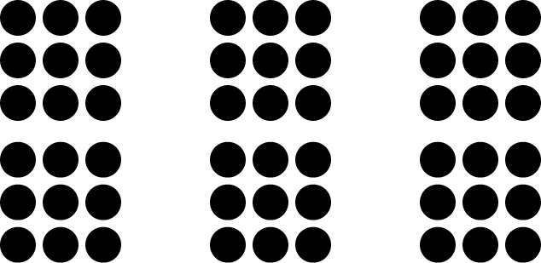
Dot Pattern 2:

5.2: Tuna Casserole
Here is a recipe for tuna casserole.

Ingredients
- 3 cups cooked elbow-shaped pasta
- 6 ounce can tuna, drained
- 10 ounce can cream of chicken soup
- 1 cup shredded cheddar cheese
- $1\frac{1}{2}$ cups French fried onions
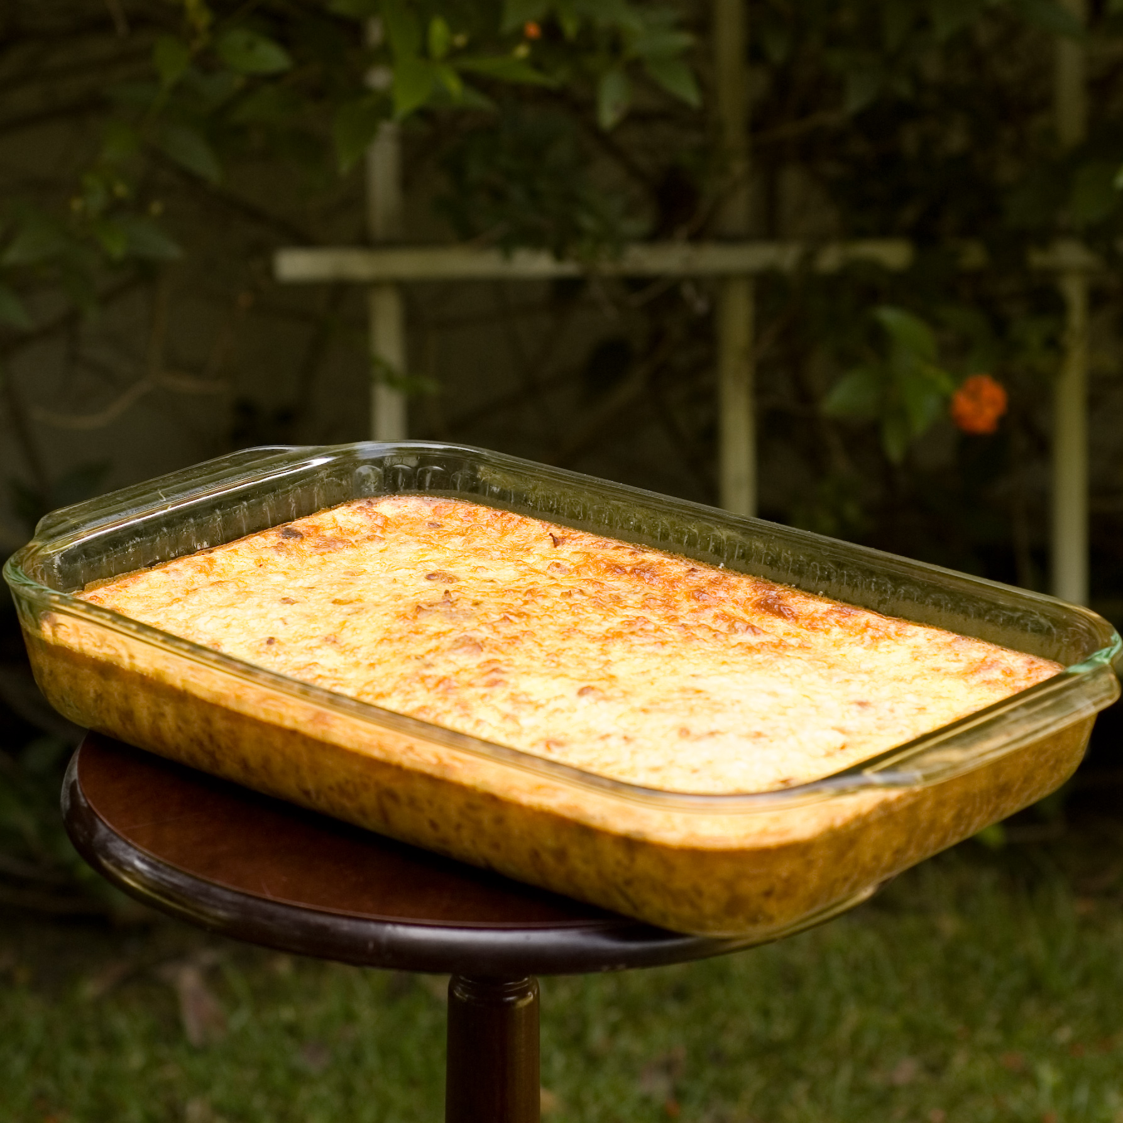
Instructions
Combine the pasta, tuna, soup, and half of the cheese. Transfer into a 9 inch by 18 inch baking dish. Put the remaining cheese on top. Bake 30 minutes at 350 degrees. During the last 5 minutes, add the French fried onions. Let sit for 10 minutes before serving.

- What is the ratio of the ounces of soup to the cups of shredded cheese to the cups of pasta in one batch of casserole?
- How much of each of these 3 ingredients would be needed to make:
  - twice the amount of casserole?
  - half the amount of casserole?
  - five times the amount of casserole?
  - one-fifth the amount of casserole?
- What is the ratio of cups of pasta to ounces of tuna in one batch of casserole?
- How many batches of casserole would you make if you used the following amounts of ingredients?
  - 9 cups of pasta and 18 ounces of tuna?
  - 36 ounces of tuna and 18 cups of pasta?
  - 1 cup of pasta and 2 ounces of tuna?

Are you ready for more?
The recipe says to use a 9 inch by 18 inch baking dish. Determine the length and width of a baking dish with the same height that could hold:
- Twice the amount of casserole
- Half the amount of casserole
- Five times the amount of casserole
- One-fifth the amount of casserole

5.3: What Are Equivalent Ratios?
The ratios $5:3$ and $10:6$ are equivalent ratios.
- Is the ratio $15:12$ equivalent to these? Explain your reasoning.
- Is the ratio $30:18$ equivalent to these? Explain your reasoning.
- Give two more examples of ratios that are equivalent to $5:3$.
- How do you know when ratios are equivalent and when they are not equivalent?
- Write a definition of equivalent ratios.
- Pause here so your teacher can review your work and assign you a ratio to use for your visual display.
- Create a visual display that includes:
  - the title “Equivalent Ratios”
  - your best definition of equivalent ratios
  - the ratio your teacher assigned to you
  - at least two examples of ratios that are equivalent to your assigned ratio
  - an explanation of how you know these examples are equivalent
  - at least one example of a ratio that is not equivalent to your assigned ratio
  - an explanation of how you know this example is not equivalent
- Be prepared to share your display with the class.

Lesson 5 Summary
All ratios that are equivalent to $a:b$ can be made by multiplying both $a$ and $b$ by the same number.
For example, the ratio $18:12$ is equivalent to $9:6$ because both 9 and 6 are multiplied by the same number: 2.
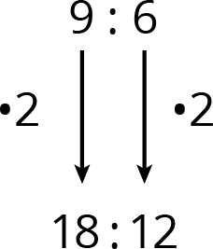
$3:2$ is also equivalent to $9:6$, because both 9 and 6 are multiplied by the same number: $\frac{1}{3}$.
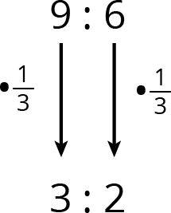
Is $18:15$ equivalent to $9:6$?
No, because 18 is $9⋅2$, but 15 is not $6⋅2$.
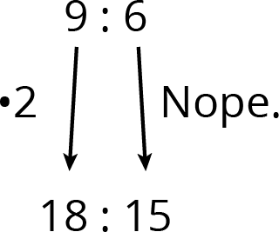
© CC BY Open Up Resources. Adaptations CC BY IM.

