Unit 7 Lesson 11: Points on the Coordinate Plane

1 Guess My Line (Warm up)

Student Task Statement
- Choose a horizontal or a vertical line on the grid. Draw 4 points on the line and label each point with its coordinates.
- 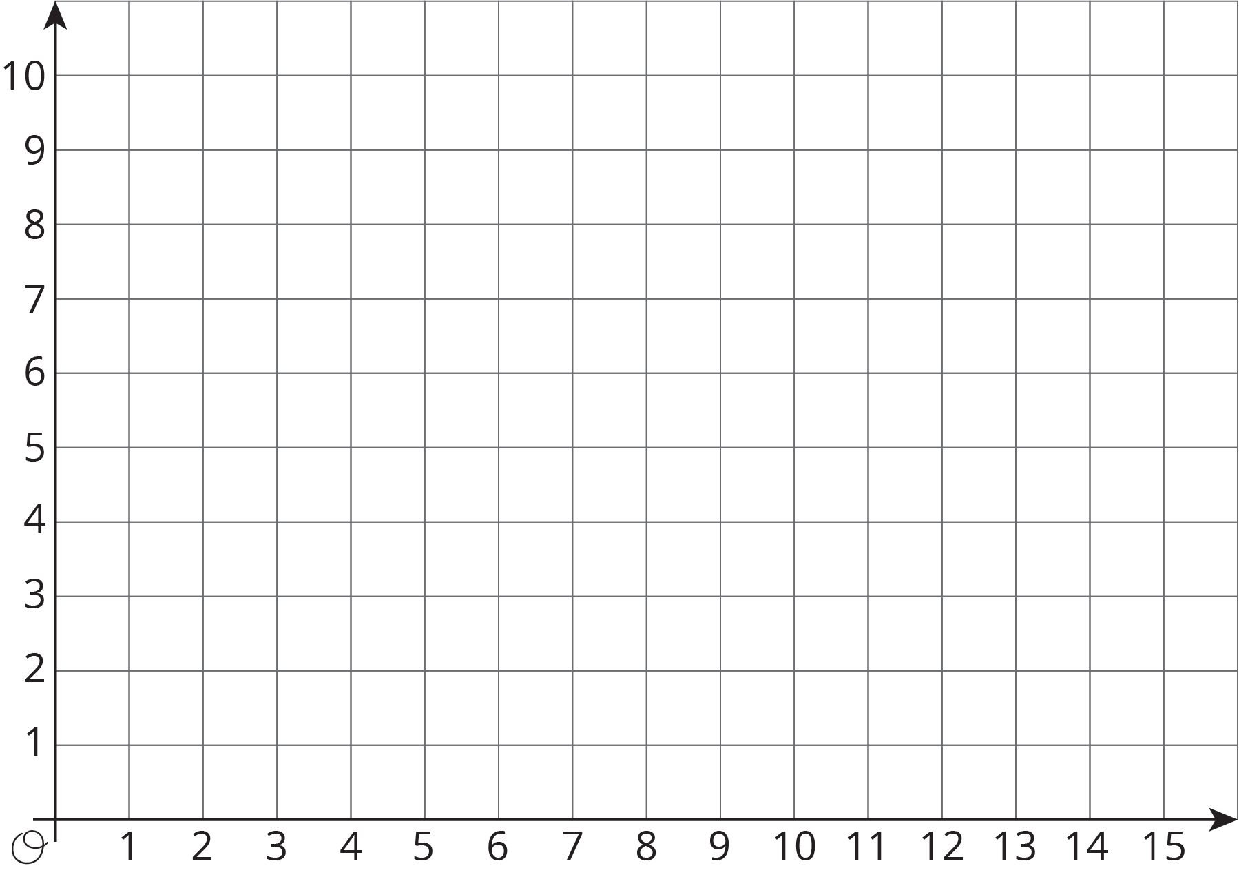
- Tell your partner whether your line is horizontal or vertical, and have your partner guess the locations of your points by naming coordinates.
- If a guess is correct, put an X through the point. If your partner guessed a point that is on your line but not the point that you plotted, say, “That point is on my line, but is not one of my points.”
- Take turns guessing each other’s points, 3 guesses per turn.

2 The Coordinate Plane

Student Task Statement
- Label each point on the coordinate plane with an ordered pair.
- 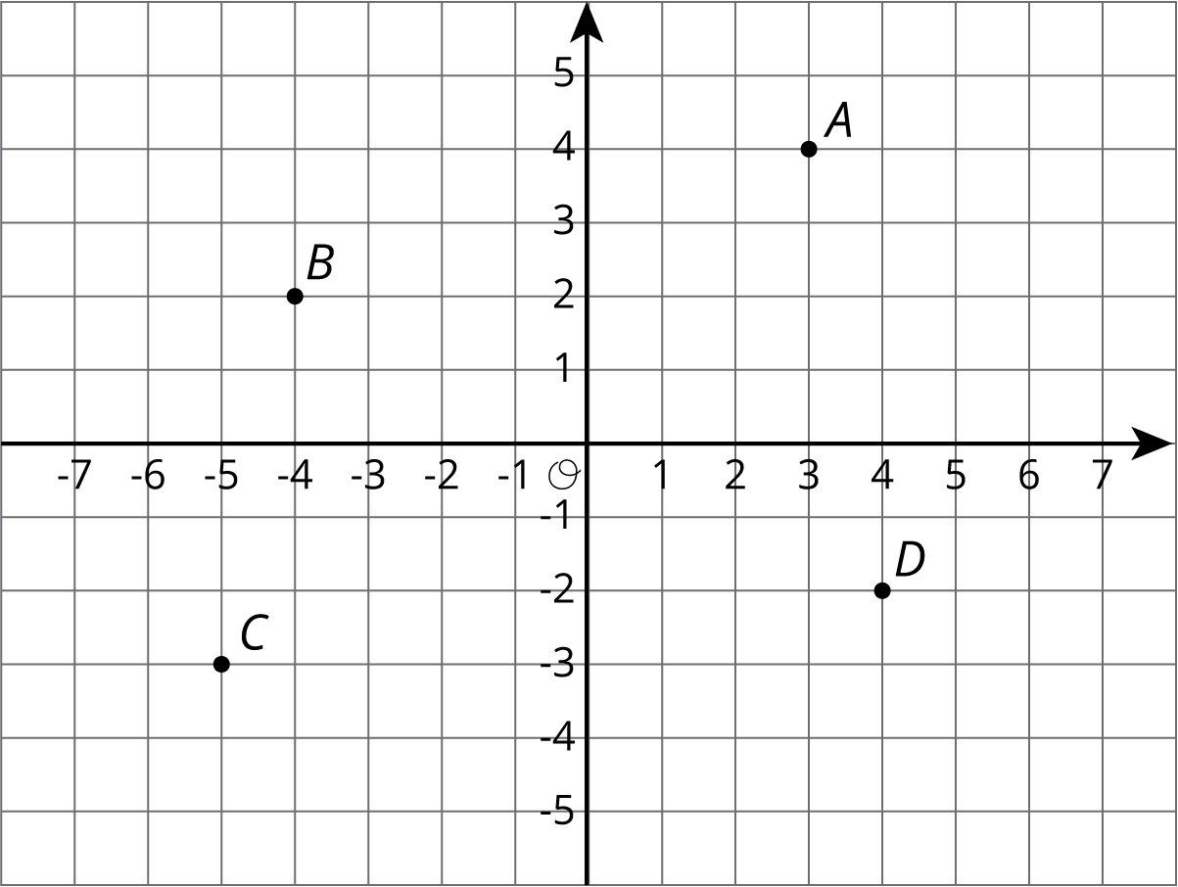
- What do you notice about the locations and ordered pairs of $B$, $C$, and $D$? How are they different from those for point $A$?
- Plot a point at $\left(\text{-}2,5\right)$. Label it $E$. Plot another point at $\left(3,\text{-}4.5\right)$. Label it $F$.
- The coordinate plane is divided into four quadrants, I, II, III, and IV, as shown here.
- 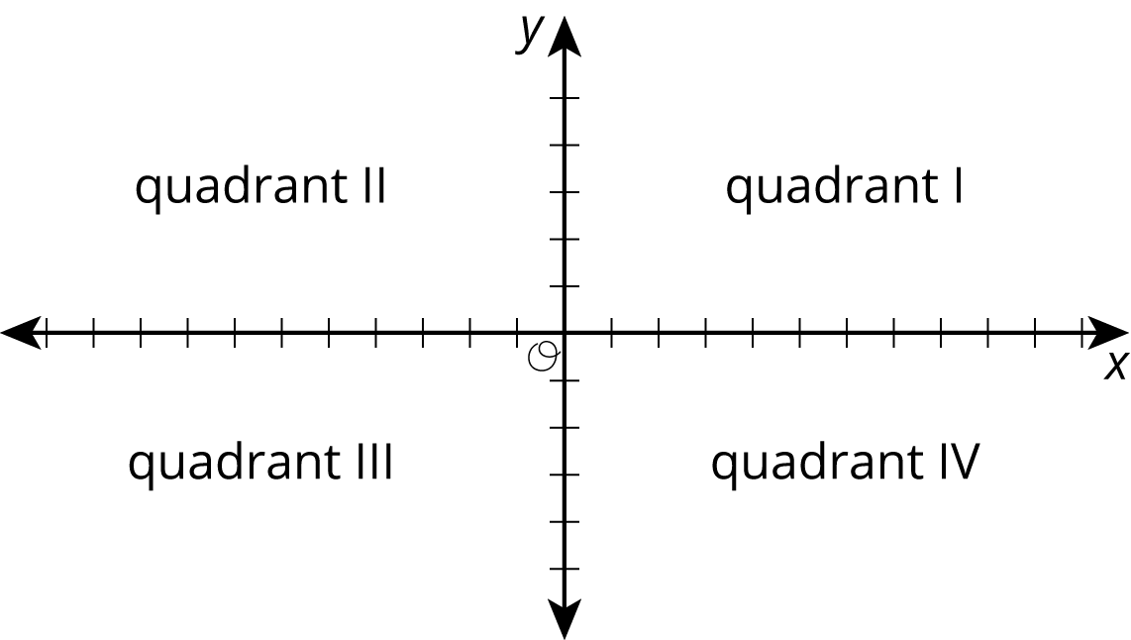

- $G=\left(5,2\right)$
- $H=\left(\text{-}1,\text{-}5\right)$
- $I=\left(7,\text{-}4\right)$
- In which quadrant is point $G$ located? Point $H$? Point $I$?
- A point has a positive $y$-coordinate. In which quadrant could it be?

3 Coordinated Archery

Student Task Statement
Here is an image of an archery target on a coordinate plane. The scores for landing an arrow in the colored regions are shown.
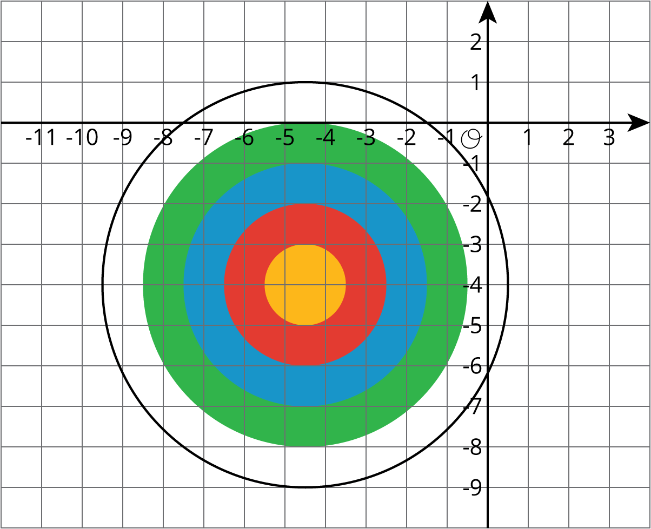
- Yellow: 10 points
- Red: 8 points
- Blue: 6 points
- Green: 4 points
- White: 2 points
Name the coordinates for a possible landing point to score:
- 6 points
- 10 points
- 2 points
- No points
- 4 points
- 8 points
© CC BY Open Up Resources. Adaptations CC BY IM.

